**Housing and Demographics**

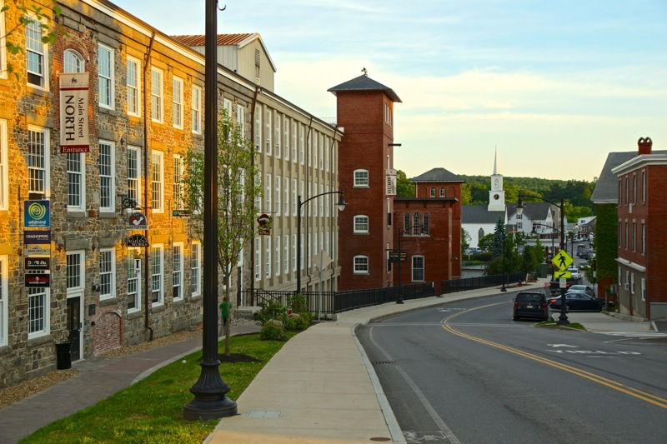Town of Newmarket Master Plan

Newmarket Mills/Downtown Source: Town of Newmarket

Introduction 4

Table of Contents

Geographic Definitions 4

Population Characteristics 5

Historic Population 5

Population Projections 6

Age Cohorts 7

Population and School Enrollment 8

Enrollment Projections 9

Income and Employment Characteristics 10

Median Household Income 10

Per Capita Income 10

Income Groups 10

Unemployment 11

Educational Attainment 12

Employment Class 13

Employment by Industry 13

Major Employers 14

Commute Patterns 14

Housing 15

Household Type 15

Family Households 16

Household Size 16

Housing Unit Vacancy 17

Building Permits 17

Assessed Home Values 18

Purchase Prices 19

Purchase Price Frequency 19

Rental Costs 20

Rental Cost Frequency 20

Severe Housing Problems 21

Housing Cost Burden 21

Housing Affordability 22

Housing Trends 26

Downtown Redevelopment Efforts and Resilience Planning 26

Age-Based Housing Trends 27

Student Housing 28

Universal Design 29

Accessory Dwelling Units 30

Condos and Cooperatives 31

Property Tax Policies 31

Expansion of Ownership Opportunities 32

Goals and Recommendations 33

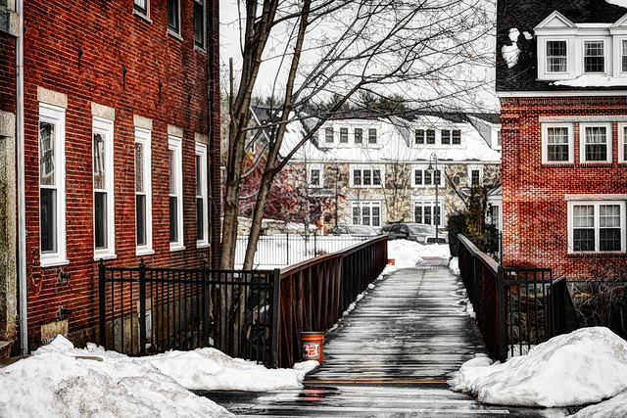 Bryant Rock/Bridge Source: Town of Newmarket

# Introduction

The Housing and Demographics chapter is intended to provide a “30,000-foot” level analysis of trends related to housing demand and supply, population demographics, and basic economic characteristics. Comparative analyses between the Town of Newmarket, Strafford Regional Planning Commission planning region, and State of New Hampshire are provided as a contextual tool for informing readers. While this chapter does provide a snapshot view, it is not a comprehensive study.

Findings are based largely on 2010 decennial United States Census 100% Count datasets, with support from American Community Survey 2012 and 2013 5-Year Estimates. Local 2014 assessing data was also employed. American Community Survey Estimates, as a sample-derived dataset, present high margins of error, and therefore, limited accuracy. As a result, estimates related to demographics, housing, and economic characteristics should be treated carefully by those reviewing this document. In many instances these data represent the best available information, and are therefore the basis for many elements of analysis within this chapter.

This chapter is intended to provide decision makers with the best possible available information for making choices for Newmarket. The above qualifications represent why the best possible information may be neither precise nor accurate enough to arrive at definitive and/or conclusive results. The analyst’s interpretation of these datasets must be considered when reviewing this chapter.

## Geographic Definitions

### Strafford Region

The Strafford region is comprised of 18 communities ranging from Wakefield in the north, Northwood to the west, Newmarket to the south, and Rollinsford to the east.

### Portsmouth-Rochester, NH HFMR Area

HUD Fair Market Rent Area, or HFMR, is a HUD housing data analysis geography for use in regional housing analyses. The Portsmouth-Rochester HFMR is comprised of: Brentwood, East Kingston, Epping, Exeter, Greenland, Hampton, Hampton Falls, Kensington, New Castle, Newfields, Newington, Newmarket, North Hampton, Portsmouth, Rye, Stratham, Barrington, Dover, Durham, Farmington, Lee, Madbury, Middleton, Milton, New Durham, Rochester, Rollinsford, Somersworth, and Strafford.

# Population Characteristics

## Historic Population

In the years between 1960 and 2010 Newmarket grew at rapid, yet consistent pace. In this fifty year period Newmarket’s population increased in total by 183%, an average of 1,157 residents per decade. Rapid 50-year growth was not unique to Newmarket. In the SRPC region and state, populations grew 123% and 117% respectively. However, Newmarket and the Seacoast’s greater rate of growth placed an additional strain on the communities to provide services for a rapidly increasing population.

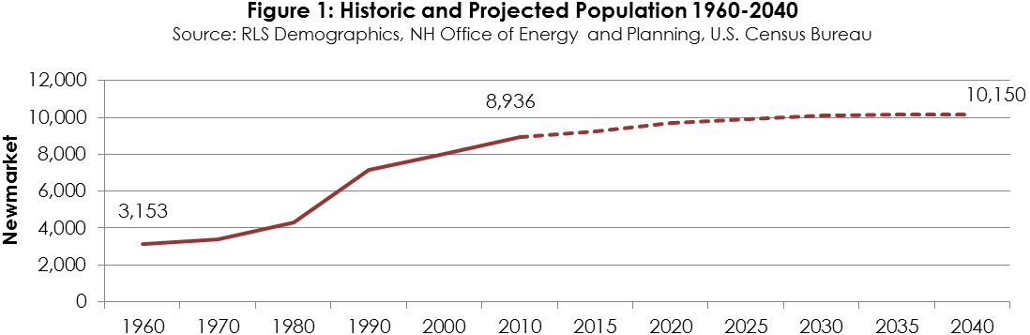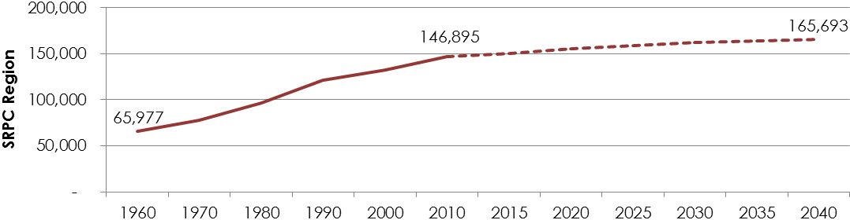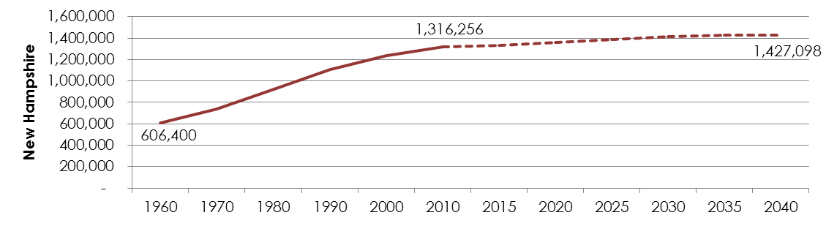

## Population Projections

Population projections are vital to understanding potential future demands for housing, infrastructure, and services within a community. The NH Office of Energy and Planning, in partnership with New Hampshire’s nine Regional Planning Commissions, completed population projections in the spring of 2014 on both a county and municipal level through year 2040. The methodology for these projections can be found at right.

**Methodology: Municipal Population Projections**

*The projections are done in five-year intervals, and are consistent with the county population projections in the report titled: State of New Hampshire, Regional Planning Commissions, Office of Energy and Planning - County Population Projections, 2013 By Age and Sex.*

*The method used to develop these municipal level projections starts with the above forecast for total population for each county in New Hampshire. Because these numbers are controlled to the county and state projections, these numbers are considered reasonable in the aggregate as well as at the local level.*

*Next, the town/city share of county population in the 2010 Census (with the Census revisions) was developed and compared to the 2000 Census share of county population for each town/city in that county.*

*This analysis revealed that the share of each municipality’s population (relative to the county) has been changing over time. To confirm the observed trend, municipal shares of the county population were examined for the Census years 1970, 1980, and 1990. That analysis confirmed the observed trend in changing shares over time.*

*The methodology used to allocate the county population projections to the municipalities assumes that the 2000 to 2010 shift in share (municipality as a share of the county) will continue into the year 2020. The method attempts to account for a community’s share of the county’s recent population change, rather than assuming an unchanging share of the county’s total population.*

*Next, that share of the municipality’s population relative to the county’s population is frozen at the 2020 share level (held constant) through the remaining 20 year projection period (2020 to 2040).*

Source: NH Office of Energy and Planning

These projections estimate that Newmarket is expected to grow by an average of 405 residents per decade through 2040. Between 2010 and 2040, this will result in an overall population growth of 14% (1,214 in total), nearly twice the projected rate for the State of New Hampshire. On a larger scale, the Strafford region is and will continue to be the fastest growing region in the state, and is expected to grow on pace with Newmarket, a 13% increase in the 30-year projection period. It should be noted that in the 5-year period between 2035 and 2040, Newmarket’s population is expected to decrease.

## Age Cohorts

### Overall Trends

In the two decades between 1990 and 2010, two significant population trends emerged in Newmarket: a significant decline in 25-34 age individuals and an observable increase in age cohorts 45 and above. This aging population trend is occurring across many of New Hampshire’s communities. Dubbed the ‘silver tsunami’ by demographers and planners, this ‘tsunami’ is the product of the shifting of baby-boom generation individuals into older age cohorts. The impact of this trend is discussed in depth later in this chapter.

### Age Cohort Details

In parallel with the 2001 Master Plan population chapter, the following age cohort discussion is divided into four age groups: preschool, school-age, labor-force, and elderly.

### Pre-school Population

The pre-school population (0-5 years old) increased by 17% in the decade between 2000 and 2010. However, this cohort has decreased in size since the 1990 Census.

### School-Age Population

Age cohorts that represent ages 5-19, those typically classified as ‘school-age’, remained relatively static between 2000 and 2010. However, each cohort did decrease in size, indicative of lower birth rates and/or decreasing families within the community.

### Labor Force Population

The 18 to 64 age group is often referred to as the labor force, although not all persons in this group are actually employed or seeking employment. Populations between 18 and 25 have remained relatively static in the past two decades. This is likely attributable to the presence of University of New Hampshire students living in Newmarket, and the University’s stable enrollment growth. Nonetheless, Newmarket has historically attracted more young adults than have the adjacent communities. In Newmarket, persons from 25 to 34 years decreased by 4% in the decade between 2000 and 2010, though not as significantly as the 19% loss between 1990 and 2000. However, persons 35 to 44 years declined by 15% over the same span, the largest value decrease of any single cohort. The 45 to 54 age category experienced an increase of nearly 35% in the ten year period between 2000 and 2010, a product of the ‘silver tsunami’.

### Elderly Population

Elderly cohorts (those ages 65 and over) grew by 127% from 2000 to 2010.

## Population and School Enrollment

Two observable demographic shifts are occurring not only in Newmarket, but across much of New Hampshire, and the nation. Though some states have been able to endure changing age demographics by attracting heavy in-migration from immigrant populations, New Hampshire’s population is rapidly aging while communities are experiencing an observable decline in families, children, and school enrollment. As part of its 2012 *Housing and School Enrollment in New Hampshire: 2000-2010-A Decade of Change* study, New Hampshire Housing Finance Authority suggests that demographics can have a greater influence on enrollment figures than housing growth/construction. In the decade between 2000 and 2010, New Hampshire communities gained nearly 45,000 housing units, but lost nearly 21,600 school enrollees. Of the state’s 161 school districts, 130 experienced a decline in enrollment, including the Newmarket school system.

In 2000, Newmarket, like many other communities in the state, attempted to address the cost of educating new students coming from new housing unit construction. In 2015 the demographic playing field has changed. Family households are in decline with a rapidly growing number of housing units occupied by only one person or multiple unrelated individuals living together to minimize costs, particularly in communities adjacent to Universities. Despite construction of new single-family homes and multi-family units in some New Hampshire communities, these projects typically produce only .64 and .17 students per unit respectively. Declining or stagnating enrollment, once considered a goal of some communities like Newmarket, is now costing taxpayers more as they work to pay for fixed education costs like maintenance and staffing. This is of particular importance in Newmarket with its current education infrastructure planning challenges. Furthermore, state-funding, often based on a student-enrollment funding formula, is also declining.

With slow growth projected for much of New Hampshire, enrollment numbers are not expected to return to 1990-2000 levels. Many school districts now have a surplus of capacity and shortage of demand that must be addressed. Communities must begin to take action to improve the overall fiscal health of their education system by addressing the provision of affordable and attractive family housing stock that will increase property tax revenues. Newmarket is no exception.

## Enrollment Projections

Newmarket has undertaken a significant effort to plan for continued excellence in education for its future students. As part of that effort, the Town of Newmarket, Newmarket School Board, and Joint Advisory Committee (JAC), in conjunction with professional education planning consultants, developed the Newmarket School Facility Report in 2015. The following projections are extracted from that report:

*”Predicting student enrollment for the next several years is a critical task. After reviewing a number of student enrollment studies conducted for Newmarket and developing some projections of our own, the consultants, with agreement by the JAC, have elected to use the 2014-2015 Student Enrollment Projections conducted by the New England School Development Council (NESDEC) as the best basis for future student enrollments. The NESDEC study is attached to this report and forms the basis both for examining tuition options and for helping determine the size of buildings needed to house Newmarket Junior and Senior High School students.*

*The NESDEC study contains projections of student enrollment through the 2024-25 school year. According to the projections, high school population will peak at 274 students in 2021-22 and decline to 265 three years later. Combined senior and junior high school population will peak at 516 students in 2020-21and decline to 489 by 2024-25.”*

[Source: Newmarket School Facility Report]

Historically, Newmarket’s enrollment in grades 1-5 in Newmarket has remained stable while enrollment in grades 5-12 has declined over time. This trend suggests that students enrolled in the District at younger ages do not remain as they age. One contributing factor may be that Newmarket’s affordable rental housing stock attracts young families, but a somewhat less affordable ownership market makes it difficult for those families to transition to appropriate housing, resulting in them leaving the community.

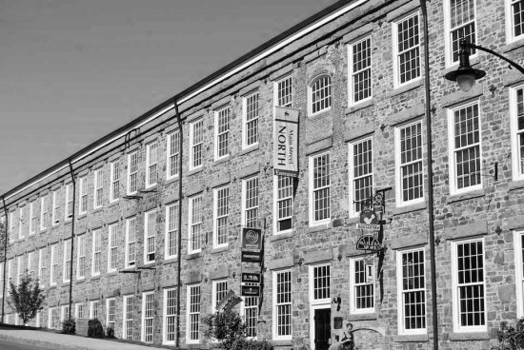

Newmarket Mills Source: Town of Newmarket

# Income and Employment Characteristics

For detailed information on Median Household Income, Per Capita Income, and Income Groups, please see Table 1 on page 11.

## Median Household Income

Newmarket’s median household income has remained slightly lower than the SRPC region (5%), and an average of 10% lower than that of the State of New Hampshire over the period between 1990 and 2013. In this period, the Town’s household income grew from $32,348 in 1990, to $46,058 in 2000, to a value of $57,429 in 2013 – a 20-year overall growth of 56%.

Note* 2013 figures are extracted from American Community Survey estimates while 1990 and 2000 figures are extracted from U.S. Census Bureau 100% count datasets

## Per Capita Income

Newmarket’s per capita income doubled in the twenty years between 1990 and 2010. Newmarket’s median per capita income has been historically higher than the SRPC planning region, likely because of its proximity to the more affluent Rockingham County and the communities of Exeter and Portsmouth. Newmarket is however lower than the State of New Hampshire. This is likely the product of the high count of University of New Hampshire students reporting low incomes within Newmarket.

## Income Groups

Newmarket’s income group classification growth illustrates a surprising shift away from middle income residents, towards concentrations of very low and very high income individuals. Although the majority of Newmarket’s residents still report in the ‘middle’ incomes ($25,000-$75,000), between 2000 and 2013 the Town saw a 236% increase in households reporting $100,000 of income or greater. Interestingly, in the same period, the community witnessed a 60% increase in those making less than $10,000. It is likely that this change is the result of a slight increase in UNH student residents and increase in senior population with limited reportable income.

|  |  |  |  |  |  |  |  |  |
| --- | --- | --- | --- | --- | --- | --- | --- | --- |
| 2014 Poverty Rate Threshold: $23,850 | Table 1: Historic Median Household Income and Per Capita Income | | | | | | | |
|  | | |  | **Change** | | **Percent Change\*\*** | |
| **Household Income Group** | **1990** | **2000** | **2013\*\*\*** | **1990-2000** | **2000-2013\*\*\*** | **1990-2000** | **2000-2013\*\*\*** |
| Less than 10,000 | 311 | 210 | 337 | -101 | 127 | -32% | 60% |
| 10,000-14,999 | 165 | 231 | 105 | 66 | -126 | 40% | -55% |
| 15,000-24,999 | 487 | 446 | 267 | -41 | -179 | -8% | -40% |
| 25,000-34,999 | 592 | 368 | 346 | -224 | -22 | -38% | -6% |
| 35,000-49,999 | 689 | 604 | 509 | -85 | -95 | -12% | -16% |
| 50,000-74,999 | 523 | 825 | 752 | 302 | -73 | 58% | -9% |
| 75,000-99,999 | 92 | 410 | 444 | 318 | 34 | 346% | 8% |
| 100,000 or more | 65 | 279 | 937 | 214 | 658 | 329% | 236% |
| Total Households | 2,924 | 3,373 | 3,697 | 449 | 324 | 15% | 10% |
| **Town of Newmarket** | | | | | | | |
| Median Household Income | 32,348* | 46,058* | 57,429* | 13,710* | 11,371* | 42% | 25% |
| Per Capita Income | 15,078* | 22,085* | 32,244* | 7,007* | 10,159* | 46% | 46% |
| **Newmarket as Percentage of SRPC Planning Region** | | | | | | | |
| Median Household Income | 98% | 93% | 85% | -6% | -8% | -6% | -8% |
| Median Per Capita Income | 111% | 101% | 102% | -10% | 1% | -9% | 1% |
| **Newmarket as Percentage of State of New Hampshire** | | | | | | | |
| Median Household Income | 89% | 94% | 88% | 4% | -5% | 5% | -5% |
| Median Per Capita Income | 94% | 92% | 97% | -2% | 5% | -2% | 5% |
| Source: U.S. Census Bureau, American Community Survey  *Figures in USD  **Percent Change numbers are subject to rounding  ***2013 American Community Survey estimates are utilized as income characteristics are no longer included in Decennial Census counts | | | | | | | |

## Unemployment

Like all communities across the State of New Hampshire and United States, Newmarket felt the impacts of the Great Recession between 2005 and 2010. In the one year between 2008 and 2009, unemployment spiked from 3.2% to 5.1%.

Much like national and state values, Newmarket’s unemployment rates have recovered in the last five year span to a September 2014 low of 3.1%.

## Educational Attainment

Newmarket has a significantly higher percentage of individuals with a bachelor degree or higher in comparison to the State of New Hampshire. This is likely due to the Town’s proximity to the University of New Hampshire, an engine for regional employment and education. Many of Newmarket’s adjacent communities also display highly educated population bases, providing them with a real competitive economic advantage.

|  |  |  |
| --- | --- | --- |
| Table 2: Industry Share | | |
|  | **Newmarket** | **Rockingham County** |
| Agriculture, forestry, fishing and hunting, and mining | 0.00% | 0.60% |
| Construction | 5.30% | 7.10% |
| Manufacturing | 12.30% | 12.50% |
| Wholesale trade | 6.10% | 3.80% |
| Retail trade | 13.80% | 13.30% |
| Transportation and warehousing, and utilities | 4.20% | 4.40% |
| Information | 2.70% | 2.60% |
| Finance and insurance, and real estate and rental and leasing | 2.70% | 6.70% |
| Professional, scientific, and management, and administrative and waste management services | 11.80% | 11.20% |
| Educational services, and health care and social assistance | 25.00% | 22.00% |
| Arts, entertainment, and recreation, and accommodation and food services | 11.20% | 7.80% |
| Other services, except public administration | 2.60% | 4.50% |
| Public administration | 2.30% | 3.80% |
| Source: American Community Survey 2013 | | |

## Employment Class

In Table 2 at right, Newmarket and Rockingham County industry employment shares are presented. Significant variability is present in Wholesale Trade, Arts & Entertainment and Food Services, and Finance and Insurance.

One-quarter of those surveyed work within the Education Services, Healthcare, and Social Assistance fields. Concentrations are also present in Manufacturing, Retail Trade, Professional, Scientific, and Management Services, and Arts & Entertainment at both the county and municipal levels.

## Employment by Industry

|  |  |  |  |  |
| --- | --- | --- | --- | --- |
| Table 3: Employment By Industry | | | | |
|  | **2002** | **2012** | **Change 2002-2012** | **%Change 2002-2012** |
| Goods Producing Industries | | | | |
| Average Employment | 406 | 235 | -171 | -42% |
| Average Weekly Wage | $764 | $956 | +$192 | +25% |
| Service Providing Industries | | | | |
| Average Employment | 780 | 668 | -112 | -14% |
| Average Weekly Wage | $477 | $682 | +$205 | +43% |
| Total Private Industry | | | | |
| Average Employment | 1,186 | 903 | -283 | -24% |
| Average Weekly Wage | $575 | $753 | +$178 | +31% |
| Government (Federal, State, and Local) | | | | |
| Average Employment | 299 | 337 | +38 | 12% |
| Average Weekly Wage | $562 | $731 | +$169 | +30% |
| Total, Private plus Government | | | | |
| Average Employment | 1,484 | 1,240 | -244 | -16% |
| Average Weekly Wage | $573 | $747 | +$174 | +30% |
| Source: New Hampshire Employment Security | | | | |

Newmarket, in the 10-year period between 2002 and 2012, experienced decreases in all industry employment, with the exception of federal, state, and local government, according to New Hampshire Employment Security. Overall employment decreased by 16%, a result of the recession and changes in Newmarket’s demographics, particularly a shift towards more college-age residents.

Goods Producing Industries were particularly strongly impacted, with a 42% loss over the sample decade. Meanwhile, Service Producing Industry employment decreased by 14%. Together making up the classification of Private Industry, Service and Goods Producing Industries together represented a 24% overall employment loss, despite a 31% increase in wages.

## Major Employers

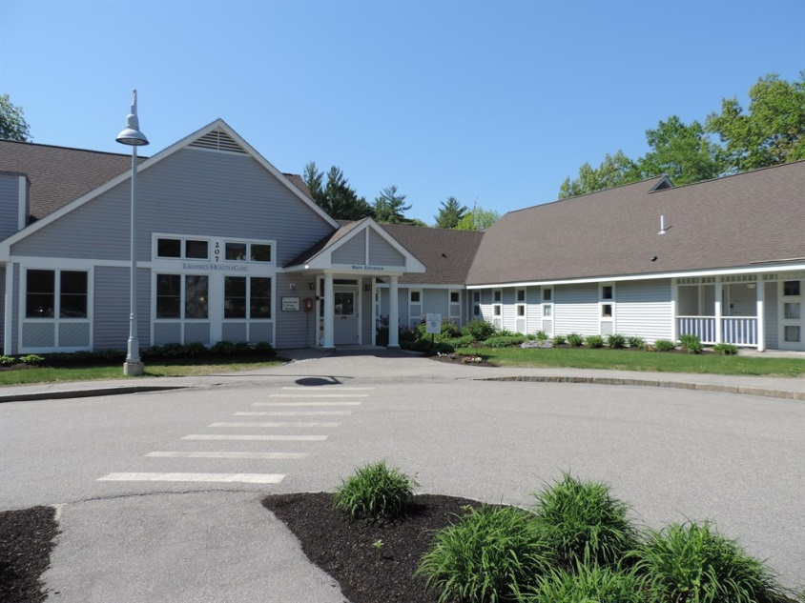

Lamprey Healthcare – Source: angieslist.com

Newmarket is home to few large employers both in the context of the region and state. Education and healthcare service industries dominate the employment sectors within the Town of Newmarket. The Town’s two largest employers are the Newmarket School District and Lamprey Healthcare. The majority of Newmarket’s residents work in adjacent communities or in employment centers in the greater region. For more information, please see the Commute Patterns section below.

|  |  |  |  |  |
| --- | --- | --- | --- | --- |
| Table 4: Major Newmarket Employers | | | | |
| Business Name | **Type** | | **Number of Employees** | |
| SAU 31 | | School district | | 146 |
| Lamprey Health Care | | Medical services & programs | | 67 |
| Town of Newmarket | | Municipal services | | 55 |
| Seacoast Sports Clubs - Great Bay | | Physical education facility | | 47 |
| Russound | | Audio, video, & multi-room systems | | 16 |
| Source: New Hampshire Employment Security(NHES) | | | | |

## Commute Patterns

2011 American Community Survey (ACS) estimates suggest that of individuals with primary employment within Newmarket, 80% commute from outside of the town. The remaining 20% both live and work within Newmarket.

ACS estimates indicate that 92.4% of Newmarket residents commute outside of the community to primary employment, many to one of the primary major employers listed below.

### Major Regional Employers

* *City of Portsmouth* - Portsmouth 1,542
* *Insight Technology, Inc.-* Londonderry 1,300
* *Portsmouth Consular Center -* Portsmouth 1,265
* *Portsmouth Regional Hospital -* Portsmouth 1,040
* *Liberty Mutual Insurance -* Portsmouth 1,013
* *Next Era -* Seabrook 1,000
* *Exeter Hospital -* Exeter 900
* *Lonza Biologies*-Portsmouth 772
* *Timberlane Regional School District* - Plaistow 740
* *Rockingham County Home & Jail*-Brentwood 690
* *Timberland* - Stratham 650
* *Derry Cooperative School System* - Derry 600
* *Fox Run Mall -* Newington 600
* *Wal-Mart -* Raymond 600
* *Sig Sauer* - Newington Manufacturing 600
* *University of New Hampshire* - Durham 4,077
* *Liberty Mutual -* Dover 3,500
* *City of Rochester* - Schools Rochester 1,155
* *City of Dover* - Dover 1,139
* *Wentworth-Douglass Hospital* - Dover,100

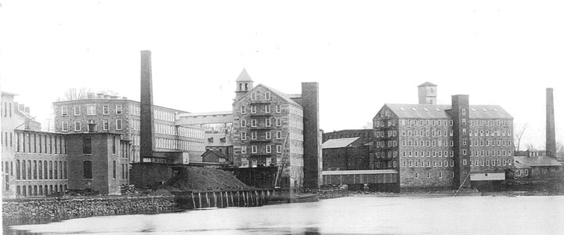

Historic Newmarket Source: Town of Newmarket

# Housing

Elements of this housing component are based upon the population and income characteristics and projections detailed previously. An intimate understanding of the relationship between housing, demographic, and income traits is integral in gaining a complete picture of the past, present, and future of Newmarket. Within this section you will find information related to housing availability, affordability, quality, suitability, and of course, viability. Together these elements forge a strong foundation upon which goals and recommendations for the future of Newmarket’s housing stock can be built.

The average lot size for single family homes in Newmarket is approximately 1.37 acres. Housing stock age varies, with the average year of construction for single-family units at 1964 and median construction year at 1985. Assessing data also indicate a median total parcel and structure value of approximately $253,558.

## Household Type

|  |  |  |  |  |  |  |
| --- | --- | --- | --- | --- | --- | --- |
| Table 5: Housing Unit Type | | | | | | |
|  | **1990** | **2000** | **2010** | **Total Change 1990-2010** | **Percent Change 1990-2010** | **Composition 2010** |
| Total Housing Units | 2400 | 3457 | 4139 | 1739 | 72% | 100.00% |
| Occupied Units | 2079 | 3379 | 3857 | 1778 | 86% | 93.19% |
| Vacant Units | 321 | 78 | 282 | -39 | -12% | 6.81% |
| Owner-Occupied Units | 871 | 1779 | 2100 | 1229 | 141% | 50.74% |
| Renter-Occupied Units | 1208 | 1600 | 1757 | 549 | 45% | 42.45% |
| Source: U.S. Census Bureau | | | | | | |

The town is home to 4,139 total recorded housing units, though 6.8% of these units were vacant in 2010. Occupied housing units are composed of 2,100 owner-occupied units and 1,757 renter occupied units as identified by the U.S. Census Bureau.

In the period between 1990 and 2010, Newmarket saw an 18% increase in owner-occupied units and a 10% increase in renter-occupied units.

## Family Households

|  |  |  |  |
| --- | --- | --- | --- |
| Table  6: Family Households | | | |
|  | Family Households | Occupied Households | Percentage Family Households |
| 1990 | 1848 | 2079 | 89% |
| 2000 | 1949 | 3379 | 58% |
| 2010 | 2219 | 3857 | 58% |
| Source: U.S. Census Bureau | | | |

There has been an observable change in family households in the study period between 1990 and 2010. The total number of occupied households in Newmarket increased from 2,079 to 3,857 between 1990 and 2010. However, 1990 figures indicated that of those 89% were self-identified as family households. Twenty years later, the 2010 Census revealed that only 58% of total households were classified as ‘family’. This change in family household composition during the study period reflects the larger trend of population loss in the 25-44 age cohorts, those that traditionally represent family-age individuals.

## Household Size

|  |  |  |  |  |  |  |  |  |
| --- | --- | --- | --- | --- | --- | --- | --- | --- |
| Table 7: Household Size | | | | | | | | |
|  | **1-Person** | **2-Person** | **3-Person** | **4-Person** | **5-Person** | **6-Person** | **7-Person+** | **Total** |
| **Total Occupied Units** | | | | | | | | |
| **2010** | 1068 | 1450 | 683 | 451 | 144 | 38 | 23 | 3857 |
| **2000** | 929 | 1230 | 564 | 435 | 178 | 30 | 13 | 3379 |
| **1990** | 682 | 1044 | 553 | 423 | 157 | 29 | 10 | 2898 |
|  | **2010 Total Occupied Unit Composition** | | | | | | | |
|  | 28% | 38% | 18% | 12% | 4% | 1% | 1% | 100% |
| Source: U.S. Census Bureau | | | | | | | | |

Household size calculations from 1990 to 2010 indicate, in concert with population statistics, that Newmarket has experienced a shift in housing formation moving towards smaller households, with fewer children in-home as baby-boom generation individuals become ‘empty-nesters’. While the Town experienced 57% and 39% growth in 1 and 2 person households respectively between 1990 and 2010, a minimal growth of 24% and 7% growth in 3-Person and 4-Person households was observed (those typically indicative of families). As of 2010, Newmarket’s owner/renter-occupied unit composition indicates a concentration (65% of all units) of one and two-bedroom units. Interestingly, 1990, 2000, and 2010 Census data shows, this concentration was relatively static, a trend that is unique to Newmarket in the region.

## Housing Unit Vacancy

The Town has exhibited variable housing unit vacancy numbers, dropping from 387 vacant units in 1990, to only 78 units in 2010, a 496% decline (a result of vacancy classification changes). In the years between 2000 and 2010, which included the economic crisis of the mid-late 2000’s, vacant unit counts increased by 262%. During the decade, all vacancy classifications increased, with the largest percentage increase occurring in “For Sale” units.

|  |  |  |  |  |  |  |  |  |
| --- | --- | --- | --- | --- | --- | --- | --- | --- |
| Table 8: Housing Unit Vacancy by Type | | | | | | | | |
|  |  | **Vacancy Type** | | | | | | |
|  | Total Housing Units | Vacant Housing Units | For Rent | For Sale | For seasonal, recreational, or occasional use | For migratory workers | Other vacant | Rented or sold, not occupied |
| 2010 | 4139 | 282 | 150 | 41 | 28 | 0 | 47 | 16 |
| 2000 | 3457 | 78 | 30 | 6 | 20 | 0 | 17 | 5 |
| 1990 | 2400 | 387 | 299 | 45 | 8 | 0 | 26 | 9 |
| Source: U.S. Census Bureau | | | | | | | | |

## Building Permits

In the past 13 years, Newmarket has experienced variable residential construction. New Hampshire Office of Energy and Planning building permit data (reported by the Town of Newmarket) show a total of 724 total residential units constructed between 2000 and 2006. In comparison, the period between 2007 and 2013 saw the construction of a mere 138 units, many of which were part of the mill redevelopment project in the downtown area (permitted in 2012). This decline in construction was largely the product of market conditions during the recession of the mid-late 2000’s and the accompanying high unemployment rates, layoffs, and a real-estate ‘crash’.

|  |  |
| --- | --- |
| Table 9: Base Residential Statistics | |
| Median Parcel Value | $253,558 |
| Average Parcel Value | $212,500 |
| Average Year Built | 1964 |
| Average Acreage | 1.37 Acres |
| Median Year Built | 1985 |
| Median Acreage | 0.4 Acres |
| Source: Newmarket Assessing Database | |

## Assessed Home Values

The chart below, extracted from Newmarket assessing data, represents a plot of home values within the community. The majority of housing units, with parcel and structure, fall between $100,000 and $300,000 in value. However, all values range between a low of $1 (likely an assessing database error) and a high of $1,693,837.

## Purchase Prices

Unfortunately, local assessing data cannot be used to compare Newmarket home values to state, regional, and housing area historic annual statistics; New Hampshire Housing Finance Authority datasets do allow for this analysis, and are used in the chart below. Over the past two decades of New Hampshire Housing Finance Authority data, Newmarket’s median purchase prices have been consistently higher than regional and state values. In comparison to the Portsmouth-Rochester HFMR, Newmarket’s values have been variable. The Strafford region, which includes Strafford County, southern Carroll County, and northern Rockingham County communities, has consistently represented the lowest home values of these areas. As of 2013, Newmarket’s median purchase price is nearly $60,000 greater than that of the region. Interestingly, the 2013 median purchase price of $233,000 is extremely close to the Newmarket assessing database median home value of $253,558.

## Purchase Price Frequency

New Hampshire Housing Finance Authority records a majority of home purchases/sales within each community including both single-family and condominium units. These data provide an opportunity for a snapshot-in-time analysis of the existing housing market. In 2013, 47 total purchases ranged from a minimum of $80,000 to a maximum of $460,000. In concert with Newmarket assessing data, the majority of sales occurred in the $100,000 and $300,000 range, with few outliers. The most frequent purchase price range for the year 2013 was between $220,000 and $250,000. All new housing unit construction purchases were greater than $400,000 in value.

## Rental Costs

New Hampshire Housing Finance Authority (NHHFA), in its annual rental cost survey, collects sample data from landlords related to monthly rental prices. Unfortunately, NHHFA’s sampling process excludes seasonal and student housing rentals, which have increased in prevalence in Newmarket and adjacent communities. NHHFA’s data illustrate a variable Newmarket rental market in comparison to the Strafford region, Portsmouth-Rochester HFMR, and State of New Hampshire. In the last 5 years however, Newmarket’s median monthly rental costs have consistently been above all three comparison geographies. Rental costs, because of Newmarket’s proximity to the University New Hampshire, are likely to be higher as students tend to live in larger households with higher rental costs.

Rental Cost Frequency

Rental cost frequency details rental survey information collected by New Hampshire Housing Finance Authority. A concentration is clear at the $1,250 per month value for both 2-bedroom units and all other units in 2013. Few units sampled are below $1,000 or above $1,700 dollars per month.

## Severe Housing Problems

|  |  |  |
| --- | --- | --- |
| Table 10: Percentage of Households with 1 of 4 Severe Housing Problems | | |
|  | Owner | Renter |
| Barrington | 6% | 4% |
| Dover | 6% | 10% |
| Durham | 8% | 23% |
| Madbury | 10% | 7% |
| Newmarket | **7%** | **10%** |
| Northwood | 9% | 1% |
| Rochester | 6% | 10% |
| Rollinsford | 9% | 9% |
| Source: CHAS, HUD 2006-2010 | | |

Comprehensive Housing Affordability Strategy (CHAS) data is provided by the US Department of Housing and Urban Development in order to relay the necessity for housing assistance. These data examine severe housing problems as grouped into four categories: incomplete kitchen facilities, incomplete plumbing facilities, more than 1.5 persons per room (not bedroom), and a cost burden greater than 50%. Cost burden is the ratio of housing costs to household income. This differs for renters and owners. For renters, housing costs includes gross rent, which is contract rent plus utilities. For owners, housing costs include mortgage payment, utilities, association fees, insurance, and real estate taxes.

When compared to other communities in the Strafford planning region, the extent of severe housing problems in Newmarket for both renters and owners is comparable to others communities in the Strafford planning region. Newmarket’s severe housing problem instances may be attributed to the number of student rental units in that they tend to correlate with lower household income and more individuals per room.

|  |  |  |  |  |  |  |  |  |
| --- | --- | --- | --- | --- | --- | --- | --- | --- |
| Table 11: Housing Cost Burden | | | | | | | | |
|  | *Between 30% and 50% of Income paid to Housing* | | | | *Greater than 50% of Income paid to Housing* | | | |
| Owner | | Renter | | Owner | | Renter | |
| Barrington | | 17% | | 3% | | 5% | | 3% |
| Dover | | 13% | | 12% | | 6% | | 9% |
| Durham | | 7% | | 7% | | 8% | | 18% |
| Madbury | | 19% | | 5% | | 6% | | 7% |
| Newmarket | | **11%** | | **8%** | | **7%** | | **9%** |
| Northwood | | 20% | | 1% | | 8% | | 1% |
| Rochester | | 16% | | 8% | | 6% | | 8% |
| Rollinsford | | 16% | | 1% | | 9% | | 9% |
| Source: CHAS, HUD 2006-2010 | | | | | | | | |

## Housing Cost Burden

As defined above, cost burden is the ratio of housing costs to household income and is dependent on different factors for renting versus owning (see diagram above). HUD considers housing cost to be a ‘problem’ if housing payments are between 30% and 50% of the respective household’s income. If payments are greater than 50% of household income, the cost burden is viewed as a ‘severe problem’. Table 11 at right illustrates the percentage of households whose cost burden is considered a housing problem (30 to 50% cost burden) or a severe housing problem (cost burden of 50% or more) for owner and renter occupied housing.

## Housing Affordability

In an effort to address issues related to the provision of affordable housing for workers in the State, the New Hampshire Legislature enacted legislation in 2008 requiring all communities to support the creation of housing through their land use regulations. New Hampshire Revised Statutes Annotated (RSA) 674:59, Workforce Housing Opportunities, states the following:

*“…ordinances and regulations shall provide reasonable and realistic opportunities for the development of workforce housing, including multifamily housing. In order to provide such opportunities, lot size and overall density requirements for workforce housing shall be reasonable. A municipality that adopts land use ordinances and regulations shall allow workforce housing to be located in a majority, but not necessarily all, of the land area that is zoned to permit residential uses within the municipality.”*

In New Hampshire, affordable is defined as when housing expenses for a unit (utilities and rent, or mortgage payments including utilities and insurance) are below 30% of the unit’s median household income. Further, in RSA 674:58, workforce housing is defined as housing for sale or rent, where homes for purchase are “affordable to a household with an income of no more than 100 percent of the median income for a 4-person household for the metropolitan area or county in which the housing is located” and rentals are “affordable to a household with an income of no more than 60 percent of the median income for a 3-person household for the metropolitan area or county in which the housing is located”. The median incomes for 3 and 4-person respectively are defined by HUD Fair Market Rent (HFMR) areas, or metropolitan and non-metropolitan counties set by the United States Department of Housing and Urban Development (HUD).

Like in many other Seacoast communities, purchasing a home or renting an apartment in Newmarket has become significantly more difficult in the past decade. However, unlike so many of those communities, Newmarket has been successful in providing a large stock of affordable housing units for multiple demographic groups. Newmarket residents and elected officials understand that housing affordability is a key factor in understanding a community’s past and future social and economic development. In so many overburdened households, where a large portion of their income goes directly towards housing cost, a shortage of funds can emerge for other critical needs, such as food, health care, heating, etc. In communities like Newmarket where a significant percentage of housing units are affordable, affordability can be a positive force for area businesses and public agencies by increasing the labor force supply available to fill a variety of jobs. Historically, the town has made significant efforts to ensure the alignment of the town’s housing stock shares with surrounding communities while maintaining its ‘fair share’ of affordable housing in the context of the region. Subsequently, the town and its residents have focused in the period since the last iteration of the master plan on the development of single-family homes that provide increased tax base and lessen impacts to the community’s services.

### Single-Family Housing Unit Affordability Analysis

### To qualify as workforce housing, owner-occupied units must be “affordable to a household with an income of no more than one hundred (100%) percent of the median income for a four person household” (RSA 674:58.IV). Affordable is further defined as housing units that do not exceed 30% of a household’s gross annual income in combined mortgage loan debt services, property taxes and required insurance (RSA 674:58.I).

The US Department of Housing and Urban Development (HUD) specifies the income threshold for a four person household in the Portsmouth-Rochester HFMR, which includes Newmarket and the following communities: Brentwood, Durham, East Kingston, Epping, Exeter, Greenland, Hampton, Hampton Falls, Kensington, New Castle, Newfields, Newington, North Hampton, Portsmouth, Rye, Stratham, Barrington, Dover, Farmington, Lee, Madbury, Middleton, Milton, New Durham, Rochester, Rollinsford, Somersworth, and Strafford.

In real terms, the purchase price of a house must be affordable to a household earning no more than $84,300. To better understand the cost of owner-occupied housing in Newmarket, an analysis was done which for a 4-person household assesses units affordable to households with incomes of 80% ($63,900) and 60% ($52,860) of the above stated HUD median. Please see Table 12 below.

In order to determine what homes values would be affordable for households making between $52,860 and $84,300 the NHHFA’s Affordability Calculator was used. The calculator for a home purchase was set to include: a 2.575% tax rate (Newmarket’s 2014 rate), $10,000 cash on hand, a 5% interest rate on a 30 year loan, and; a 0.5% home insurance rate. The Calculator produced a home value of $240,865 for Newmarket.

|  |  |
| --- | --- |
| Table 13: Newmarket Affordable Purchase Price for Single Family Housing Units | |
| Percent of Median Household Income (4-Person Owner Occupied) | Affordable Purchase Price |
| 100% | $240,865 |
| 80% | $184,277 |
| 60% | $153,571 |
| Source: NHHFA Affordability Calculator | |

|  |  |
| --- | --- |
| Table 12: Portsmouth-Rochester HFMR Median Income Values | |
| Percent of Median Household Income (4-Person Owner Occupied) | Income Value |
| 100% | $84,300 |
| 80% | $63,900 |
| 60% | $52,860 |
| Source: New Hampshire Housing Finance Authority | |

Next, the NHHFA Affordability Calculator’s purchase price of $240,865 or less was compared with the Total Value of each owner-occupied unit in the Newmarket Assessor’s database. Table 14 details the number and percentage of affordable single-family housing units within the Town of Newmarket.

|  |  |  |  |
| --- | --- | --- | --- |
| Table 14: Newmarket Affordable Housing Units | | | |
| Percent of Median Household Income (4-Person Owner Occupied) | Affordable Purchase Price Range | Number of Affordable Housing Units | Percentage Affordable Housing Units  (Units in affordable purchase price range/total Newmarket housing units) |
| 100% ($84,300) | **$0-$240,865** | **1,858** | **64%** |
| 80% ($63,900) | $0-$184,277 | 971 | 33% |
| 60% ($52,860) | $0-$153,571 | 654 | 23% |
| Source: Newmarket Assessing Database | | | |

Of the 2,901 single-family housing units in Newmarket, 64% (1,858) of properties would be affordable to a household earning the median household income for a 4-Person owner-occupied unit.

### Rental Cost Affordability Analysis

As previously indicated, Newmarket is home to a large rental housing stock occupied by young families, low-to-middle income earners, and University of New Hampshire students. This section discusses the affordability of renting a housing unit, with utilities, in Newmarket in comparison with the SRPC planning region. Although the Town of Newmarket does not maintain a local comprehensive rental database, New Hampshire Housing Finance Authority (NHHFA) conducts an annual Residential Rental Cost Survey throughout New Hampshire’s communities which provides specific rental data on the municipal level. The NHHFA Cost Survey is intended to avoid sampling of seasonal, part-time, or student housing units, but some margin of error likely exists. Table 15 below shows median monthly rental costs for 1, 2, and 3-bedroom units in 2013, in addition to all sampled rental units.

Under the state statute, in order for rental units to be considered “affordable” they must be available to a household with an income of no more than sixty (60%) percent of the median income for a three-person household” (RSA 674:58.IV). New Hampshire defines affordable rentals as units which, in combination with utility costs, do not exceed 30 percent of a household’s gross annual income (RSA 674:58.I). The HUD specified income threshold for a three person household in the Portsmouth-Rochester HFMR for 2013 was $47,580. To be considered a rental unit affordable by definition in Newmarket, the median annual costs would have to be less than $14,274.

|  |  |  |  |  |
| --- | --- | --- | --- | --- |
| Table 15: 2013 Newmarket Average Gross Monthly Rental Costs | | | | |
|  | All Units | 1-Bedroom Units | 2-Bedroom Units | 3-Bedroom Units |
| Newmarket | $1,267 | $931 | $1,267 | $1,927 |
| Region | $967 | $745 | $1,012 | $1,395 |
| Source: New Hampshire Housing Finance Authority | | | | |

As shown in Table 16 below, Newmarket’s median rental prices for 1-bedroom units are below the $14,274 cost threshold. However, 2 and 3 bedroom unit median rental costs, and the overall median rental cost, are not considered affordable by definition. In fact, Newmarket’s 3-bedroom annual median rental costs are more than $5,000 higher than the SRPC regional 3-bedroom median value, and nearly $10,000 higher than the affordable rental threshold. This can be primarily attributed to historically stable rental cost growth in Newmarket, a generally attractive rental housing stock, and the Town’s proximity to destinations such as the University of New Hampshire and Portsmouth.

|  |  |  |  |  |
| --- | --- | --- | --- | --- |
| Table 16: 2013 Newmarket Gross Annual Rental Costs | | | | |
|  | All Units | 1-Bedroom Units | 2-Bedroom Units | 3-Bedroom Units |
| Newmarket | $15,204 | $11,172 | $15,204 | $23,124 |
| Region | $11,604 | $8,940 | $12,144 | $16,740 |
| Source: New Hampshire Housing Finance Authority | | | | |

### Housing Unit Projections

As suggested in the Population Projections section of this Housing and Demographics chapter, Newmarket is expected to grow by an average of 405 residents per decade through 2040.Between 2010 and 2035 (last year of projected population growth), this will result in an overall population growth of 14%, nearly twice the projected rate for the State of New Hampshire. Population growth typically results in a natural increase in demand for housing supply. SRPC conducts basic housing unit projections that estimate future demands for total, vacant, renter-occupied, and owner-occupied housing units.

As of the 2010 Census, Newmarket’s average household size for all units was 2.16 persons. Assuming that this household size remains constant out to 2035 (the maximum projected demand year), and the population grows by the projected 1,214 individuals, SRPC estimates that Newmarket will need approximately 562 new housing units over 25 years between 2010 and 2035. SRPC projects that this will necessitate the creation (through new construction, redevelopment, or renovation) of 285 new owner-occupied housing units and 239 new renter-occupied units (assuming the current 6.81% vacancy rate). As with any projection, consideration of this estimate should be done carefully as not all population growth is likely to be new residents.

*\*Note: Building permit data from the New Hampshire Office of Energy and Planning (NHOEP) from 2010-2013 illustrate a total growth of 130 units. Although NHOEP data do not include year 2014, the real growth of 130 units parallels SRPC projections that indicate a growth of 149 units in the years between 2010 and 2015.*

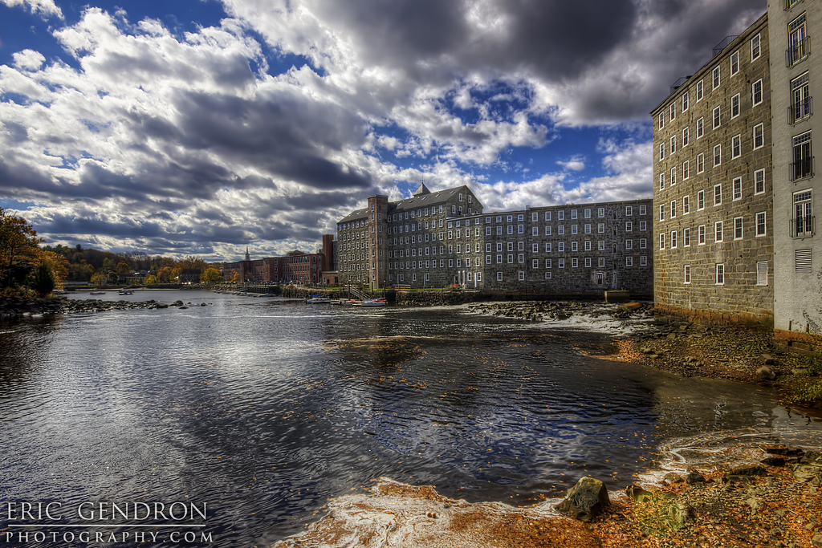

Newmarket Mills Source: Eric Gendron Photography

# Housing Trends

The Housing Trends component of the Newmarket Housing and Demographics Master Plan chapter is a discussion of observed and anticipated trends in housing development in Newmarket, the SRPC region, and State of New Hampshire. These trends include: Newmarket downtown redevelopment efforts, senior housing preferences, UNH student housing trends, and single family housing development.

## Downtown Redevelopment Efforts and Resilience Planning

Beginning in 2001, Newmarket began to experience significant redevelopment (particularly of the Newmarket Mills) in its downtown area, sparked by investment in a Tax Increment Finance (TIF) district. The Newmarket Mills development, in particular, represents an attractive and affordable rental opportunity for a mix of demographics ranging from single young professionals to retirees. Developments in this area are particularly attractive to multiple age groups because of their excellent access to downtown services and amenities, as well as their scenic location along one of the region’s most valued natural resources, the Lamprey River (which runs through the heart of the community).

Unfortunately, several recent downtown redevelopment and development projects are at risk of flood inundation as a result of severe storm events and even seasonal flooding following heavy precipitation. The Newmarket Mills and Bryant Rock properties represent high-risk properties because of their proximity to the Lamprey River. The Town of Newmarket will need to continue to closely monitor floodplain changes and changes to coastal flooding projections when considering future areas for development in the core of the downtown along the Lamprey River.

## Age-Based Housing Trends

Newmarket, the State of New Hampshire, and much of New England are experiencing a shift in population demographics. This change is driving a shift in housing preferences among both older and younger generations, which may result in a misalignment between housing supply and demand in the coming decades. Between 1960 and 2010, New Hampshire’s housing market was largely controlled by the high rate of in-migration of Baby Boom-age individuals to the state. Now, population projections indicate slowing growth and rapidly aging demographics, a trend that communities must plan and prepare for. This chapter acknowledges that the following trends are emerging.

### Home ow**nershi**p is declining.

Declining in-migration, a slow-recovering housing market, and difficulty in securing financing have each contributed to a declining attractiveness of owning a home. In particular, seniors are experiencing liquidity challenges as they attempt to downsize and relocate. At the same time, student-debt burden and wage quality make home ownership by younger people problematic.

### Housing Preferences are evolving.

Housing preferences of young people have shifted from ownership towards more flexible housing arrangements such as renting. Older populations, with average household sizes of approximately 1.5 persons, are down-sizing from large 3+ bedroom homes to 1 and 2 bedroom units closer to community centers. Together, these shifts significantly reduce the demand for larger, more rural homes and are creating a supply shortage for smaller, more flexible spaces.

### Existing housing stock is not flexible.

It is expected that construction rates will decline with slowing population growth in New Hampshire’s communities. Competition among older and younger generations for single-family homes and rental units in or adjacent to community center areas will create excessive demand on a limited supply of housing in these areas. One solution is the repurposing of existing living space using the principles of universal design (detailed later in this chapter). This means that communities must take proactive steps to ensure that local ordinances and regulations allow for innovative repurposing, rehabilitation, and expansion of spaces.

### Senior housing is a concern.

The aging of the Baby Boom generation is expected to result in the doubling of New Hampshire’s senior population by 2030. In parallel, housing unit occupancy by seniors will double, requiring consideration of how to design and retrofit housing for seniors with and without disabilities. Though a high percentage of seniors are interested in ‘aging in place’, this choice could become strained by increasing taxes and real estate costs, increased prevalence of disability combined with a decrease in the ‘caregiver’ population, and a decrease in median household income. Statewide figures estimate that median incomes for seniors are just over half that of all households.

### Seniors choosing to ‘age in place’.

Despite anecdotal evidence suggesting that seniors migrate to southern, warmer climates, only 3% of New Hampshire’s seniors move annually. A 2010 AARP survey of the 45 and older population indicated that 86% of respondents would “like to stay in their current residence as long as possible”. However, the ability of seniors to remain in their community is directly related to factors such as income, healthcare, housing stock, and housing cost burden. Nearly 45% of the state’s senior population classify themselves as having one disability. Of those, 18% report that their disability makes independent living challenging. Historically, social agencies have played a key role in ensuring that seniors are able to remain independent, though predicted funding shortages could lead to widespread cuts in these services. As indicated above, although seniors often have more assets, they tend to make one-half of the state’s median income, and they pay more than 30% of that income towards housing costs. More than 75% of the state’s senior population lives in suburban or rural areas; these areas typically lack access to key services and amenities such as healthcare and food. As a result, down-sizing seniors are searching for housing in locations with close proximity to these vital services. Unfortunately, much of the existing community-center housing stock is older and not ‘senior-friendly’.

### Statewide assisted living demand will rise.

NHHFA’s Senior Housing Perspectives report estimates demand for nursing home beds will increase in New Hampshire by more than 50% by 2025 (state nursing homes are currently at 100% capacity). In parallel, New Hampshire’s total demand for assisted living units is expected to grow from 4,400 to 7,400 in the next 15 year period, a 68% increase.

## Student Housing

Newmarket plays a critical role in housing off-campus undergraduate, graduate, and junior level faculty and staff from the University of New Hampshire in the adjacent community of Durham. In recent years, Durham’s downtown and periphery have been transformed by the combination of two forces: changing preferences among younger generations in student housing and a significant increase in the interest among developers in capitalizing upon this very change.

These housing preferences among University students have evolved significantly in the last ten years. Current students, commonly grouped into what are known as Millennials, are expressing much different expectations for housing from those of their Baby-Boom and Generation X parents. Unlike Baby-Boomers who shared bedrooms, bathrooms, and other amenities, Millennials seek private accommodations that offer shared social spaces, and are willing to pay for it. In fact, one national survey of students indicates that only 3.2% of respondents would prefer ‘traditional’ dormitory-style housing; the most popular housing-type being mixed-use apartments with retail on the first floor and within close proximity to campus.

Housing has become an important marketing tool for higher education institutions when recruiting students. In order to compete with other colleges and universities, schools like UNH must strategically diversify their on-campus housing stock, a task that has proved challenging for many state funded higher education institutions. State institutions, like the University of New Hampshire, are under pressure to maximize the use of limited financial resources as a result of decreased government funding of higher education. The result is a lucrative market opportunity for private housing developers in communities like Durham.

The University of New Hampshire, as of October 2013, has approximately 12,531 undergraduate and 2,411 graduate students enrolled. In order to house these students, the University provides 7,180 beds of undergraduate housing and 333 beds of family/graduate housing. Therefore, 57% of undergraduate and 14% of graduate students can, and do, reside on-campus. This means that 5,351 undergraduate and 2,078 graduate UNH students need some form of off-campus housing. Historically, these students have occupied rental housing units in downtown and adjacent traditional neighborhood single-family homes in Durham, or affordable rental units in Dover and Newmarket serviced by COAST and Wildcat transit agencies.

However, with the increase expected in supply within the community of Durham as a result of several large and small student housing developments, it is anticipated that demand will soon be matched with supply. This could potentially decrease interest from UNH students and staff in finding housing in both Dover and Newmarket.

A decrease in off-campus housing demand for UNH students represents both a challenge and opportunity for the community. With fewer transient residents, vacancy rates have the potential to increase, and several businesses may struggle to adjust to a change in demographics. Nevertheless, vacant downtown housing units represent a solution for creating housing stock for young professionals, families, and even elderly; all of whom seek access to services and amenities located in the downtown area.

## Universal Design

The traditional housing model defines a gradient of housing based on ‘life-stage’ progression, with individuals moving from smaller, more affordable rental units, to larger, more expensive ownership experiences. However, housing’s new model is a more age-universal one focused on the provision of housing that is attractive and affordable to multiple generations of owners and renters.

Housing developers and real estate markets have historically attempted to target specific homeownership stock to specific demographic groups, i.e. “first-time buyer”, “empty nester”, etc. Similarly, labels such as “family” and “elderly” have been applied to multi-family rental developments that are not significantly different from one another. The concept of universal design removes such labels, and instead promotes designs that facilitate more flexibility for those in sometimes very different “life stages” or physical conditions.

Universal Design Sample Source: SRPC RHNA

Universal design concepts include:

* Decreased reliance on the use of stairs to enter, exit, and move through the home
* No step entrances and door openings wide enough to accommodate a wheel chair
* At least one bedroom and an accessible bathroom on the first floor
* An open floor plan for good interior circulation
* Bathrooms with adequate maneuvering space and an accessible toilet and sink
* Kitchens with clear knee space under the sink, countertops and cook tops, thereby making them accessible for persons in wheelchairs
* Hardware such as lever door handles, push plates, and loop handles (instead of knobs) on drawers and cabinet doors

[Source: tjpdc.ord]

## Accessory Dwelling Units

It is impractical to assume that every elderly homeowner will be willing or able to move from their single family home to an apartment, condominium, or cooperative unit specially designed for their needs. One reason is there is a preference to remain in one’s home. A second reason is there are few alternatives available for seniors to purchase a different type of home without incurring new mortgage debt, or to rent a unit at a reasonable cost. A third issue could emerge from the demographic projections by age group over the next 20 years. If a large number of senior homeowners want to sell their homes in order to downsize or relocate, there may not be a sufficient pool of younger households with the interest or financial capability to buy them, thus resulting in high vacancy rates.

One approach is to make the single family home more versatile by incorporating accessory units into new single family construction, and to provide opportunities to create additional units through the conversion of existing homes to more than one unit. Such provisions provide valuable housing options for young workers as well as seniors. Though typically created in connection with a pre-existing single family use, consideration should be given to regulations that would allow for accessory units to be constructed within new housing units as well. While the use of “in-law” apartments is one response, restrictions that limit their occupancy to persons related to the owner introduces yet another constraint on the flexibility of the housing created.

The creation of an accessory unit may be regulated by reasonable limits on floor area and number of bedrooms. These smaller units can serve emerging market needs by enabling various types of household transitions. First, an accessory unit could be added by a senior household renting out that unit for extra income while providing housing for another smaller household (related or not related). An accessory unit might be added by a young family to provide a separate unit for an elderly relative or other small household of 1-2 persons. Another situation might involve a senior homeowner moving into the accessory apartment, then renting the principal unit to a household that needs the larger space. In all cases the flexibility of the housing site is enabled so that it can be used by more than one household, or can serve intergenerational needs. Local zoning regulations, however, may not currently permit such flexibility.

In some cases, any conversion or modification that creates a second unit or the subdivision of the house into multiple units would be bound by regulations that essentially recognize any additional unit as equivalent to adding another single family home. To add even a small dwelling unit under some zoning regulations may require a doubling of land area, increased frontage, more septic capacity, parking, or other features all to accommodate the impact of another one or two persons on the site. Alternatives should be sought which permit these small increments in living area and occupancy in recognition of the marginal demands of small apartments.

[Source: SRPC Regional Housing Needs Assessment 2015]

## Condos and Cooperatives

More opportunities are needed to accommodate today’s smaller households as well as to allow a growing senior population to move to downsized housing products. A common approach to senior housing in New Hampshire is the creation of “55-and-over” age restricted communities (many of which are large single family home subdivisions or attached housing) or rental housing for the elderly (age 55+ or age 62+). There are fewer multifamily condominium units designed for this age group, and very little experience with senior cooperatives with the exception of manufactured housing parks.

Condos and coops offer households, particularly seniors, the opportunity of preserving the assets gained from the buildup of home equity, and apply them to the purchase of smaller, more accessible and manageable homes. Such units would allow the household to preserve its equity position as it makes a transition without incurring new mortgage debt.

Products that are priced to allow households to buy a unit purchased with the proceeds from the sale of their larger single family home are needed, with prices that are comparable to the resale value the average homeowner can expect to receive. Creation of such units may require participation of a non-profit developer to achieve pricing goals and the preservation of affordability through covenants. If the condo or coop unit is marketed as a luxury product, it may instead attract a more affluent market.

[Source: SRPC Regional Housing Needs Assessment 2015]

## Property Tax Policies

New Hampshire municipalities are required to allow exemptions for Elderly Homeowners (RSA 72-39: a.), ages 65 or older, via the opportunity to exempt a certain portion of the assessed valuation of their homes from property taxation.

The amount of valuation that may be exempted increases by the age of the recipient. However, the criteria and exemption amounts vary based on the policy of each community. The intent is to reduce the total property tax expense for elderly homeowners of limited means which in turn helps seniors “age in place” by reducing their ownership carrying costs.

Participating homeowners must have a household income as well as assets that are below stated maximums adopted by the locality.

The use of these exemptions results in shifting some of the local tax burden away from low income elderly homeowners, and to other taxpayers (which includes non-elderly homeowners of limited means).

Municipalities will be dealing with an increasing number of exemption applications and the related tax shifts that will be involved. The exemption amount per participant is likely to rise as the population ages and more households fall within age groups that qualify for higher valuation exemptions.

Additionally, exemptions can be provided for improvements to Assist Persons with Disabilities (RSA 72: 37-a). Assessed valuation of property that is attributable to components of the structure including wheelchair ramps, extra wide doorways, elevators or other eligible improvements may be exempt from property taxation.

[Source: SRPC Regional Housing Needs Assessment 2015]

## Expansion of Ownership Opportunities

Although Newmarket has created ample owner and renter housing stock, demographic trends suggest that many renters are unable to transition easily from renting to owning while remaining in the community. The following are a selection of methods that may create more ownership opportunities for those of varying means.

### https://origin.ih.constantcontact.com/fs135/1102397538905/img/123.jpgNew Construction of Homes

Both private and non-profits developers have developed opportunities for people with middle incomes to purchase their own homes. Most of these approaches are geared toward helping first-time buyers (renters) enter the homeownership market. These approaches often involve public-private partnerships, a mix of financing sources, and cooperation from host communities with regulatory incentives, and resale controls to preserve affordability to future buyers. New developments incorporating middle income units range from small cottage-style developments to condominium units. In some communities, there has been municipal and non-profit participation in the development of housing through the use of state and federal funds, in order to make homeownership opportunities available.

Cottage Design Source: PlanNH

### Purchase of Existing Homes

The existing housing inventory is a less expensive approach to providing units than subsidizing the construction of new homes. Lower prices in a slower economy can represent a buying opportunity for organizations that have the capacity to purchase, improve and resell the properties to qualifying buyers.

Qualified first time buyers may benefit from the lower interest and reduced down payment requirements of New Hampshire Housing Finance Authority (NHHFA) mortgage programs. Under these programs, purchases can include owner-occupancy of properties of up to four units. This might be advantageous in the older urban areas with this inventory. Typically, a portion of net rental income is credited to the buyer when underwriting a purchase mortgage, improving the buyer’s effective income to support the loan.

Programs that have been developed by various non-profit housing organizations, housing authorities, and employers include buyer assistance including deferred second mortgage loans for rehabilitation, down payment and closing cost assistance, and lease/buy agreements.

[Source: SRPC Regional Housing Needs Assessment 2015]

# Goals and Recommendations

This section outlines the goals and recommendations associated with the key conclusions of this chapter. They are intended to guide the Town’s housing and community development efforts over the coming decade. The goals and recommendations below are not prioritized.

1. *GOAL: Integrate Smart Growth and Resilience principles into redevelopment AND new construction housing projects*
   1. Ensure the resilience of new housing development in the context of extreme storm event frequency and coastal flooding, particularly in areas adjacent to the Lamprey River.
   2. Encourage sustainable and energy-efficient design of new housing units.
   3. Continue to promote mixed uses in the downtown as other uses are phased out by current downtown redevelopment efforts.
   4. Encourage sustainable and energy-efficient retrofitting of existing housing units.
   5. Continue to encourage redevelopment in the downtown.
   6. Plan for development in a manner that maximizes the use of existing infrastructure and reduces the need for new roads, services, and facilities.
   7. Promote linkages and integration between neighborhoods, community facilities, and places of employment.
   8. Encourage new housing development and redevelopment in downtown mixed-use areas that promote live, work, and play lifestyles.
   9. Encourage infill development within established neighborhoods that is compatible with the existing density, land uses, and in scale with surrounding areas, and adequately supported by public utilities and the existing transportation system.
   10. Plan for an anticipated ~190 additional housing units over the next decade in a way that will not adversely impact the environmental and fiscal health of the community.
   11. Continue to ensure the environmental compatibility of new construction projects during site plan review and planning board approval process.
2. *GOAL: Create and maintain housing STOCK THAT ALLOWS FOR ‘AGING-IN-PLACE’ AND ‘AGING-IN-CoMMUNITY’* 
   1. Consider the services needed to allow residents to remain in their homes as the population ages.
   2. Support the development of a live, play, and stay community focused on resident retention that includes: a periodic assessment of resident needs, more neighborhood-based services, expanded transportation services, and increased housing options.
   3. Actively encourage senior housing development on lands most suitable, such as locations within walking distance to the downtown, and locations served by existing infrastructure, services, and amenities.
   4. Explore zoning changes that allow for compatible density and size for the development of assisted living, housing ‘co-ops’, and continuing care retirement communities to facilitate transitional housing opportunities in multi-generational neighborhoods.
3. *GOAL: SUPPORT PROPERTY TAX POLICIES THAT ALLOW INDIVIDUALS TO REMAIN IN THE COMMUNITY*
   1. Educate residents about elderly tax exemptions under RSA 72:39 as a method to ‘age-in-place’ or ‘age-in-community’.
   2. Review existing local property tax exemption standards for senior homeowners and evaluate impact on their ability to remain in Newmarket.
   3. Market and publicize property tax exemption programs for home improvements intended to improve accessibility for persons with disabilities.
   4. Continue to support the use of RSA 79-E (Community Revitalization Tax Relief Incentive) where and when appropriate.
4. *GOAL: PROMOTE NEW CONSTRUCTION AND REDEVELOPMENT EFFORTS THAT ADHERE TO PRINCIPLES OF UNIVERSAL DESIGN*
   1. Encourage use of universal design principles intended to serve multiple age groups.
   2. Provide zoning for mixed-use developments that create housing in close proximity to shopping and services.
5. *GOAL: CONTINUE TO PROVIDE OPPORTUNITIES FOR ACCESS TO ATTRACTIVE OWNER AND RENTER HOUSING STOCK*
   1. Continue to provide zoning regulations that allow owner-occupied housing that is attractive to a diverse group of current and prospective Newmarket residents.
   2. Accommodate accessory units as a viable option for downsizing, starter homes, and multigenerational uses.
   3. Promote repurposing and/or redevelopment of vacant and deteriorating housing stock that would contribute to expanding the tax base.
   4. Conduct a comprehensive re-evaluation of zoning ordinances and regulations.
   5. Establish design review standards in the downtown area.
6. *GOAL: CONTINUE TO BUILD PARTNERSHIPS WITH LOCAL AND REGIONAL HOUSING ORGANIZATIONS AND ENTITIES*
   1. Continue to foster a productive relationship with the Newmarket Housing Authority in an effort to provide opportunities for housing for individuals and families with diverse socio-economic backgrounds.
   2. Continue to explore and document the relationship between overall community development, economic growth, and housing stock availability.