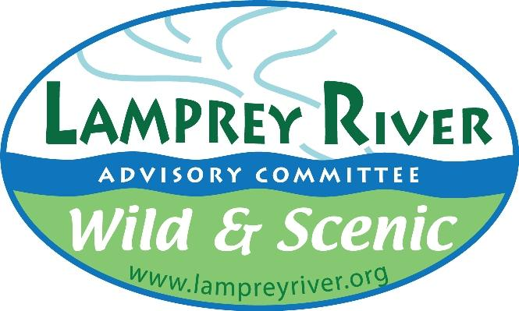
Lamprey River Advisory Committee
Grant Application Form

date: January 18, 2024

name of applicant
or organization: Newmarket Arts, Culture & Tourism Commission

contact information for applicant: name, address, phone number, email address
Debra Smith, Chair, Arts, Culture & Tourism Commission
atcommission@newmarketnh.gov
Newmarket Town Hall
186 Main Street, Newmarket, NH 03857
860/836-7370

Ben Buckley, Member, Arts Culture, & Tourism Commission
b.buckley.act@gmail.com
Newmarket Town Hall
186 Main Street, Newmarket, NH 03857
(781) 385 0442

type of grant being sought: (Community Grant, Research Grant, other-specify)
Community Grant- $7500

title of proposed project:
Willey House Central Park

goals of proposed project:
- Enhance downtown Newmarket with another park for community gathering & enrichment
- Expand town art installations to include permanent kinetic sculpture using historic farm and woodworking tools to artistically represent the “river’s edge”
- Educate public on the river that runs through Newmarket including its impact on life today and in the past
- Create awareness of water conservation & area wildlife preservation through art creation & installation
- Engage community in creation of art
- Build awareness and appreciation for the treasures which live in the Lamprey River.

goals of 2013 Lamprey River Management Plan addressed
(see https://www.lampreyriver.org/download_file/view/407/484
Engaging the public and working with the LRAC are critical to our shared future. Central to this work will be encouraging the public and various partners, which include Main Street Corporation, New Market Historical Society and Newmarket Business Association to view the rivers as important and worthy of the collective efforts that will be needed for protection of our water resources now and into the future.

As noted in the LRAC Management Plan, “The future of the Great Bay’s community assets rests squarely on the willingness of individuals, commercial interests, and Newmarket town staff to be knowledgeable and careful stewards of the Lamprey River and Great Bay. We must all learn to “tread lightly” in the watershed if we are to meet this challenge with success”.

Through a full 6 months of community engagement programs as described below in the project timeline, the Willey House Central Park Project will work to educate the Great Bay residents of all ages about the assets we enjoy and are obligated to protect for future generations. The programs, activities and permanent art installations will serve to reinforce this message and get buy-in from the town of Newmarket and landowners to engage in good land stewardship practices that protect the rivers and associated habitats as well as the ability to enjoy river-related art downtown.

The finished park will serve to keep the water, land and wildlife stewardship in the forefront of the public’s mind for generations to come. This project’s permanent educational elements, including signage, kinetic art and interactive displays, will continue to engage residents and visitors alike about the Lamprey River on which Newmarket proudly resides.

intended audience or beneficiaries:
The intended audience is Newmarket residents, as well as visitors to the downtown from across New Hampshire and the surrounding states.

location of project (if applicable):
The project is located in the green space in front of the Willey House, originally called Rundlett Tavern, built in 1822 for people coming to Newmarket to enjoy the mill town that existed at the time. This land has been donated to the town by the former owner. It is between the 1894 Durgin Block Building and the Edwin Smith Building.

project procedures:
How ACT solicits and uses the community input received is what makes the proposed Willey House Central Park project the epitome of Community Engagement for the Town of Newmarket. From the voting on mural and sculpture designs to the selection of the best “Why We LOVE Newmarket on the River’s Edge” photos, the community will make the choices, which will determine the permanent art installations in their town. In the process, they will learn about what makes Newmarket a memorable stop at the river’s edge with a clear focus on the river’s impact on the Town’s history and how together we can protect it for generations to come.

proposed timeline: start date, milestones, end date
Milestone Dates & Activities

February 15: Request for Proposals (RFP) for mural design and kinetic sculpture from local artists.
March 15 : Install “Coming Soon: Willey House Main Street Pocket Park” Sign

APRIL Community Engagement Activity- Photography Education Series (audience: children & adults)
Partner: Newmarket Parks & Recreation Dept., Newmarket High School Photography Club, local professional photographers & the Newmarket Library
  - How-to use your cellphone camera features
  - How-to use a digital camera (digital cameras will be donated and/or purchase for use by those who do not have a camera of their own)
  - How-to edit your pictures with Adobe Lightroom or Photoshop
  - How-to find and photograph wildlife respectfully.
  - Outcome: Use participant pictures in the Welcome to Newmarket mural.
May 1 RFP Submissions Due

MAY Community Engagement Activity- Herring Aid Event (audience: children & adults)
Partner: LRAC, Newmarket Parks & Recreation Dept., Newmarket High School Environmental Club & Newmarket Library

- Add photographic highlights which encourage the public to appreciate the importance of wildlife and ecology to clean, abundant water, public enjoyment, education, and land protection.
- Share how important river herring and lampreys using the river are. Even if it's just a photo, people will be drawn to look.
- Celebrate the annual run of river herring that have returned from life in the ocean to spawn in the freshwater of the river.
Outcome: Incorporate river herring into the kinetic metal sculpture.

May 15 Finalist Design Presentations
June 1 Artist Design selections

JUNE Community Engagement Activity - Historic Photography Scavenger Hunt (audience: family, couples, singles)
Partner: Newmarket Historical Society & Great Bay Discovery Center
- In partnership with the New Market Historical Society, we will use the existing Walking Tour to sponsor a scavenger hunt related to the river and the history of the mills. Participants will learn about Newmarket's special place in history along the Lamprey River and its connection to the Great Bay.
- Participants will submit photos that will be integrated into the permanent art collection at Willey Park and other public locations in town.
Outcome: Establish a recurring fundraising event for the benefit of AC&T future projects.

JULY Community Engagement Activity- Life is an Adventure on the River (audience: children & adults)
Partner: Newmarket Parks & Recreation and Library
- Education series about river, wildlife & conservation
- Contract with Art For Water speaker, Christine Destrempes, to facilitate discussion and creation of artistic representation of audience’s thoughts about the importance of water
Outcome: Create WAVE graphic display in Community Center, Library, Senior Center & Town Hall to sustain focus on water conservation for our community. Sample below.
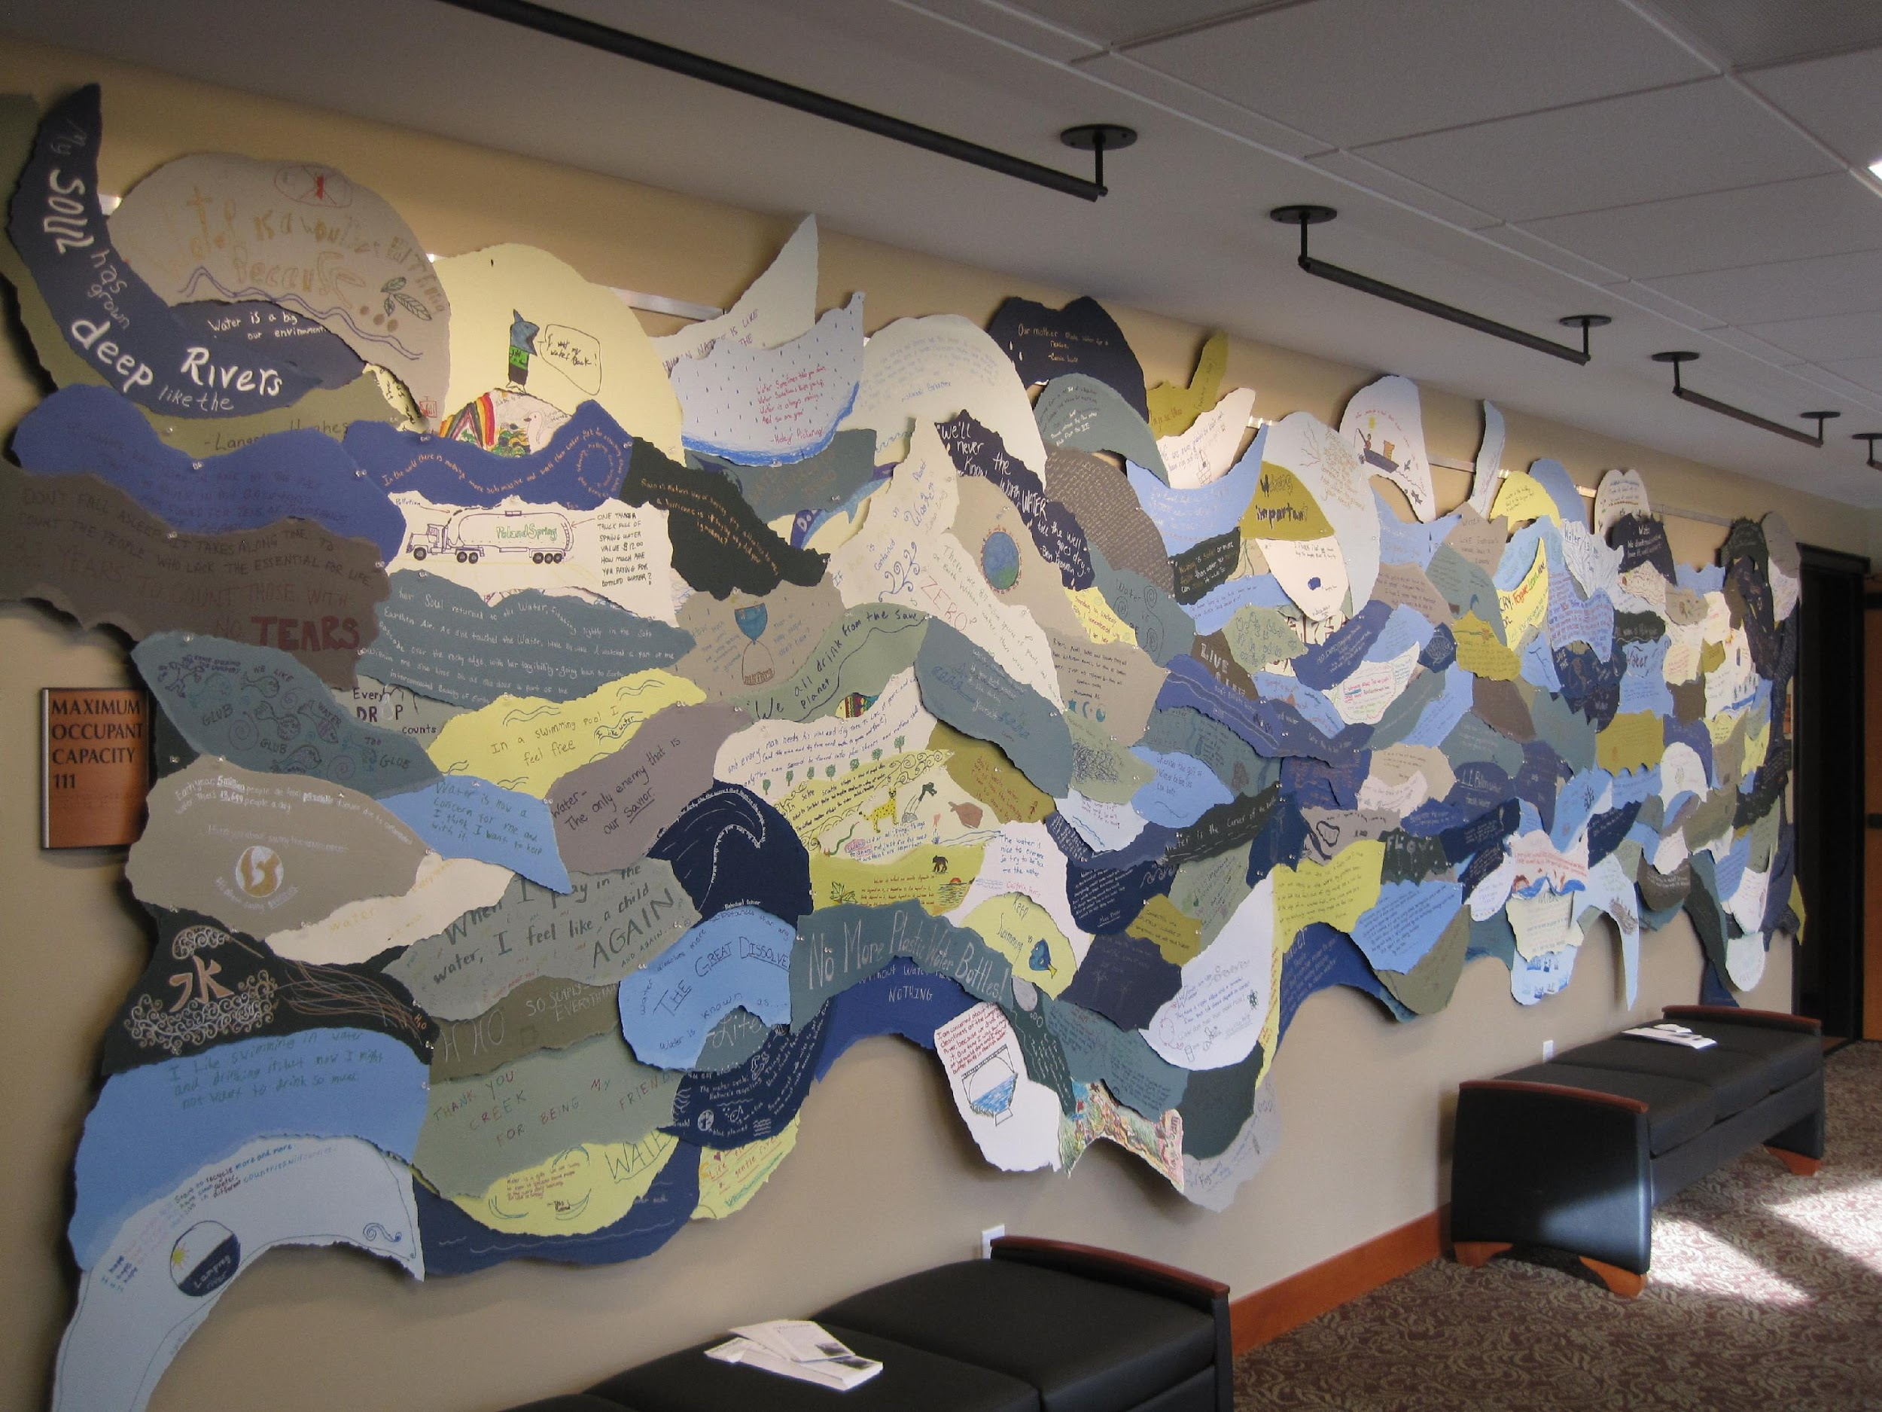

Aug. 8 Resident Mural Photos Due

AUGUST Downtown Night Out Celebration (audience: all)
Partners: Main Street Corporation & Newmarket Business Association
- Downtown Main Street event featuring an Ice Cream Social
- Unveil park plans and recognize contributing artists, planning committee and funding sources for their efforts.
Outcome: Stimulate community engagement with plan and interest in future projects.

Aug. 12-31 Best of Best Photo Town Voting

SEPTEMBER “Why We LOVE Newmarket at the River’s Edge” Sidewalk Photo Exhibit (audience: all)
Partner: Newmarket Business Association & the MillSpace
- Public display of photo submissions for voting purposes. Once all the “Why I LOVE Newmarket” photo submissions have been received, the Planning Committee will cull the submissions to select BEST 5 in each category (people, places & events).
- Print each on 24”x 36” PVC substrate for an exterior sidewalk display for public voting.
- All images received will be incorporated into the Welcome to Newmarket mural
Outcome: Following voting, prints will be permanently installed in town hall, library & schools for continued reinforcement of the beauty and value of our water, land & wildlife resources.

Sept. 1 Final design files & sculpture due
Sept. 9-23 Park landscaping and seating installation
Sept. 15-27 Park Art Installation
Sept. 28 Park Unveiling

proposed budget up to $7500 (Grant money is to be used for expenses directly associated with the project, with not more than 10% going to overhead.):
100% of all grant money to be used for the project. Commission and Planning Committee members are all volunteers. There will be NO administrative costs associated with implementation of this project.
LRAC Community Grant Request for $7500 to be used as per attached Project Budget Summary, which reflects additional grant funding recently awarded by NH State Council on the Arts ($5100) for this project, plus Town Budget Arts, Culture & Tourism funding from the town of Newmarket.

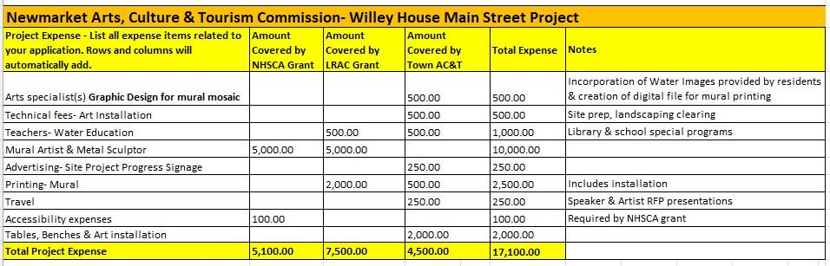

final products that will be produced:

Willey House Central Park will feature the following permanent public educational art displays:
- “Welcome to Newmarket” mural featuring a photographic mosaic within each letter of the word Newmarket.
- Kinetic metal sculpture using farm & woodworking implements donated by the Newmarket Historical Society
- Educational displays regarding river’s cultural impact, local wildlife preservation, and water conservation housed in a mini art gallery
- Public seating and gathering space representing water influenced creatures and activities
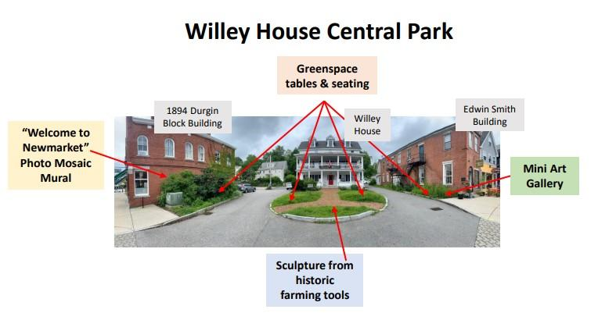

sustainability: (How will the project or intended impacts be sustained in the future without LRAC funding?)
All art installations will be maintained by the Town of Newmarket including landscape maintenance of the greenspace. Art will be permanently installed.

outreach opportunities:
We have already connected with the Newmarket Library, Historical Society and Parks & Recreation Department to collaborate on community educational programs and events for residents of all ages to not only spotlight water issues, but to create memorable art for the perpetual benefit of all.

evaluation of project: (How many people benefit, how is the river protected, etc. )
The creation of another art focused park on Main Street, where the space was previously not utilized, is a measurement of success in and of itself. In addition, the park will attract additional visitors and provide them with the opportunity to sit and/or linger downtown, which will simultaneously provide opportunities to educate visitors about water protection and wildlife preservation.

This project will also enable us to build a previously non-existent community of “Art & Water Conservation Supporters,” which will ultimately facilitate funding sources for future Newmarket arts, culture & tourism projects.

As so aptly noted by, Greg Bird, abutting property owner to the Willey House Central Park Project, “Investing in the town center will create a welcoming space that reflects Newmarket's unique identity at the river’s edge. Additionally, as the owner of 98 Main Street, I would be honored to showcase local artists' work on my building exterior. There’s no doubt that this community engagement project will significantly contribute to the enrichment and vitality of the Newmarket community.”
Below is a rough draft of the proposed mural for reference only. The letters, which makeup the word NEWMARKET, will be filled with the photos received from residents of water wildlife, activities and scenes which make Newmarket a memorable stop along the way. 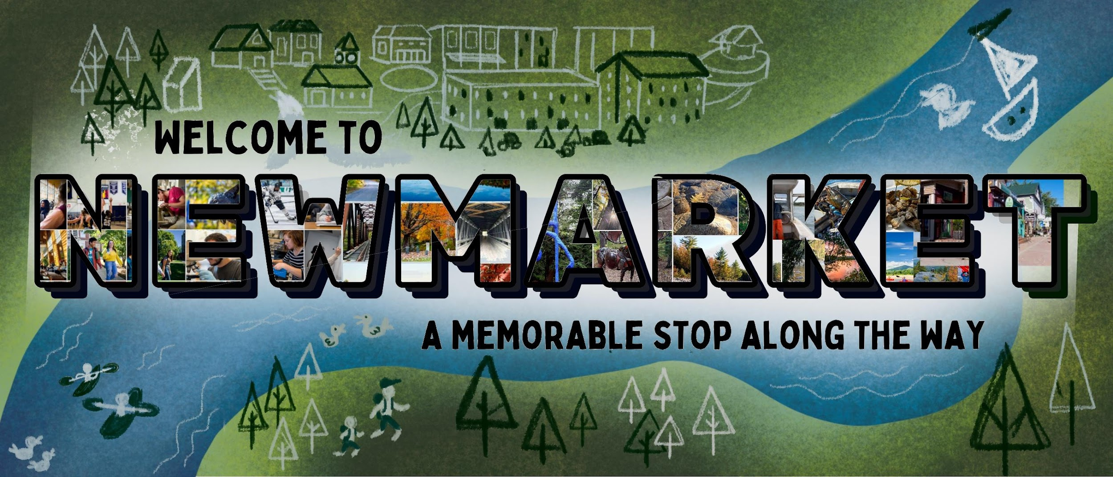

Reports and products:
Open communication between the grantee and the Lamprey Rivers Advisory Committee is encouraged. At least one written interim progress report is required midway through the term of the grant. An interim presentation to the committee or managing subcommittee is also encouraged.

Final reports must contain the following:

- a brief description of the project, including title, purpose, audience, procedures, & evaluation procedures
- a list of valuable accomplishments & who benefited
- funds budgeted and how they were spent
- two copies of any products (reports, press releases, photos)

Grantees are often invited to speak to the full committee when their project is completed.

Disclaimer for funded projects: Grantees are required to complete an IRS Form W-9 for tax and accounting purposes. All projects and associated publicity/outreach will acknowledge LRAC funding. “These funds are provided by the National Park Service under CFDA 15.962 – National Wild and Scenic Rivers System.” As a sub-recipient, the sub-contractor is responsible for meeting the audit requirements of OMB Circular A-133 regarding the expenditure of $750,000 or more in federal awards during the contractor’s fiscal year, if applicable, and for compliance with other laws, regulations, and the provisions of the parent grant agreement, including those regarding employee whistleblower rights, trafficking in persons, and requirements for publications.

The LRAC retains copyright rights and may use any and all materials generated as it sees fit without any additional compensation.

Applicants are encouraged to contact LRAC to discuss the proposal prior to submission of the application.

Completed applications should be emailed to spetersen.lrac@comcast.net or mailed to Joe Foley, chair, 88 Hedding Road, Epping, NH 03042.

