TOWN OF NEWMARKET, NEW HAMPSHIRE
BUDGET COMMITTEE
JANUARY 27, 2014
TOWN HALL AUDITORIUM

MEMBERS PRESENT: Chair Ellen Snyder, Vice Chair Amy Thompson, Judy Ryan, Dana Glennon, Drew Kiefaber, Russ Simon, William “Blue” Foster, David Foltz, Michael Lang, Town Council Rep Larry Pickering, School Board Rep Cliff Chase
Chair Snyder opened the meeting at 7:00 p.m., followed by the Pledge of Allegiance. The purpose of the meeting was to discuss the 10% rule as it applied to School Bond Warrant Article #1, and to approve minutes from the previous 3 meetings.
SCHOOL BOND WARRANT ARTICLE #1 AND THE 10% RULE
Chair Snyder gave some background. On January 22, 2014 the Budget Committee voted, 5 – 6,to not recommend Article 1, the School Construction Bond. The 10% Rule, which she paraphrased, states that the total amount, including that from separate and special warrant articles appropriated by Town Meeting cannot exceed the total recommended by the Budget Committee by more than 10%. The total amount of appropriations recommended by the Budget Committee was $17,247,363, of which $16,647,363 was for the operating budget, $500,000 for the Dual Purpose Fund and as much as $50,000 each for the Repair/Maintenance and Special Education Trust Funds. Ten percent of the $17,247,363 would be $1,724,736, which when added together would bring the maximum allowable appropriation to $18,972,099.The School Bond was for $45,125,263.
Chair Snyder said that the following day, January 23rd, she received a document, (included as Appendix 1) from Dr. Hayes which told of steps the School Board would take to add a statement at the beginning of the Warrant Article as a result of the Budget Committee’s vote. She forwarded the information to the members for the sake of information as the Budget Committee has no authority over the language of a Warrant Article, only over recommending or not recommending its amount. After sending out the information, she had received several emails from Budget Committee members who were concerned about the document Dr. Hayes had sent. The sentence to be added, which was approved by the School Board on January 24th was: “Passage of this article shall override the 10 percent limitation imposed on this appropriation due to the non-recommendation of the budget committee.” Dr. Hayes also sent background information on the purpose and meaning of this sentence. Chair Snyder said the emails she received from 3 Committee members expressed concerns about the legality of including the language, and asked for a legal opinion from DRA and the Town Attorney. Also, there was a call for the Budget Committee to schedule a meeting to discuss concerns.
On Friday, January 24th, Chair Snyder followed up and made several phone calls. She contacted Jeanne Saams, Newmarket’s School District representative from DRA, and she was the person who had recommended the language to the School District. Ms. Saams said that the language came from RSA 32: 18, and essentially was required when the 10% rule came into effect. She referenced page 13 of DRA’s website that included sample Warrant Articles that were not approved by a Budget Committee. The sentence at the beginning of the Article had the same language that the School Board was adding to Warrant Article I. Chair Snyder had provided a link for the Budget Committee members. Ms. Saams had explained that since DRA takes Warrant Articles in numerical order, and this was number one, subsequent Articles would be in disarray if the language was not included. DRA could not arbitrarily decide which Warrant Articles the voters wanted to fund.
Chair Snyder also contacted Paul Sanderson, Staff Attorney with NH Municipal Association, (NHMA), and he responded by email,(included as Appendix 2), which she shared with Budget Committee members. Attorney Sanderson said that State Statute allowed the School Board to include the language in the Article. He concurred with Ms. Saams and also referenced RSA 32: 18-a. Chair Snyder then spoke to Town Administrator Fournier and relayed the conversations she had with DRA, forwarded the information from Dr. Hayes and NHMA and told him that perhaps they should also have a response from the Town Attorney. Town Administrator Fournier’s response, (included as Appendix 3) referred to RSA 32:18-a, (included as Appendix 4) and stated that he and the Town Attorney agreed that the wording added to Warrant Article 1 was appropriate. He also raised concerns about “reply all “emails sent between some Budget Committee members, (included as Appendix 5). These were considered a concurrent discussion that did not “permit the public to hear, read or otherwise discern meeting discussion”. (RSA 91-A: 2 II c). The Committee would discuss in public what they had found out about the 10% rule.
DISCUSSION/COMMENTS
Mr. Glennon said he understood the legalities, but he felt this was all prearranged and once the Committee voted the way it did, it put the wheels in motion. He also felt that it would have been appropriate for Dr. Hayes to share the next steps of the process. He said he was not sure what they were trying to do, were they trying to save the Bond or were they trying to add more money somewhere. He questioned the $18M figure as it was above the $16M figure. He asked if Article 1 passed, would it mean that everything passed or just the Bond. Chair Snyder explained that the wording at the beginning of Article 1 was essentially a required statement which either the Town or School would have to insert in a Bond Article that was not recommended by the Budget Committee, but was passed by the Town or School. Mr. Glennon said he wanted to know about the money, and Chair Snyder said there was no change in the financial part of any Warrant Article. The language had to be added because if the Bond passed, no one would know what the voters had approved and this would affect everything else, especially the operating budget. She said the Budget Committee had approved the $17,247,363 for the operating budget, a contribution to Fire and Life Safety and contributions to 2 other trust funds, and the 10% brought the figure to $18,972,099. This would the highest amount the voters could approve for all the Warrant Articles without the additional language in Warrant Article 1.
Mr. Foster said the language was provided by the State, and basically said that by voting in favor of Warrant Article 1, this would allow the voters to over-ride the 10% rule if the Article passed. This would also allow the voters to vote on the Bond, even though it was over the amount approved by the Budget Committee by 10%. He further stated that the amount of overage didn’t matter, only the percentage. If the Bond did not pass, this would be a moot point. Ms. Thompson explained that the Bond Article put the amount over the 10%, but it was her understanding that any Warrant Article that put them over would have to contain the same language. Any time the aggregate total voted by the Budget Committee had the possibility of being exceeded by 10%, explanatory language had to be included. Since this Bond Article was number 1, and DRA takes Articles in numerical order, if all the Articles passed without the language included, there would be a giant mess that would jeopardize all the other Articles. The Warrant would have to be reposted, a Special meeting called, and legally it would turn into a quagmire. She added that, not knowing the outcome of the vote, it was prudent to add the legal language. She said that people needed to know that approval of the Bond would put them over the 10%, similar to a tax cap, but regardless of any Article that put them over the result would be a legal nightmare.
Mr. Chase said he didn’t think this was exactly a tax cap, but Ms. Thompson said she was trying to explain this in familiar vernacular. Mr. Chase appreciated that the meeting had been called because it gave them the opportunity of explaining this process to the public. However, he deeply resented the claim that the School Board and especially Dr. Hayes had a devious scheme to pull something over on the Budget Committee and the voters, and asked how Mr. Glennon dare make such an implication. Mr. Glennon asked, how he dare do this the way he did, as it seemed to everyone … Chair Snyder said that Mr. Glennon had made an inaccurate statement. Mr. Glennon said that the people he knew and those who called him asked him what had happened, and he said he really didn’t know. Chair Snyder suggested that Mr. Glennon needed to read his budget law book and understand that the Budget Committee had voted on January 22nd, and no one knew what the outcome would be. She said that Dr. Hayes spent January 23rd trying to understand the implications of the vote, and after consulting with attorneys, he developed the fact sheet, (Appendix 1), that he sent to the Budget Committee for its information. She believed this was before it went to the public. She said there was no rearrangement or predetermination, and she also took offense at Mr. Glennon’s comment as it was inaccurate. She said this was a very simple process, and she had hoped that by consulting with 3 different attorneys this would be clear. There was one sentence added, as approved by law, which would avoid a mess. Also, it allowed the decision on the Bond to be made by all the voters, not just 6 people. Mr. Glennon said he understood why the sentence was included, but questioned why this was done so quickly. Chair Snyder stated that January 27th, the day of this meeting, was the final date to post the Warrants. Also, the School had to understand and know that it could include the language and post the School Board meeting of January 24th. Then the Town had to post this meeting.
Mr. Simon said he had always thought in the past that the application of the rule meant that voters at the Deliberative Session could not raise the amount in a specific Warrant Article by more than 10%. He said it was a great learning experience to find out that it applied to all the Warrant Articles as a whole. He had thought that the 10% applied only to the Articles recommended by the Budget Committee, and the $45M Bond, which was not recommended by the Budget Committee, would be removed from the budget before the Deliberative Session. However, the Bond could go before the public for a vote by including specific language, and if the Bond Article passed, the entire Warrant could be exceeded by more than 10%. He said this had been a learning experience for all of them, and he appreciated that all of the information had been brought forward so quickly. Chair Snyder said there might be a need to explain some of this at the Deliberative Session, but overall, it was a fairly straight-forward process.
Mr. Foster held up the budget book the Committee had been given at the beginning of the year, and said he had read through some of it, but had forgotten about the 10% rule until it was brought up. He said that he and all the members should have know about this and brought it up. He asked Mr. Glennon how this helped the School Board as it made it more confusing for people to understand. Mr. Foster said it didn’t help to place blame because it happened. He did not think that the School Board went to the Budget Committee’s meeting thinking the Bond would be voted down. This gave the Board 2 and a half days to find out and decide what to do. Mr. Glennon said he had read the 10% rule and could not comprehend how it related to a bond as they never had this on the Council side. Mr. Foster said it only related to bonds, but Ms. Thompson and others pointed out that it pertained to the total, to which Mr. Foster agreed. Mr. Glennon said that his frustration was in receiving an email saying what was being done, and it appeared that this was all happening behind the scenes. He questioned why this was not brought up at the last Budget Committee meeting. He said if they had knowledge of this that perhaps Dr. Hayes should have addressed the process that would take effect after the vote to not recommend the Bond at the meeting. Mr. Foster said the Budget Committee had no authority over the language. Mr. Glennon said the only say the Budget Committee would have would be if the dollar amount changed. He was concerned with how this affected everything, and originally had thought that everything on the Warrant, including the budget, would be increased by 10% when the language was added to the Bond Article. Mr. Foster said that his could be misconstrued that way and, for that reason, was not a good thing for the Warrant Article.
Ms. Ryan clarified that the governing body, here the School Board, had the responsibility to add the language per State law, while the legislative body, the voters, would make the final decision. She added that this was not a done deal, as the Warrant still will go to the Deliberative Session and in March for the final vote. She noted that this could also happen on the Town side. She said this was very confusing, but it was the Budget Committee’s responsibility to ensure that the public understood the meaning of the language. Chair Snyder stated that this did not change any of the Warrant Articles on the School or Town side, there was only a sentence that allowed the voters to vote on the Bond. Mr. Foltz said he felt that was the intent of the law: to ensure that a small group of people could not decide on what a large number of people would vote. He said this not only allowed the voters to vote, it would prevent a legal mess. Also, since the Budget Committee’s vote was so close, it was important that the public be given this chance. Mr. Glennon asked if the language of Warrant Articles could be changed at the Deliberative Session, and Mr. Chase said that there could be some changes as long as the purpose of the Article was not changed. The language added to the Bond Article could not be changed.
Mr. Chase thanked Chair Snyder for providing a chronology of events at the beginning of the meeting. He said that one thing that they had not discussed was that, in his opinion and in that of Town Administrator Fournier, the Budget Committee might have stumbled into having an illegal meeting in violation of RSA 91A, (Appendix 5). Meetings have to be posted and cannot be held extemporaneously; everyone has to be in the same room and the public has to be aware of the meeting. He said that while comments about scheduling meetings or being able to attend a meeting were allowed, anything beyond that was not. He said there was some commentary, and he felt this left the Committee exposed and he felt they should, at the least, make copies of the emails a part of the record for this meeting, to open up what could be seen as a secret meeting. Chair Snyder stated she sent documents to the Committee members without any commentary. She knew it was a very natural thing to hit “reply all”, sometimes intentionally or sometimes by accident. In this situation, she did not know if this was purposeful of accidental, but there were several emails that were sent to the entire group. She emphasized that members could not hit “reply all”, because discussion by email constituted a quorum. She said she copies the Town’s Administrative Assistant and Budget Committee’s Recording Secretary on all emails she sends to the Committee so that they become part of the public record. She said she had not included them in the specific emails in question. She said those emails would be included in the minutes of this meeting. Mr. Glennon said that the emails and information from the Town Administrator and the attorneys could have waited until this meeting. He said that was what had precipitated hitting “reply all”, even though it wasn’t right. Mr. Pickering said that he felt Chair Snyder had made it clear all year that she only wanted Committee members to respond to her only. Mr. Kiefaber said that, for the record, this applied to all committees. Chair Snyder said, that as to the Town Administrator’s email, the Budget Committee had requested he get an attorney’s opinion, which he had provided to all the members, which was customary and appropriate.
APPROVAL OF MINUTES
January 13, 2014
Ms. Thompson moved to approve the minutes of the January 13, 2014 meeting. Mr. Lang seconded.
Discussion: Chair Snyder asked that the word “recommend” be added on page 4 in the first sentence of the (School) Public Hearing. Mr. Simon asked that “$200,00” be changed to “$200,000” in the middle of paragraph 2 of the Town Budget Hearing. He also asked that the tape be checked to verify that a speaker had said the remaining 23 years of the Bond, rather than 24.
Motion to approve as amended passed 10 – 0 – 1, with Mr. Foltz abstaining as he had been excused from the meeting.
January 15, 2014
Ms. Thompson moved to approve the minutes of the January 15, 2014 meeting. Mr. Kiefaber seconded.
Discussion: Mr. Simon asked that the work “taxes” be added in the 4th paragraph after” through” and before “was $1,272M”, and Ms. Thompson asked that “$1,272M” be changed to $1.272M. She also asked that the vote of “110 – 0” for the 300thAnniversary be changed to “11 – 0. Mr. Simon thought that the $70,000 in tax forgiveness in the discussion of the operating budget on page 3 should be clarified through the tape to see if Ms. Thompson said this happened every year. Mr. Simon asked that the words “but was not required “be added to Town Administrator Fournier’s reading of the law in the 1st sentence of the 2nd paragraph of discussion after the motion on page 1. He asked that qualifying language stating this was allowed as an option be added at the end of the same paragraph to Mr. Pickering’s statement about not knowing about the law. This would be verified on the tape.
Motion to approve as amended passed 11 – 0.
January 22, 2014
Mr. Simon moved to approve the minutes of the January 22, 2014 meeting. Mr. Glennon seconded. Mr. Simon said that his written statement would be included. There was no objection. Motion to approve the minutes as written passed unanimously, 11 – 0.
MEETING SCHEDULE AND ADJOURNMENT
Mr. Kiefaber moved to cancel the February 7, 2014 meeting. Mr. Foltz seconded. The purpose of the meeting had been to approve minutes, which had been completed. Motion passed unanimously, 11 – 0.
Mr. Chase moved to adjourn and Mr. Glennon seconded. Motion carried unanimously, and the meeting adjourned at 7:45 p.m.
Respectfully submitted,
Ellen Adlington, Recording Secretary

APPENDIX 1

Cost Estimate, Building Aid, Financing, & Tax Impact
What is the Ten Percent Rule?
For School Districts in towns which have adopted the Municipal
Budget law and cooperative School Districts which have
adopted the Municipal Budget law (RSA 195:12a), the total
amount appropriated at an annual meeting may not exceed, by
more than 10, the total amount recommended by the Budget
Committee for the meeting. The limitation on appropriations
does not prohibit the School District meeting from raising and
appropriating money for purposes included in the School
Board's budget, or in the warrant, but not recommended by the
Budget Committee, provided that the meeting stays within the
10 limit. However, voters may override this requirement for
certain matters, including passage of a bond.
How does this affect us, now that our Budget Committee
has not recommended Article 1?
The Budget Committee has recommended Articles, 2, 3, 5, and 6
the only other articles with a specific financial impact. Article 2
addresses the operating budget of $16,647,363. Article 3 is for
the $500,000 in funds to be placed in the Dual Purpose Fund.
Articles,S and 6 could place into the Repair and Maintenance
and Special Education trust funds as much as $50,000 each.
These four articles have a recommended amount of
$17,247,363, and 10 of that is equal to $1,724,736. Adding
those two figures together results in the maximum allowable
appropriation to vote, which would be $18,972,099. This is the
most that could be voted at the Annual Meeting.
How can voters override this Ten Percent Rule?
Under RSA 32:18, the School Board may put a statement at the
beginning of the bond article advising the voters that passing
the article will override the ten percent limit. On Friday,
January 24th, our School Board will meet at 4:30 PM to vote to
insert the following sentence at the beginning of Article 1:
Passage of this article shall override the 10 percent limitation
imposed on this appropriation due to the non-recommendation
of the budget committee. If the voters approve the article, the
appropriation is valid, notwithstanding the ten percent rule.

APPENDIX 2
Budget committee docs
From: Ellen Snyder <ellen.snyder@comcast.net> Fri, Jan 24, 2014 07:19 PtJ
@6 attachments Subject: Budget committee docs
To: Amy Thompson <amyt2465@aol.com>, Drew Kiefaber <drew.kiefaber@gmail.com>, Cliff
Chase <chasec@newmarket.k12.nh.us>, Larry Pickering <LarryLPickering@yahoo.com>,
Dave Foltz <daveJoltz@comcast.net>, Michael Lang <langmichaeI5@gmail.com>, Blue
Foster <blufurd@yahoo.com>, Judith Ryan <jrmax19@gmail.com>, Dana Glennon
<dglennon2@gmail.com>, Russ Simon <rsimon48@comcast.net>, Ellen Snyder
< ellen .snyder@comcast.net>
Cc : Kathy Castle <kcastle@newmarketnh.gov>, emcgarr@comcast.net
Hi Budget Committee, In advance of our meeting Monday night, I wanted to make sure you had the following documents or links as reference information for
our discussion:
- Email response below from NHMA Attorney Paul Sanderson in response to my phone conversation with him regarding BC
members' request for opinion on the 10 rule language
- Email from Town Administrator Steve Fournier stating his and the opinion of the Town Attorney on the 10 rule (you received
this directly from Administrator Fournier today)
- RSA 32-18-a (provided by Administrator Fournier and attached here for your reference)
- As recommended by DRA staff Jeanne Saams (per a phone call) see the following document on DRA
website: http://www . revenue. nh .gov /muncprop/technical-assistance/documents/twn_sch_ village_genericwarrantarticles. pdf on
suggested warrant article language, pages 13-14
- Updated information sheet from Superintendent Hayes
- Agenda for BC meeting Jan 27, 2014
- BC Meeting minutes: Jan 13, Jan 15, Jan 22
See you Monday night.
Regards, Ellen
Ellen Snyder

From: Paul Sanderson <psandersonennhmunicipal.orq>
Subject: Budget committee
Date: January 24,20149:10:58 AM EST
To: "'ellen .snyder@comcast.net'" <ellen .snyder@comcast.net>
Cc: legalinquiries <Iegalinquiries@nhmunicipal,org>
You have noted that following a budgetary bond hearing the school board has added language to a
proposed warrant article indicating that if the vote passes as required in RSA 33:8-a it will override
me .LU'Yo rule even though the article was not recommended by the budget committee. Here is the
statute that permits this action to be taken. The statute exists to assure that major issues actually
reach all ofthe voters for decision, and are not defeated by a simple vote ofthe budget
committee:
32:18-a Legislative Body Override of Limitation of Appropriations. -
I. Notwithstanding any other provision of law, in any municipality electing this subdivision, or any
district wholly within a town electing this subdivision, if a bond request is not recommended in its
entirety by the budget committee, the governing body of such municipality, after a majority vote
by the governing body of the municipality in favor of the bond request at a duly posted meeting,
shall place the bond request on the warrant.
II. The legislative body of any municipality described in RSA 32:18-a, I, may approve a bond
request despite the 10 percent limitation provided in RSA 32:18 in the following manner:
(a) The governing body shall place the following statement at the beginning ofthe warrant
article for such bond request: "Passage of this article shall override the 10 percent limitation
imposed on this appropriation due to the non-recommendation of the budget
committee." Immediately below the bond request on the warrant shall be displayed (1) the
recommendation of the governing body and (2) the recommendation of the budget committee, as
included in the budget forms for the annual meeting pursuant to RSA 32:5, IV.
(b) If those voting "Yes" on the bond request satisfy the requirements of RSA 33:8, the bond
request is thereby approved.
III. If the bond request is approved pursuant to RSA 32:18-a, the governing body of such
municipality shall forward a copy of the minutes of the duly posted meeting described in RSA
32:18-a, I to the commissioner of the department of revenue administration.
This statute is also the source ofthe recommendation that the warrant and the official ballot not
include any explanations or financial projections of the possible impact of the proposed project.
The warrant is the legal document that calls the town to its meeting. The official ballot is the means
by which votes are recorded. The Attorney General's Office has consistently taken the position that
these documents must remain free of language that is not specifically allowed by statute. Such
material is appropriate for discussion at public hearings, or in voter guides, or in oral advocacy at
other meetings, but it cannot be added to the warrant or to the official ballot.
Paul G. Sanderson, Esq.
Staff Attorney
NH Municipal Association

APPENDIX 3
From: "Steve Fournier" <sfournier@newmarketnh.gov>
Subject: RE: Be Meeting
Date: January 24,2014 11 :07:54 AM EST
To: "Steve Fournier" <sfournier@newmarketnh.gov>
All: Wed, Jan 29,201405:02 Pt'I
~1 attachmen1

I have seen the number of interactions on the topic of the 10 rule and the bond and was asked to
have the Town Attorney review it. I have reviewed the concerns and also the opinions of the
Department of Revenue Administration and the NH Municipal Association legal counsel. I have
looked at the law myself (RSA 32:18-a, which is attached) and consulted with the Town Attorney. In
2000 the legislature enacted RSA 32:18-a that specifically states that the governing body shall place
this wording in the article. The Town Attorney and I concur that this wording is appropriate and
necessary. In addition, it is a reminder that it is up to the governing body to determine the wording
of warrant articles, not the budget committee. The budget committee may only recommend or not
recommend the passage of an article.
In addition, I do want to raise a red flag over ernails and the right to know law. RSA 91-A:2 II (c) is
clear "No meeting shall be conducted by electronic mail or any other form of communication that
does not permit the public to hear, read, or otherwise discern meeting discussion
contemporaneously at the meeting location specified in the meeting notice." While it is easy to
send an ernall out and reply all after, this is a concurrent discussion and cannot be done under the
law.
Thank you t 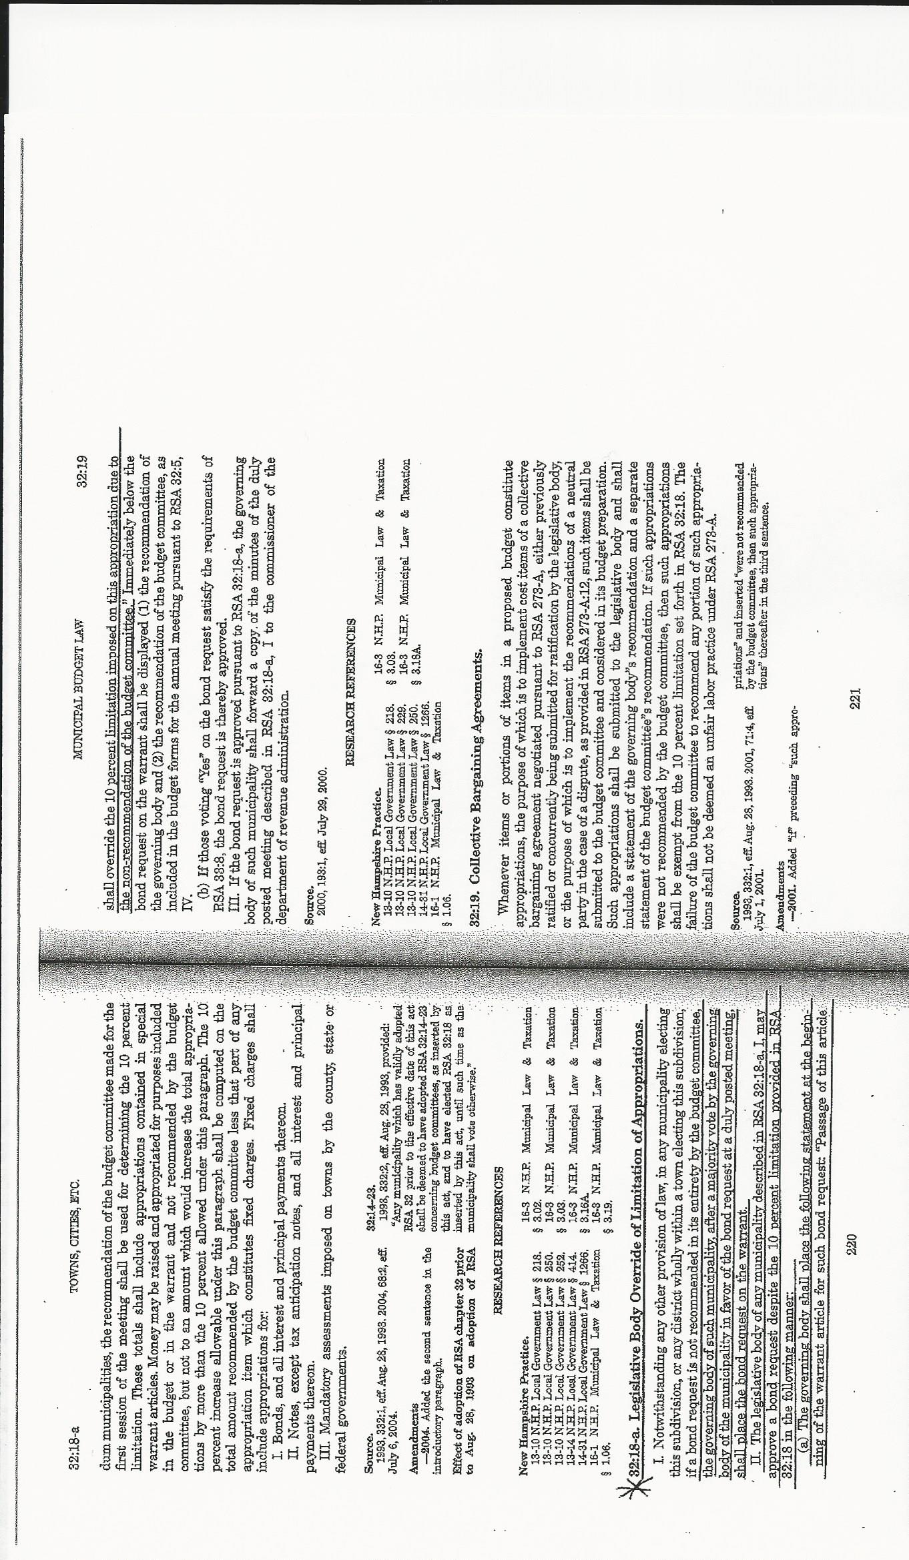

APPENDIX 4

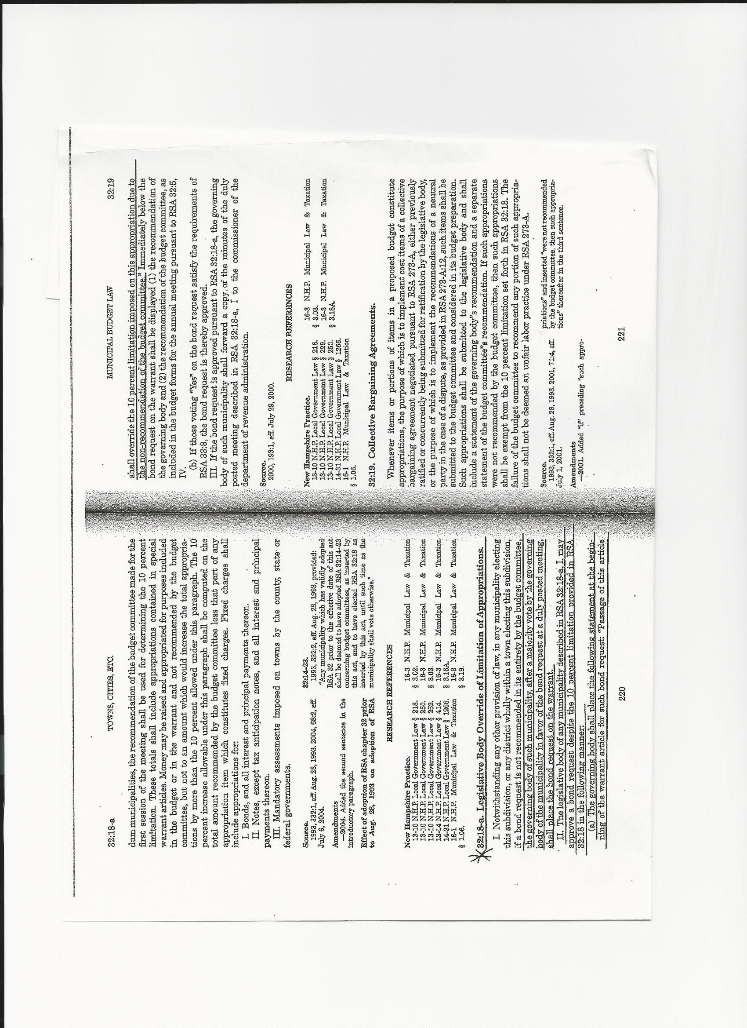
APPENDIX 5
On Thu, Jan 23, 2014 at 8:12 PM, Ellen Snyder <Ellen.5nyder@comcast.net> wrote:
Hi Budget Committee,
Please find attached the following documents:
- BC Agenda for Feb 8, 2014
- BC Draft Meeting Minutes: Jan 13, 2014
- BC Draft Meeting Minutes: Jan 15, 2014
- BC Draft Meeting MInutes: Jan 22, 2014
Also, FYI, Dr. Hayes has provided the attached document (re: 10 rule) as a result of the Budget Committee's vote not to recommend the
school bond.
See you on Feb 8th.
Regards, Ellen

Re: Feb 8th BC Meeting
Thu, Jan 23, 201408:46 PM

From: Judith Ryan <jrmaxI9@gmail.com>
Subject: Re: Feb 8th BC Meeting
To: Ellen Snyder <Ellen.Snyder@comcast.net>
Cc : Amy Thompson <Amyt2465@aol.com>, Dana Glennon <dglennon2@gmail.com>, Cliff Chase
<chasec@newmarket.kI2.nh.us>, Drew. Kiefaber <drew.kiefaber@gmail.com>, Larry Pickering
<LarryLPickering@yahoo.com>, Russ Simon <rsimon48@comcast.net>, William Blue Foster
<Blufurd@yahoo.com>, Michael Lang <langmichaeI5@gmail.com>, Dave Foltz
<daveJoltz@comcast.net>, emcgarr@comcast.net, Kathy Castle <kcastle@newmarketnh.gov>
All
Dr. Hayes interpretation of the 10 rule needs further legal interpretation.

It was clear from the School Board Legal Council at the Public Hearing on Tuesday that no new language (the long term tax impact) could
be added to the Warrant article.
How can the School Board legally insert language at the beginning of the Warrant article?
We need to have an attorney and DRA rule on this.
Judy +

-------.---.~ .. - .. -.------ ... -.--------.------.~--.-- .. ----.-. '---

From: Dana Glennon <dglennon2@gmaiLcom>
Subject: Re: Feb 8th BC Meeting
To : Judith Ryan <jrmax19@gmaiLcom>
Cc : Ellen Snyder <Ellen.Snyder@comcast.net>, Amy Thompson <Amyt246S@aoLcom>, Cliff
Chase <chasec@newmarket.k12.nh.us>, Drew. Kiefaber <drew.kiefaber@gmaiLcom>, Larry
Pickering <LarryLPickering@yahoo.com>, Russ Simon <rsimon48@comcast.net>, William
Blue Foster <Blufurd@yahoo.com>, Michael Lang <langmichaeI5@gmail.com>, Dave Foltz
<dave.foltz@comcast.net>, emcgarr@comcast.net, Kathy Castle
Ellen;
I think the BC should schedule another meeting to address this issue.
Dana

Thu, Jan 23, 2014 08:50 PM

RE: Feb 8th BC Meeting -~
--'"-- .•. ---.-- ------~.- .---- From: Russ Simon <rsimon48@comcast.net>
Thu, Jan,2014 09:16 PM
Subject: RE: Feb 8th BC Meeting
To: 'Judith Ryan' <jrmax19@gmail.com>, 'Ellen Snyder' <Ellen.5nyder@comcast.net>
Cc : 'Amy Thompson' <Amyt2465@aol.com>, 'Dana Glennon' <dglennon2@gmail.com>, 'Cliff
Chase' <chasec@newmarket.k12.nh.us>, 'Drew. Kiefaber' <drew.kiefaber@gmail.com>,
'Larry Pickering' <LarryLPickering@yahoo.com>, 'William Blue Foster' <Blufurd@yahoo.com>,
'Michael Lang' <langmichaeI5@gmail.com>, 'Dave Foltz' <daveJoltz@comcast.net>,
My initial thought is that until we get legal opinions from both the School and the Town,
we should not meet on this. This does need to be settled before the Deliberative
Session.
My reasoning is that a legal opinion is just that, an opinion, as I have explained before.
We would be remiss, as I think we have been in the past, in just taking the School's legal
opinion and not seeking another legal opinion from the Town (Le., Last year's Default
Budget Opinion provided by the School).
If both opinions are the same, we can feel comfortable that we have done our due
diligence and have fulfilled our Fiduciary Responsibility to the voters that elected us. If
they differ, then we either have to work it out between the two legal firms or go to court.
This issue is too important not to satisfy the Obligation we have as an independent
elected Committee of the Town.
Regards,
Russ

.. ------_._--_._--

From: Ellen Snyder [mailto:ellen.snyder@comcast.net]
Sent: Thursday, January 23, 2014 9:20 PM
To: Amy Thompson; Dana Glennon; Cliff Chase; Drew. Kiefaber; Larry Pickering; Judy Ryan; Russ Simon;
William Blue Foster; Michael Lang; Dave Foltz; Ellen Snyder
Cc: emcgarr@comcast.net; Kathy Castle
Subject: Re: Feb 8th BC Meeting
A reminder NOT to reply to all if you have a question, concern, or issue. We are not allowed to
discuss via email.
Thanks, Ellen
Ellen Snyder RE: Feb 8th Be Meeting
From: Russ Simon <rsimon48@comcast.net> Thu, Jan 23, 2014 09:44 PM
Subject: RE: Feb 8th BC Meeting
To: 'Ellen Snyder' <ellen.snyder@comcast.net>, 'Amy Thompson' <Amyt2465@aol.com>, 'Dana
Glennon' <dglennon2@gmail.com>, 'Cliff Chase' <chasec@newmarket.k12.nh.us>, 'Drew.
Kiefaber' <drew.kiefaber@gmail.com>, 'Larry Pickering' <LarryLPickering@yahoo.com>, 'Judy
Ryan' <jrmax19@gmail.com>, 'William Blue Foster' <Blufurd@yahoo.com>, 'Michael Lang'
<langmichaeI5@gmail.com>, 'Dave Foltz' <daveJoltz@comcast.net>
Cc : emcgarr@comcast.net, 'Kathy Castle' <kcastle@newmarketnh.gov>
Ellen,
I recognize your concern and the rules, but you dropped this on us and we are not
scheduled to meet until the deliberative session and that is not acceptable.
I think you need to call a meeting ASAP and mention to Steve or the Town Council that
the BC may need a legal opinion quickly.
Russ

From: Dana Glennon <dglennon2@gmail.com> Thus Jan 23, 2014 09:49 PM
Subject: Re: Feb 8th BC Meeting
To : Russ Simon <rsimon48@comcast.net>
Cc : Ellen Snyder <ellen.snyder@comcast.net>, Amy Thompson <Amyt2465@aol.com>, Cliff
Chase <chasec@newmarket.k12.nh.us>, Drew. Kiefaber <drew.kiefaber@gmail.com>, Larry
Pickering <LarryLPickering@yahoo.com>, Judy Ryan <jrmax19@gmail.com>, William Blue
Foster <Blufurd@yahoo.com>, Michael Lang <langmichaeI5@gmail.com>, Dave Foltz
<dave.foltz@comcast.net>, <emcgarr@comcast.net> <emcgarr@comcast.net>, Kathy Castle
< kcastle@newmarketnh.gov>
We are not be holding to the Town Council.

