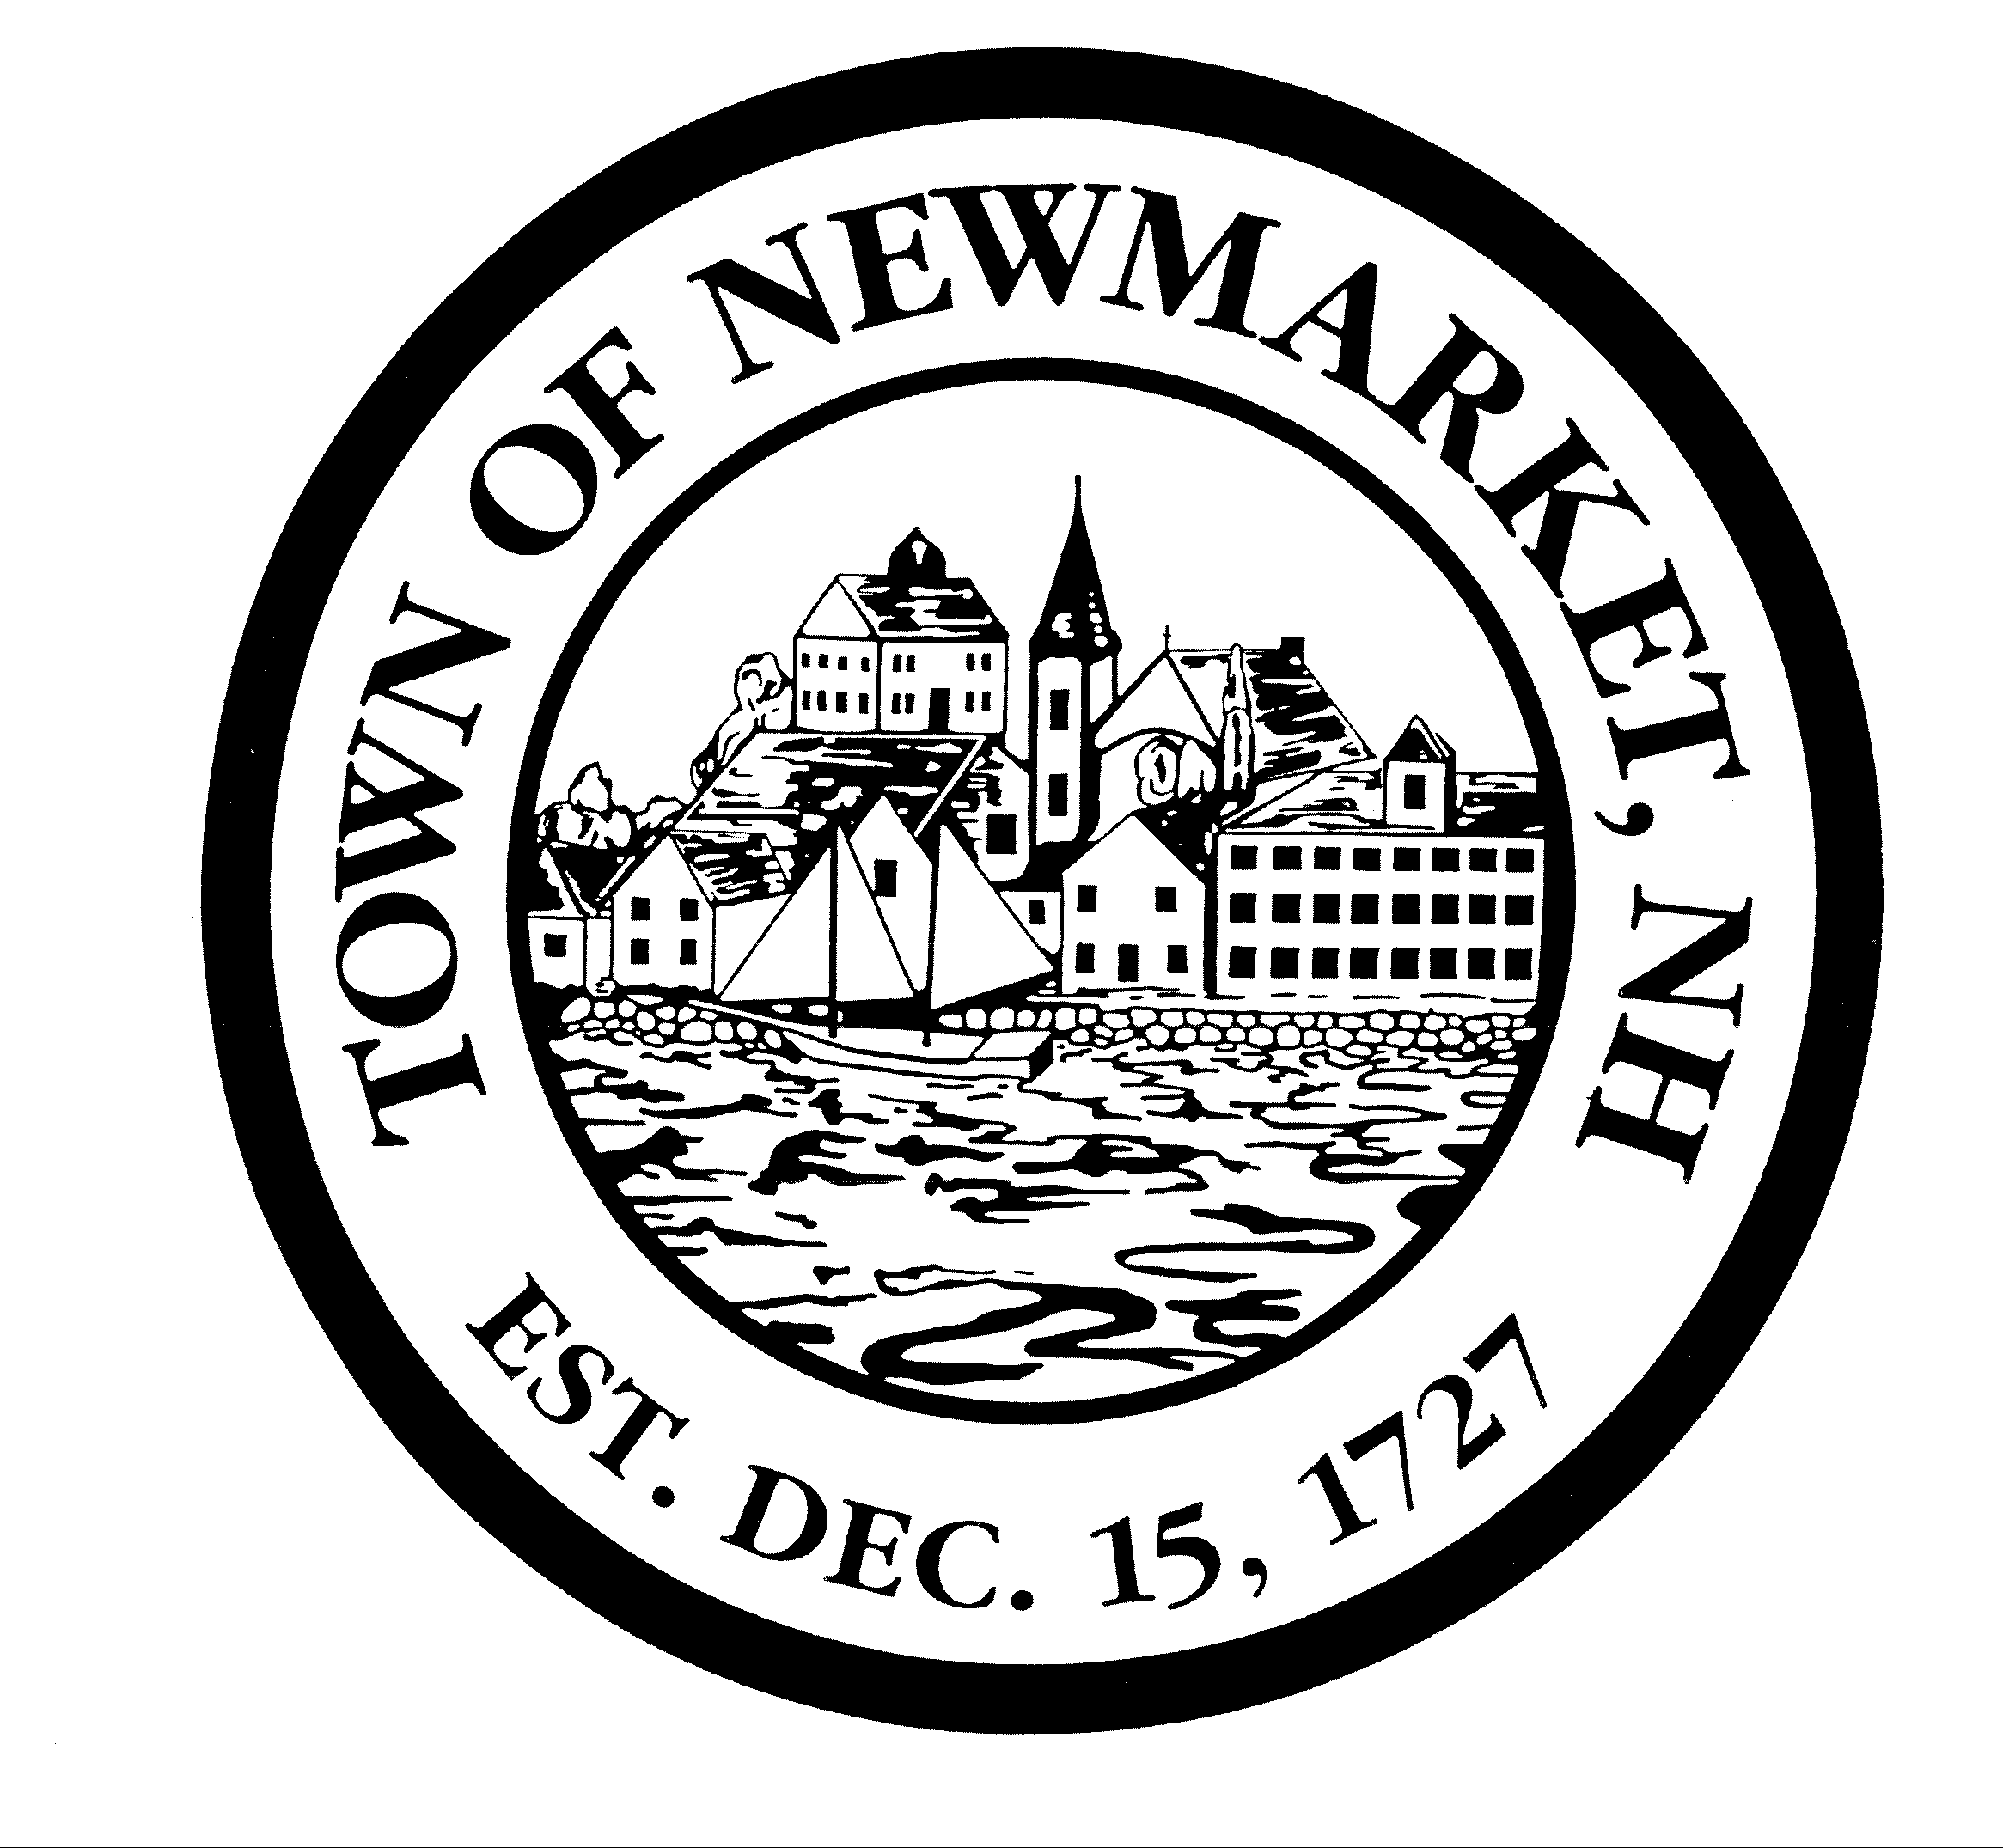

OFFICE OF THE
Town Planner

INCORPORATED
DECEMBER 15, 1727
CHARTER JANUARY 1, 1991

Macallen Dam Study Committee
Wednesday, October 31, 2018
3:00 p.m. – 4:30 pm
Town Council Chambers

- Project Status Report: Todd Monson, Geo-Environmental Inc.
- Feedback from Stakeholders and Abutters
- Update on Budget process-CIP request and Bond Issue
- Other Business
- Adjourn

