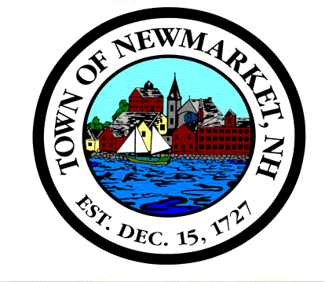

LEGAL NOTICE
Town of Newmarket
Macallen Dam Removal and Alternatives Feasibility Study Committee
Town Council Chambers
Newmarket Town Hall
Monday, February 3, 2014
7:00 P.M.

- Update of project – Gary LeMay and Mark Wamser of Gomez and Sullivan
- Review of Technical Summary Memorandum
3. Status of Draft report
4. Scheduling and Public Information Meeting
5. Other Business

