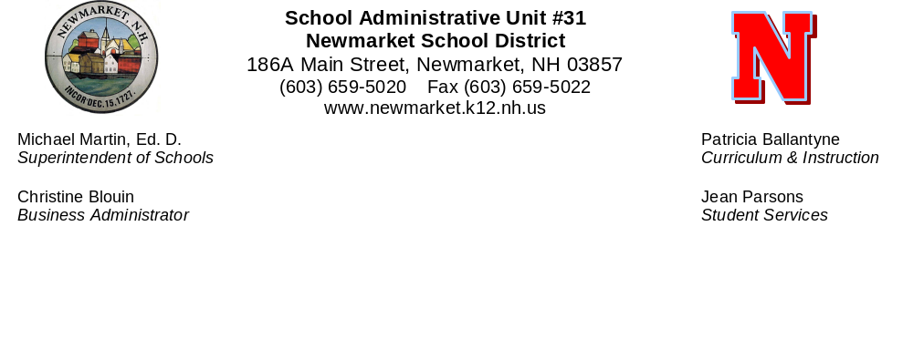
October 16, 2015

The Newmarket School District is searching for a Superintendent of Schools who will lead our educational system for many years.

The Search is underway and the New England School Development Council (NESDEC) has been hired to manage the advertising campaign and selection process. Dr. Carolyn Burke is serving as our NESDEC consultant.

Highly qualified candidates can also be found through referrals and introductions. As Chair of the Search Committee, I am asking for your assistance in identifying these potential candidates.

Attached is a copy of the Candidate Profile, which reflects the comments of staff, parents and the general public focus groups relative to the qualities and experience considered critical to the success of the next Superintendent. A great deal of work has gone into developing a “unique profile for the needs of Newmarket” and should entice progressive and innovative educators to apply.

Please forward the information or contact potential candidates or individuals who may be able to identify potential candidates.

Information can be found on the school district website www.newmarket.k12.nh.us or e mails may be sent to the attention of Dr. Carolyn Burke at search@nesdec.org.

Al Zink
Newmarket School Board
Chair, Superintendent Search Committee

