PLANNING BOARD
July 11, 2023 at 7:00 PM
Town Hall Auditorium
APPROVED MEETING MINUTES
Members Present: Eric Botterman (Chair), Val Shelton (Vice-Chair), Scott Blackstone (Town Council- Ex officio), Jane Ford, Jeff Goldknopf, Bart McDonough (Director of Planning & Community Development), Patrick Reynolds, and Michal Zahorik (Alternate)
Member Absent: Timothy Rossignol
The Chair opened the meeting at 7:00 PM. [time on DCAT 5:31]
The Chair appointed Michal Zahorik (Alternate) as a voting member tonight.
The voting members this evening will be Eric Botterman, Val Shelton,
Scott Blackstone, Jane Ford, Jeff Goldknopf, Patrick Reynolds, and Michal Zahorik.
1. Pledge of Allegiance
2. Public Comments
The Chair opened public comment at 7:01 PM for anything not on the agenda. No one responded. The Chair closed public comments at 7:03 PM.
3. Review & Approval of Minutes
Consideration of the June 13, 2023 draft minutes was moved to the next meeting of the Planning Board in August.
4. Regular Business
Read by the Chair: [time on DCAT 6:29-14:40]
a. Presentation and discussion with Phil Nazzaro, Capital Improvement Program Committee Chair, on modifying the capital improvement plan process.
Phil Nazzaro introduced himself as the current Chair of the CIP Committee and appointee to the CIP as the representative of the School Board. Phil was here this evening to discuss current modifications under consideration in the CIP process. The Committee sees the Capital Improvement Plan as a tool in support the vision of the Town Master Plan. They propose to begin a closer collaboration with the PB and would like to gain preliminary insight into the PB’s long term vision for the community to help inform their work in the coming months. The CIP Committee now meets year round. The newly created vision is to develop a coherent integrated long-range CIP plan aligned with the goals of the community as outlined in our Town Master Plan. This requires 1) a stronger connection to the Planning Board, 2) a greater working relationship with the community, and 3) a voice on the Master Plan Subcommittee as it is scheduled to begin work on the new Master Plan update. (Please see the power-point presentation as Addendum pages 1-5 for additional information.) Jane Ford is currently the PB Rep to the CIP and has been a Rep for over 10 years. She is pleased to point out that both Bart and Phil have worked diligently to move the CIP toward a “planning” committee and away from the “finance/budget” committee. Phil said that the CIP will have a document ready for the PB shortly with more information about the plan going forward.
************************************************************************************************Read by the Chair: [time on DCAT 14:44]
b. Pursuant to RSA 676:4, and Appendix-A Subdivisions, Appendix-B Site Plans, and §32-236 Affordable elderly housing of the Municipal Code of the Town of Newmarket, New Hampshire, notice is hereby given that a public hearing shall be held for an application filed by DR Lemieux Builders LLC
requesting Minor Subdivision, Major Site Plan, and Special Use Permit approval for a proposed development seeking to create a split lot subdivision with the original lot (0.54 acres) retaining the existing single-family housing unit and the new lot (7.22 acres) constructing a 32-unit, age-restricted, multi-family development with associated utilities, parking, landscaping and stormwater mitigation infrastructure located on real property with an address of 242 South Main Street, Tax Map U4 – Lot 69 within the R2 zoning district.
Jeff Goldknopf recused himself. Val Shelton disclosed that she has represented the applicant in the past during the normal course of her business. She has no financial interest in this project, but wanted to ask the applicant and the PB members if they objected to her hearing this proposal. There was no objection from the members or from Attorney F.X. Bruton speaking on behalf of the applicant.
Bart stated that the applicant has submitted all the directives and documentations to be considered a complete application. He recommended that the PB roll all the requests into one motion and Attorney Bruton agreed. When it comes time for consideration of the applicant requests, each one will be considered separately and voted on individually.
Action
Motion: Val Shelton moved to approve the application as complete.
Second: Jane Ford
Discussion: none
Vote: Approved 6-0-0
Bart had information for the Planning Board regarding the recommended criteria for regional impact. Although he did not find any issue with this proposal, he wanted to go through the criteria: 1) Does this project affect traffic regionally? 2) Does it affect environmental conditions? i.e. storm water, drinking water, sewer?
Action
Motion: Val Shelton moved that, in the opinion of the Board, this application
does not constitute requirements for regional impact notification.
Second: Patrick Reynolds
Discussion: none
Vote: Approved 5-0-1 (Michal Zahorik abstained)
The Board will discuss the regional impact notifications in the future as a requirement for all applications going forward.
Bart asked Attorney Bruton if any waivers were being requested and there are none.
The Chair opened Public Comments at 7:25 PM [time on DCAT 36:56]
Attorney F.X. Bruton, Bruton & Berube PLLC of Dover, rose to represent the applicant. He introduced the members of the team present this evening to make presentations to the Board. The team members will present the technical aspects of the project. Since the previous meeting in March when they came before the Board for a design review, the team has tried to incorporate many comments and concerns made by the public and the Board. Present this evening are: Dave Lemieux, Principal, and Heather Droesch, General Manager, of D.R. Lemieux Builders LLC., Christian Smith, Principal at Beals Associates, PLLC, Jim Gove, Gove Environmental, Jeff Dirk, Vanasse & Associates, Inc., Brian White, White Appraisal, Robbi Woodburn, Woodburn & Co.,
Sarah Hourihane and Michal Kaleta, Lassel Architects. Attorney Bruton gave a brief summary of how they have reached this point after careful consideration of all of the Town requirements for such a project. The Town requirement is for 75% of these units to be affordable, but they have decided to exceed the minimum requirement by making these 32 units 100% affordable.
The team feels that they have met or exceeded all requirements and they begin with Christian Smith, Principal at Beals Associates, PLLC. He spoke about the technical aspects of the 32 unit building, the sub-division of the lot, the number of parking spaces, and the siting of the driveway. He has met with the Town Engineer and DPW to address the best placement of a pedestrian crosswalk, the two bioretention ponds, and drip edges for roof runoff. The Town would allow 39 units because they would be allowed to use 25% of the area designated as poorly drained soils, but the developer has decided to build only 32 units and avoid using any poorly drained soils. He mentioned that they are using Charron Inc. as their professional lighting engineers. They have also done the calculations for two 100 year storms. The property will be serviced by both Town sewer and water. All erosion controls will be in place during construction.
[time on DCAT 39:44]
Jim Gove, Gove Environmental, spoke next about the siting of the building as proposed. He completed all the wetland flagging of the property with the goal in mind to protect and avoid any wetlands located to the rear of the parcel. One must use every effort to avoid and minimize disruption to the wetlands when building/siting a project. He wants to avoid fragmentation of the wetlands. If they had sited the building in the rear of the parcel, it would have been denied as there is a suitable alternative on the lot. He also discussed how a priority resource area is defined. This property does not meet that criterion.

Attorney Bruton asked Robbi Woodburn, Woodburn & Co. Landscape Architect, to speak about efforts to buffer the neighborhood with landscaping. She described all the plantings proposed in detail while giving special attention in preparing this project to enhance the compatibility with the Town and neighborhood.
[time on DCAT 51:50]
Attorney Bruton asked Sarah Hourihane and Michal Kaleta, Architects with Lassel Architects, to speak. Sarah described the different orientation of the building since the design review meeting in March. This new siting is better suited to engage the community and neighborhood for this 32 unit building. She described the porches, shared laundry facilities, and common room with a kitchenette. She also described the building as two stories, with a third story described as an attic area. They have used precedent buildings within the community to help lead their design, so that this building will blend into the community. Michal described how this building meets the Passive House Certification requirements which means that it will meet and exceed the highest standards of energy efficiency. They plan to install all dark sky compliant lights. This means that all lighting is expected to reduce light pollution, glare, light trespass, and night sky pollution. Sarah mentioned that they have been working with other developers in the area about the parking needs and they have housing with .95 parking spaces per apartment. This project will be going on a one space per unit model with two extra spaces. Patrick Reynolds asked about what they were planning for heating and cooling systems. Although no decision has been made yet, Michal stated that he would prefer to go with a heat pump making this a full electric building. His desire is to have a zero carbon footprint for this site.
[time on DCAT 1:06:18]
Attorney Bruton asked Jeffrey Dirk, Vanasse & Associates, Inc., to address the traffic study. He is the traffic consultant for this project. His first objective was to quantify the current traffic by volume and speed in this area where schools are present. The study covered three days: Wednesday, Thursday, Friday collecting data for one hour in the morning, mid-day, and evening. 6,900 vehicle travel through his portion of South Main Street every day. He projected that 10 cars from this project would be added to this load each day based on the age qualification of the residents. He considers this a low traffic impact project. He discussed site line requirements based on the speed of vehicles. They are proposing a Rectangular Rapid Flashing Beacon (RRFB) at the crosswalk which will connect to the sidewalk on the southern side of South Main Street. Several PB members had questions about children crossing from the sidewalk on the south and traveling east bound without a sidewalk on the north side.
[time on DCAT 1:24:23]
Attorney Bruton asked Brian White, White Appraisal, to speak next. He has been a commercial and residential appraiser for 39 years with his office located in Dover. In preparation for his report, he spoke with Theresa Hervey, Deputy Assessor for Rochester, Donna Langley, Property Assessment for Dover, Michael Pelletier, an approved Supervisor Assessor by the New Hampshire Department of Revenue, and Jim Rice, Assessor for Durham, about affordable housing projects in their communities. No one he spoke with found any decrease in property values in the surrounding areas based on the siting of elderly affordable housing projects. His conclusion, therefore, is that there will be no decrease in value with this project.
Attorney F.X. Bruton returned to sum up the presentation. He mentioned that the increased detail presented this evening was not always normal in these kinds of projects, but the developers wanted the community to know that they work, live, and have been associated with Newmarket since 1985. They have deep connections to this community. He then spoke to the Special Use Criteria #1 through #5. Please see the Special Use Criteria as Addendum pages 6-9.
The Chair thanked Attorney Bruton and his team for the presentation. Before hearing from the public present this evening, the Chair explained the next steps in the process as the Planning Board moves forward with this application. #1 A Technical Review Board shall be selected. The TRC consists of 2-3 members of the Board who meet with
Department Heads in the Town (Fire, Police, DPW, and Water & Sewer) to carefully review this proposal and they will come back to the PB with recommendations. #2 In a project of this size, an independent Engineer is used to review every aspect of the proposal. #3 There will be many meetings (all public hearings) as this is a long process moving forward. There will be many more opportunities for public input about this proposal.
Speakers: [time on DCAT 1:48:50]
#1 Derek Conrad, 245 South Main Street. Mr. Conrad’s concerns this evening included safety for senior pedestrians which he mentioned at the last meeting. He also believes that the crosswalk placement is ‘inviting’ especially for children using the sidewalk. He would like the applicant and specialists to give more care to the dangerous traffic situation at this section of South Main Street.
#2 Dawn Mazur, 34 Maplecrest Street. Ms. Mazur’s concerns this evening include those she spoke of in March. She has 155 ft of direct abutment with this lot at the back of her property line. Her sump pump goes off every 20-45 minutes. Ms. Mazur has lived in her house for 64 years. Her house would not be constructed today due to the wetlands. Where is the water going to go from this project? She is also fearful about the constant speeding along South Main Street. She experiences difficulty exiting Maplecrest Street on to South Main Street in both directions and trying to turn from South Main Street on to Grant Road especially with the excessive speed of oncoming traffic. She also wanted to know about the growth of the landscaping and where the utility poles will be placed. She is also concerned about the height of the building with respect to the rest of neighborhood.
#3 Linda Doshier, 249 South Main Street. Ms. Doshier lives directly across the street. She also believes that this proposed building does not blend into the neighborhood in any way. She met with Mr. Lemieux earlier in the year and asked if he would consider downsizing the project, but he declined. She indicated that she would like to see more landscaping around the parking lot to avoid car lights. As a 55+ (which is not old) elderly complex, one can be sure that tenants will be coming and going frequently. This project is just too big for the neighborhood.
#4 Gail Wasiewski, 236 South Main Street. Ms. Wasiewski is a direct abutter and has never been contacted by the owner of the property regarding any concerns that she may have with this project. She lives on a curve in the road and is very concerned about traffic (both speed and accidents). There is only one speed limit sign and hardly anyone obeys the limit. He also mentioned the lack of visitor parking. As a retired nurse, 55 is no longer elderly – 65-70 is more like it. They will have families and visitors – where do they park? The flashing crossing lights at the high school are not always used. She is very concerned about the wetlands and the disruption to the water flow caused by digging and putting in a foundation for this building.
#5 Liv Albee, 262 Wadleigh Falls Road. Ms. Albee has sent an email. She has two small children and has to find an alternative way to travel to school each day. She has witnessed speeding up to 60 mph and cars passing on a double yellow line. She is concerned about water pressure with the addition of this project. There are beavers in the area and they are constantly changing the flow of the water.
#6 Steve Suraci, 240 South Main Street. Mr. Suraci is the former owner of 240 South Main Street. His son now owns that property. He spoke to site line requirements for the driveway. He spoke to the property values and was told by two realtors that the value of his property was definitely going to be impacted and that he was required to disclose the mere “possibility” that this 32 unit apartment was going in nearby. He read from the requirements for landscaping which must buffer adjacent properties during ‘all seasons’ of the year. The deciduous trees being planning will not do that. He wants to know what buffer plantings they plan all around the building. He mentioned that the smoking patio issue has not been addressed. He mentioned that there is no buffer for the sound, no buffer for the speaking voices, no buffer for the traffic coming and going in the parking lot, and no buffer for the mechanicals. He mentioned that last project for this developer in Rochester that shows the mechanicals for the building are set in the front yard with no buffer at all.
#7 Dawn Mazur, 34 Maplecrest Street. Ms. Mazur had another statement. Today she had to stop for a white pick-up truck and lawn mower trailer (landscaping company) in front of 242 South Main Street. They were parked by the side of the road and she had to wait for ten oncoming cars to pass before she could go around the parked equipment. She cannot emphasize enough about the hazards of parking on South Main Street due to the width and site lines of the road.
#8 Ed Suraci, 240 South Main Street. Mr. Suraci is the new owner of 240 South Main Street. He mentioned his surprise that the purchase and sale agreement had the disclosure of the possibility that this project would be built. He also mentioned that the architect mentioned that the placement of the building sideways to the street was a benefit because the tenants could look out at the field…however, the field will be a parking lot.
#9 Linda Doshier, 249 South Main Street. She spoke with a realtor who mentioned that the planned project will negatively impact housing values in the area. She is also concerned about ambulances. The Town only has one – which has frequent runs to the Pines of Newmarket (9 Grant Road) and to the Wadleigh Senior Housing (290 Wadleigh Falls). When the Newmarket ambulance is busy, Durham is called for backup.
What plans does the Town have to increase ambulance service? Sometimes there are not enough volunteers to staff the ambulances. How will the Town pay for this?
#10 Jen Palasciano, 2 Pond Street. Ms. Palasciano is not a direct abutter, but she lives very near on Pond Street. She wanted to know if the property will remain 55+ forever? She is concerned about visitors parking in front of the building on the curve. Will the Town water and sewer be sufficient for addition of 32 units with landscaping? She strongly feels that this building does not fit into the neighborhood…it is a monstrosity.
[time on DCAT 2:25:39]
Letters received read into the record: Bart read into the record two letters: Elizabeth Dowst, 255 Wadleigh Falls Road and Lisa Henderson, 6 Maplecrest Street. Bart also placed into the record the letter written by Liv Albee, 262 Wadleigh Falls who already spoke this evening. Please see the letters received as Addendum pages 10-14.
The Chair opened the meeting for questions from the members. Val Shelton asked Jim Gove when the wetlands were flagged. He said they were flagged in April 2023 and the map was produced in May 2023. She asked Christian Smith about the silt fence being planned prior to construction. The silt socks will be driven into the ground as they do a better job of preventing erosion. The drip edge will be 5 ft. of stone. Bart asked what material is used in the silt socks. Mr. Smith said it would be mulch. Val asked Robbi Woodburn what will the height of the trees be at planting. Robbi stated that the canopy of the trees planted will be 8-12 ft. and they will be 15 ft. tall at planting (when full grown they are ~25’ ft ). She also commented on the evergreen vs. deciduous discussion which was brought up during audience comments. She pointed out that the buffer of shrubs (3-5’ ft. tall) alternating between deciduous and evergreen. They intend to make every effort to keep the two trees on the right of the property by performing root pruning to protect them during excavation. There is no guarantee that the tree will be saved, but every effort will be made. Val asked about whether or not solar was proposed. David Lemieux confirmed that they plan a solar component to the project. He confirmed that it will be on the roof. Patrick Reynolds wanted to know why the appraiser did not look at towns like Lee, Epping, and Newfields. When Brian White began the comparison to other properties he only found the property on Wadleigh Fall and one in Durham. That is why he went farther afield to check in Dover and Rochester. The Chair has questions for Jeffrey Dirk as to whether he had any worries about the placement of the driveway across from Grant Road. Jeffrey recalled that when he first studied the plans, the driveway was in a different place. He agree to look at the speed limit and the offsets. Eric also mentioned that on the plan the existing vegetation would be cleared for a 400 ft. line of site. The vegetation sits within the right-of-way and the owner would be required to maintain that area. Jane Ford asked a question about the solar- will there be a rectifier and battery on site. Mr. Lemieux replied that the solar will be roof mounted, they will retain some power and feed the rest back into the grid for credits. They will be single mode panels and lie flat on the roof. All equipment is to be placed in the mechanical room inside the building. Val had a question about utilities and where they would be placed considering the buffers. The Chair has asked for a copy of the third floor plan to be submitted as soon as possible. There were no further questions right now.
The Chair asked for volunteers for the Technical Review Committee (TRC). Jane Ford, Patrick Reynolds, and Eric Botterman shall constitute the TRC. Bart would like to set up a meeting with all the parties very soon – before the end of July. A discussion established a site walk for Saturday, July 29, 2023 at 8:30 AM. The site walk will be publicly noticed.
Action
Motion: Val Shelton moved to continue the public hearing to August 8, 2023.
Second: Jane Ford
Discussion: none
Vote: Approved 6-0-0
Jeff Goldknopf returned to the meeting.
************************************************************************************************
Read by the Chair:
c. Pursuant to RSA 676:4 and Appendix-B Site Plans, of the Town of Newmarket, New Hampshire, notice is hereby given that a public hearing shall be held for an application filed by Bingham Junction LLC – Shawn McGowen requesting an Amendment to Major Site Plan to include the relocation of the existing building on to a new foundation and a parking barn. The lot is located at 3 Rockingham Junction, Tax Map R3, Lot 13A, B1 Zone.
Bart stated that the application was complete.
Action
Motion: Val Shelton moved to approve the application as complete.
Second: Jane Ford
Discussion: none
Vote: Approved 7-0-0
The Chair opened Public Comments at 10:03 PM.
Mr. Shawn McGowen came forward to speak about his request to amend the Major Site Plan for the property at 3 Rockingham Junction. He has reconsidered his earlier request and wishes to restore the B&M Rockingham Junction building back to its original state (based on an original picture displayed over his desk). Tonight he seeks a reduction in his plan by eliminating the addition thereby reducing the impact to the lot by 900 sq. ft. The reduction in the building make moot the point of ever using this building as a café in the future. He is therefore eligible to reduce the septic system down to something that is appropriate for the size of his private office. He has also adjusted the parking. Bart asked what is the sq. footage of the driveway and Shawn will get that to Bart. Shawn and Bart will have a discussion regarding storm water. All questions asked by the members were addressed.
No members of the public wished to speak.
The Chair closed Public Comments at 10:14 PM.
Action
Motion: Val Shelton moved to approve the application with the condition that the increase in impervious surface is not to exceed the existing approved plan and that a plan be submitted to confirm those calculations.
Second: Jane Ford
Discussion: Mr. McGowen asked how soon he could begin this work. Bart explained that there is a 30 day appeal period which would go to the Superior Court and that he will notify Mr. McGowen of the Planning Board decision within 72 hours.
Vote: Approved 7-0-0
*****************************************************************************************
Read by the Chair:
d. Notice is hereby given that the Planning Board shall hold a discussion on proposed language to amend §32-161 Downtown Overlay District and §3.21 Architectural/aesthetic review of the Municipal Town Code of Newmarket, New Hampshire, that seeks to add architectural design requirements within the Downtown Overlay District, or take any other action relative thereto.
Without objection, Val Shelton moved that we consider this matter at the meeting on August 8. The Chair has asked that all members take a walk downtown to look at the building before our next meeting.
*******************************************************************************************
Read by the Chair:
e. Discussion relative to forming a Master Plan Committee for the upcoming comprehensive update.
Bart asked the members for 2-3 volunteers to serve on the Master Plan Committee for the upcoming review/update to begin this fall. Eric Botterman, Val Shelton, and Jane Ford volunteered. Bart will continue his work to constitute this committee with other Town boards, committees, and commissions.. He was pleased to announce that the Town has received a $37,000 Coastal Resiliency Grant for the funding of the Master Plan update for the riverfront area.
*****************************************************************************************
6. Adjourn
Motion: Jane Ford moved to adjourn the meeting at 10:19 PM.
Second: Valerie Shelton
Discussion: none
Vote: Approved 7-0-0
Respectfully submitted,
Sue Frick
Recording Secretary
DCAT:
https://videoplayer.telvue.com/player/XSekkdEeRsk0JHQVHAvKJVka7_5VjxKP/videos
Addendum page 1
Addendum page 2
Addendum page 3
Addendum page 4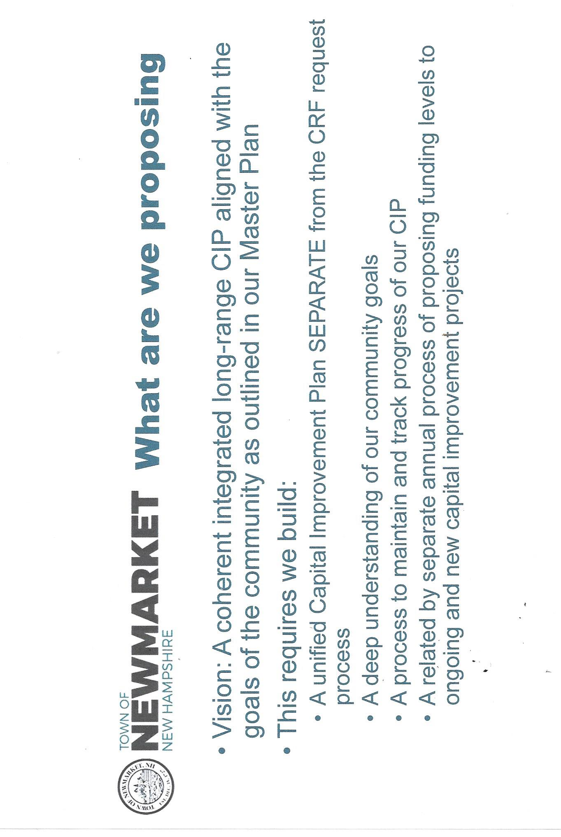
Addendum page 5
Addendum page 6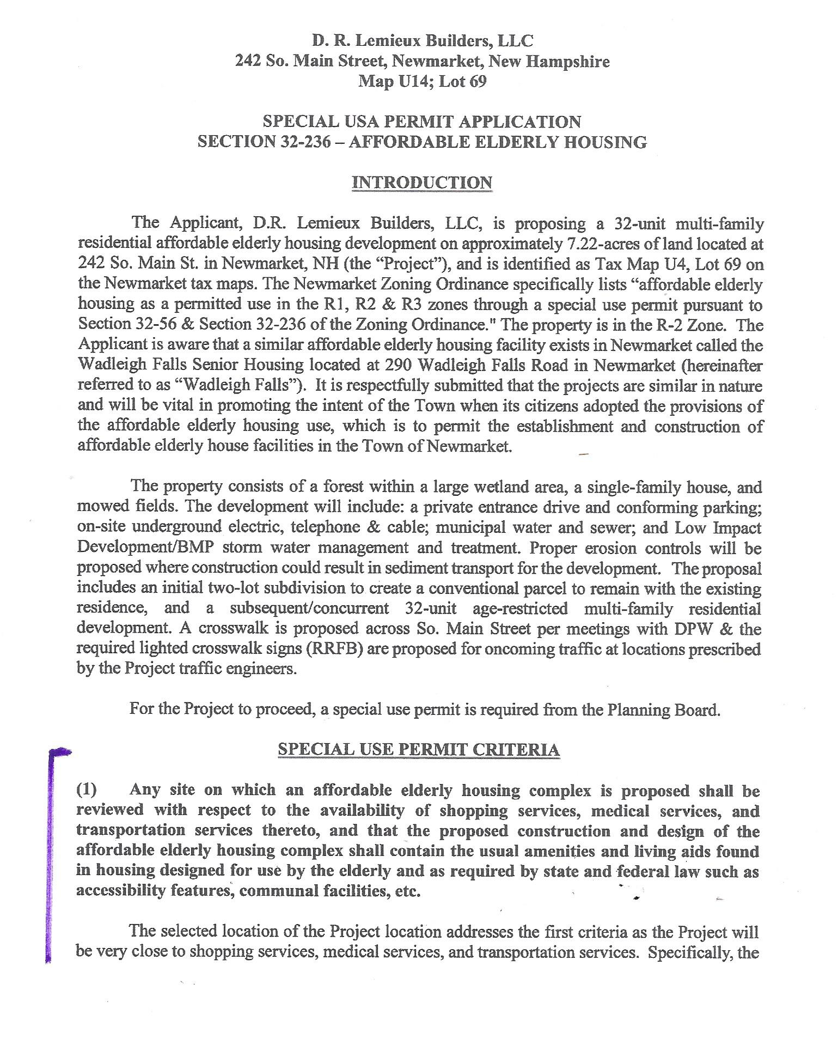
Addendum page 7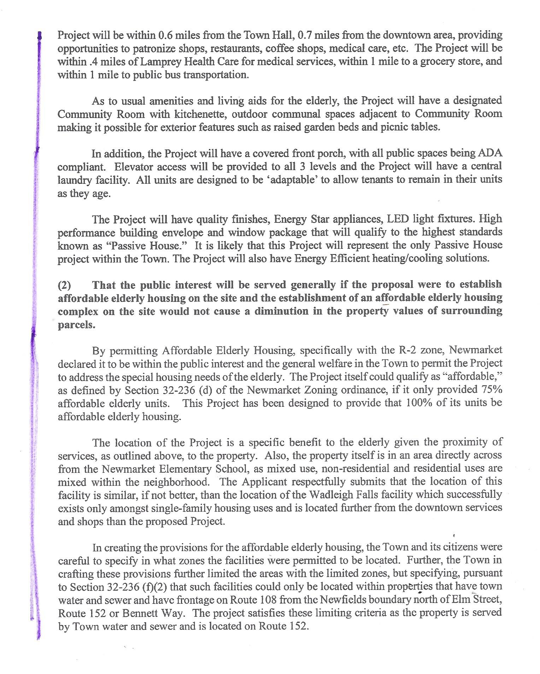
Addendum page 8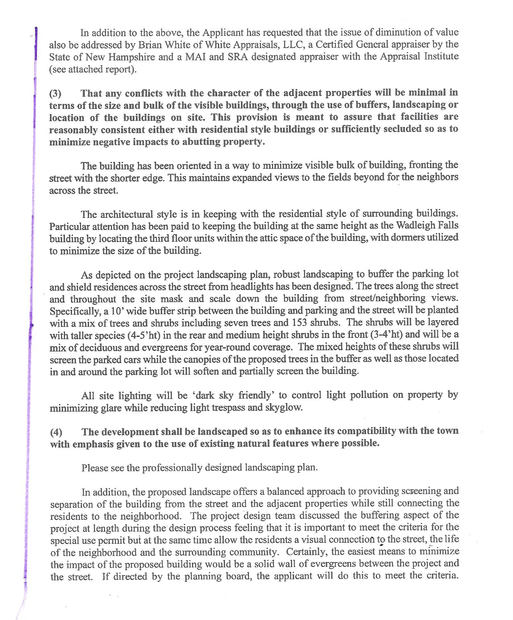
Addendum page 9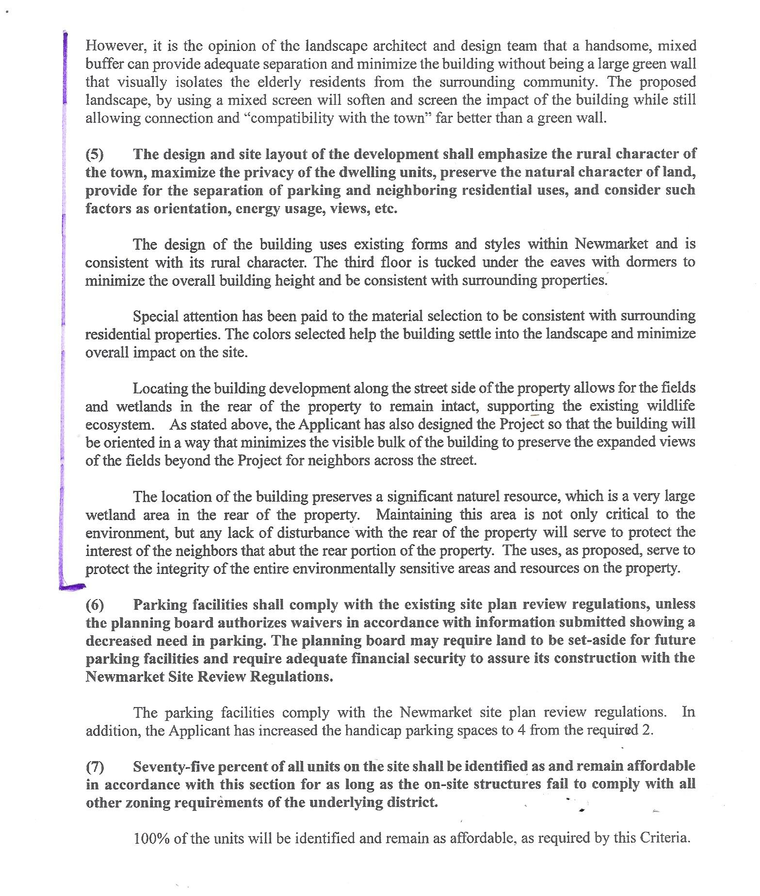
Addendum page 10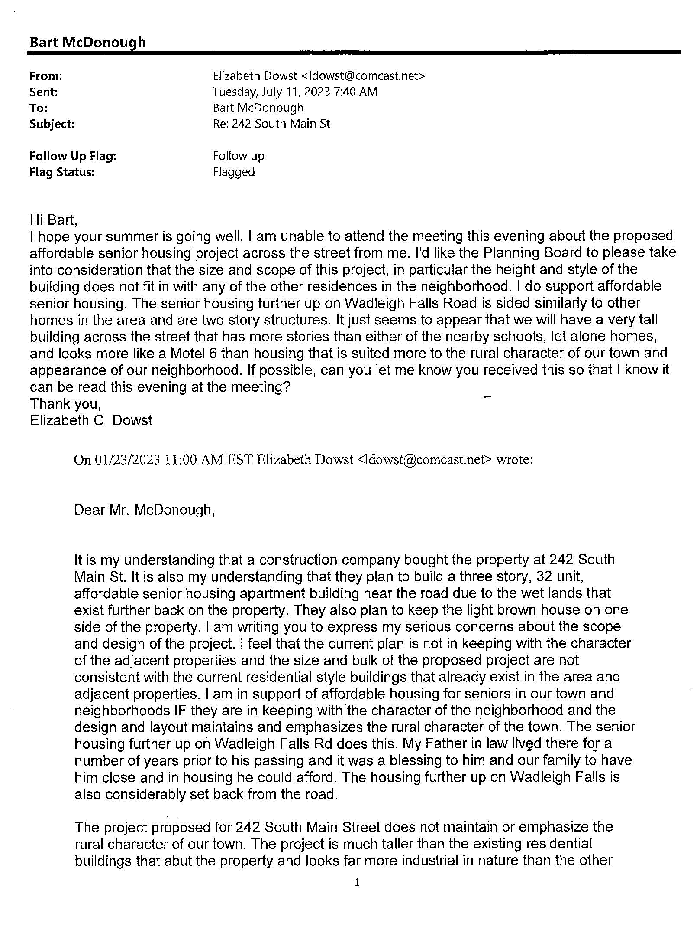
Addendum page 11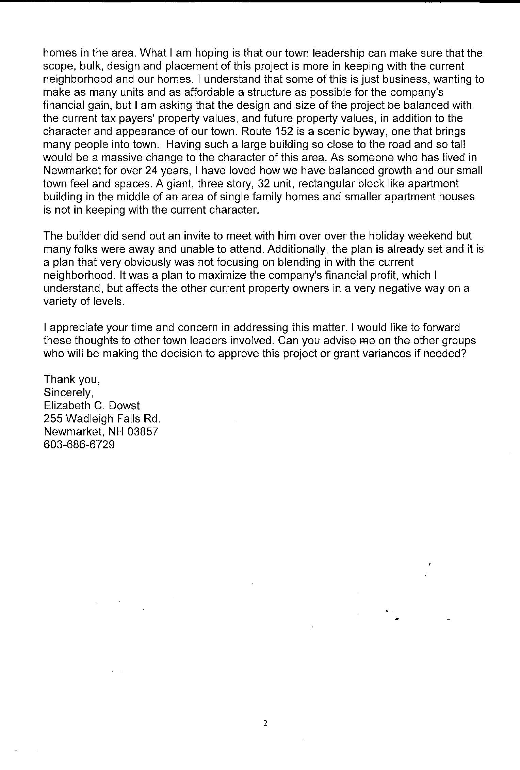
Addendum page 12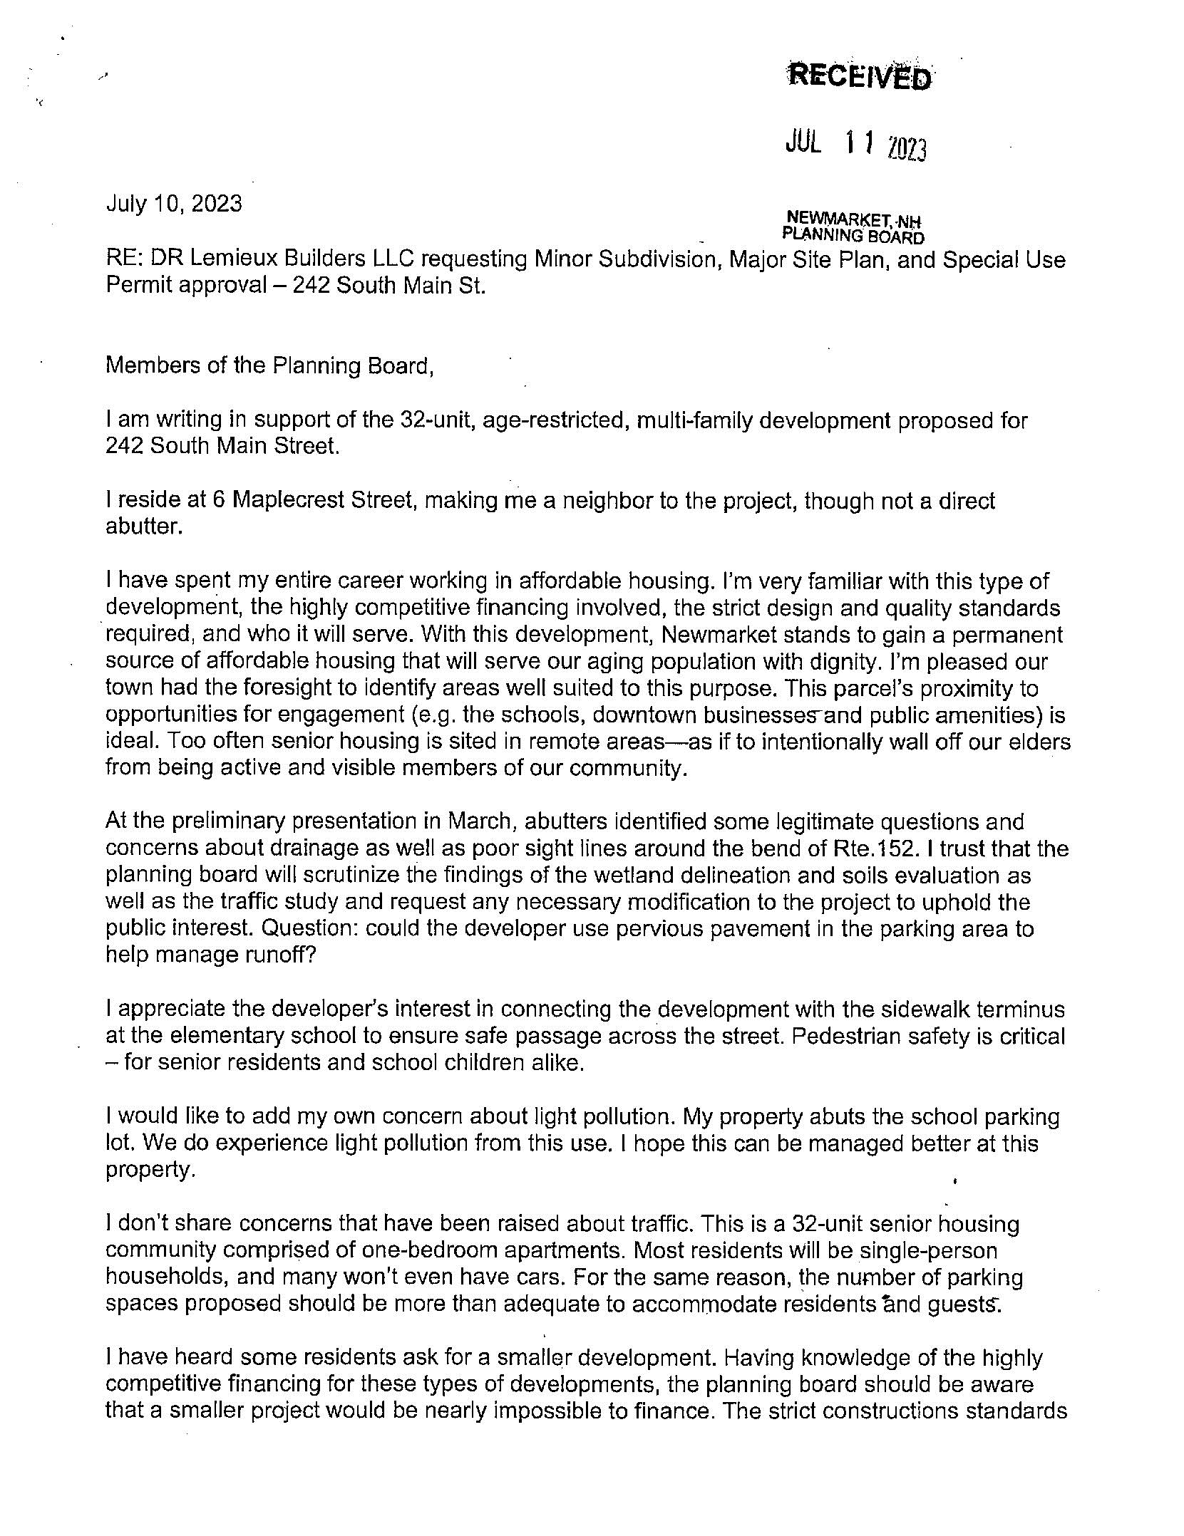
Addendum page 13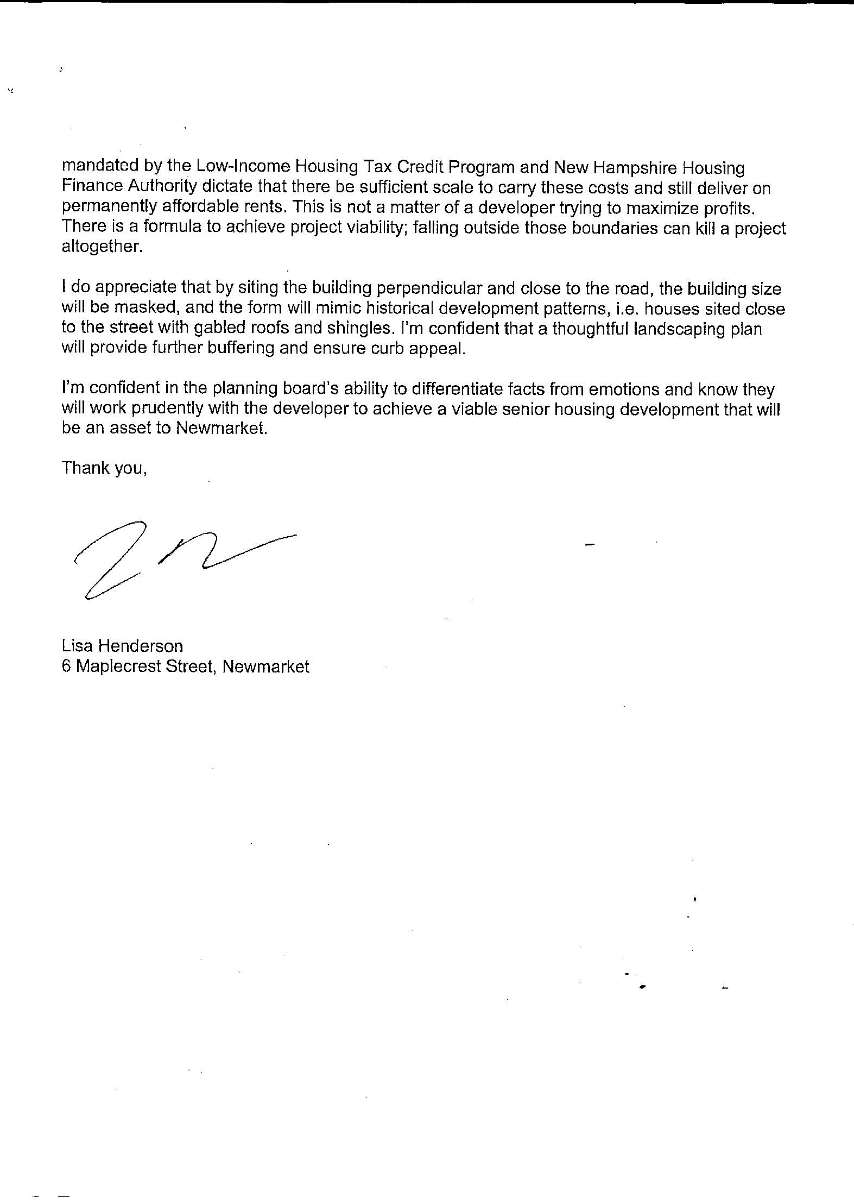
Addendum page 14