PLANNING BOARD
January 10, 2023 at 7:00 PM
APPROVED MEETING MINUTES

Members Present: Eric Botterman (Chair) via zoom, Val Shelton (Vice-Chair),
Scott Blackstone (Town Council Ex officio), Jane Ford, Jeff Goldknopf, Bart McDonough (Director of Planning & Community Development), Patrick Reynolds, and Michal Zahorik (alternate)
Member Absent: Timothy Rossignol
Chair Eric Botterman opened the meeting at 7:01 PM. [time on DCAT 4:06]
Roll call was taken. The Chair appointed Michal Zahorik as a voting member this evening.
Agenda Item #1 - Pledge of Allegiance
Agenda Item #2 - Public Comments
The Chair opened the Public Comments for any non-agenda items at 7:02 PM.
Seeing no one wishing to speak, Public Comments were closed at 7:03 PM.

Agenda Item #3 - Review & Approval of Minutes
a. November 8, 2022
b. December 13, 2022
Motion: Valerie Shelton made a motion to move the Review and Approval of Minutes for November 8 and December 13, 2022 until the next meeting on February 14, 2023.
Second: Patrick Reynolds
Discussion: none
Vote: Approved Unanimously by Roll Call 7-0-0
Agenda Item #4 – Regular Business
Read by Chair: [time on DCAT 7:23]
a. Pursuant RSA 674:35 and 676:41(d) and Appendix B – Site Plan of the Municipal Code of the Town of Newmarket, New Hampshire, there will be a continuation of a public hearing for an application for Major Site Plan Review, requested by SCG Management Corp/Second Bennett Way Limited Partnership, for property located at 4 Bennett Way, Tax Map U4, Lot 4-11, within the B1 Zoning District. The proposed application seeks approval to develop the east-side of the parcel with a 2-story, 12-unit building with associated parking and amenities.
The Chair asked for an update from the Planner on this agenda item. Bart reported that he and Lyndsay Butler, Town Engineer, met onsite with Mike Sievert to go over some concerns regarding the Bennett Way site plan application. The main area of focus was on stormwater and concerns staff had during their review. It was a productive meeting and it was determined that more time will be needed to address those concerns and provide a revised plan and stormwater analysis. Accordingly, all parties agreed that it would be best to continue the application to the February meeting. The applicant has formally requested a continuance of the public hearing.
Motion: Valerie Shelton made a motion to continue the application for a public hearing for an application for Major Site Plan Review, requested by SCG Management Corp/Second Bennett Way Limited Partnership, for property located at 4 Bennett Way, Tax Map U4, Lot 4-11, within the B1 Zoning District to the next meeting of the Planning Board on February 14, 2023.
Second: Jane Ford
Discussion: none
Vote: Approved by Roll Call Vote 6-0-1 (Jeff Goldknopf recused himself)
**************************************************************************************************
Read by Chair: [time on DCAT 9:58-1:16:52]
b. Pursuant to §24-1 Zoning ordinance amendment procedures, of the Municipal Code of the Town of Newmarket, New Hampshire, there shall be a continuation of a public hearing for proposed amendments to §32-5 Nonconformities; §32-9 Special use permits; §32-11 Definitions; §32-155 Wetland protection overlay district and §32-234 Accessory apartments of the Municipal Town Code of Newmarket, New Hampshire, that seeks to expand the use of accessory dwelling units, or take any other action relative thereto.
There were three emails from members who commented on the draft proposal. Michal’s email said that he didn’t have any additional comments or suggestions about the ADU Ordinance Draft. Val’s email mentioned several grammatical/editorial changes she would like to suggest. She was asked to review her email suggestions with the members. Changes in the draft were made after discussion and by consensus of the members.
Jane’s comments were more philosophical and she particularly wanted to know what problem we were solving. She wrote that she “…remained deeply concerned about the unintended consequences…” and whether or not they will have an effect and how does changing the ordinance map back to “…the Master Plan, police, fire, rescue, water, roads, and other.” The members had a productive discussion of unintended vs. intended consequences. The expense of building an ADU may mitigate the enthusiasm by homeowners as well as those properties currently on septic systems. Bart reported that there are currently ~ 40 ADUs permitted in Town. The Planner will give the PB an annual update on the permitted ADUs in Town and to help them determine the success of these ordinance changes. Val prepared a spreadsheet comparing several towns and it was distributed to the members. (The spreadsheet is attached as Addendum #1.)
The members discussed the comparisons. [time on DCAT 57:54]
The Chair polled each member if they like the changes offered by Val:
Eric likes it with Val’s changes.
Patrick likes it with Val’s changes and is looking forward to seeing the environmental benefits to the Town.
Jeff likes it with Val’s changes and is looking forward to seeing the impacts.
Jane likes it with Val’s changes and is happy with the change from two ADUs to one.
Val would like to see a bedroom limit of two.
Michal likes it with Val’s changes and is glad to see increasing density, but not reducing the open space and thinking of the environmental benefits to the Town.
Scott likes it with Val’s changes.
The members wish to re-evaluate in one year.
Val asked for a poll for the determination of bedroom limits. The majority of the Board approved the limit of two bedrooms.
The Chair opened Public Comments at 8:10 PM.
Hearing none, the Chair closed Public Comments at 8:11 PM.
[time on DCAT 1:14:39]
Motion: Valerie Shelton made a motion to recommend to the Town Council to adopt the proposed amendments to §32-5 Nonconformities; §32-9 Special use permits; §32-11 Definitions; §32-155 Wetland protection overlay district and §32-234 Accessory apartments of the Municipal Town Code of Newmarket, New Hampshire, that seeks to expand the use of accessory dwelling units as proposed and modified by the edits recommended by Valerie Shelton and amended comments by Jeff Goldknopf regarding DADUs and also with the addition that under the Standards (e) (2) that bedrooms be limited to two.
Second: Jane Ford
Discussion: none
Vote: Approved Unanimously by Roll Call Vote 7-0-0
The Chair would like to thank Bart and all the members of the Board for all of their hard work on this project. He believes that this will be a real benefit to the Town. Bart also wanted to thank the members for their thoughtful comments and help in making this a more perfect document.
**************************************************************************************************
Read by Chair: [time on DCAT 1:16:53-1:49:05]
c. Pursuant to §24-1 Zoning ordinance amendment procedures, of the Municipal Code of the Town of Newmarket, New Hampshire, the Planning Board shall review draft language proposed by the Newmarket Town Council to amend §32-161 Historic overlay district of the Municipal Town Code of Newmarket, New Hampshire, that seeks to add architectural design requirements within the historic overlay district, or take any other action relative thereto.
The Chair mentioned the letter received from the Town Manager, Steve Fournier, dated January 3, 2023. (Attached to these minutes as Amendment #2). Scott reviewed the
discussions at the Town Council meetings and the background regarding the proposed language which they felt needed to be modified. People have come before the TC with their concerns about new construction in the Historic Overlay District and that any construction should be architecturally compatible with the existing historic building or the surrounding District buildings. Originally written by Scott, the language has been modified by the Town Attorney. The TC would like to create an Historic District Commission or let the Planning Board take over the process to initiate historic conformity in the review process. The Chair has asked Bart to 1) research the 1980 Register to determine the delineation of the District and 2) create some appropriate amendment language for the members to consider at the next meeting. Val would like to review/compare both the Downtown District and the Historic Overlay District.
**************************************************************************************************
Agenda Item #5 – New/Old Business [time on DCAT 1:49:11]
Committee Reports:
Energy and Environment Advisory Committee: Patrick Reynolds reported on the recent letters from ReVision Energy and Amicus Cooperative (attached to the minutes as Amendment #3 and #4) to discuss their sourcing of materials for solar panels. SCG Management Corp is working with ReVision Energy on the Bennett Way project. Jane was very thankful for the work that Patrick has done to get this information. Q Cells is the company that she (in her professional life) uses the most. She does recommend that the Town should ask for a Solar Supply Chain Traceability Report just to be on the safe side for any Town purchases of solar panels.
Town Council: Scott Blackstone reported on that the TC approved the police collective bargaining agreement that will now appear as a warrant article. Al Zink was reappointed to the Zoning Board. The Town had a private contractor who was paid by the State to monitor Town sewage for COVID levels. They used to give us the results of their testing, but now the data is being kept by the State. There was concern about the COVID tests because we take septage from unknown sources, but the State assured the Town that the septage was such a small percent of our total waste that it wouldn’t matter. We are building the new facility just for the septage, so we will be able to monitor that separately in the future. The Ad-hoc Art and Tourism Commission has changed their name to the Art, Culture and Tourism Commission. There will be a $100,000 warrant article on the ballot for design and engineering at Moody Point for stormwater mitigation with respect to the federal Clean Water Act. If approved and once completed, the Town would then apply for additional grants for further work.
Conservation Commission: Jeff Goldknopf reported that the ConCom is very busy completing the year-end monitoring, applying for grants, and setting priorities for the coming year.
Energy and Environment Advisory Committee: Patrick Reynolds reported that the committee will meet tomorrow and he will report back.
Planner’s Report: Bart had nothing further to report this evening.
Agenda Item #6 – Adjourn [time on DCAT 2:02:29]
Motion: Jane Ford moved to adjourn the meeting at 8:59 PM.
Second: Jeff Goldknopf
Discussion: none
Vote: Approved Unanimously 7-0-0
Respectfully submitted,
Sue Frick
Recording Secretary
DCAT:
https://videoplayer.telvue.com/player/XSekkdEeRsk0JHQVHAvKJVka7_5VjxKP/videos

ADDENDUM #1
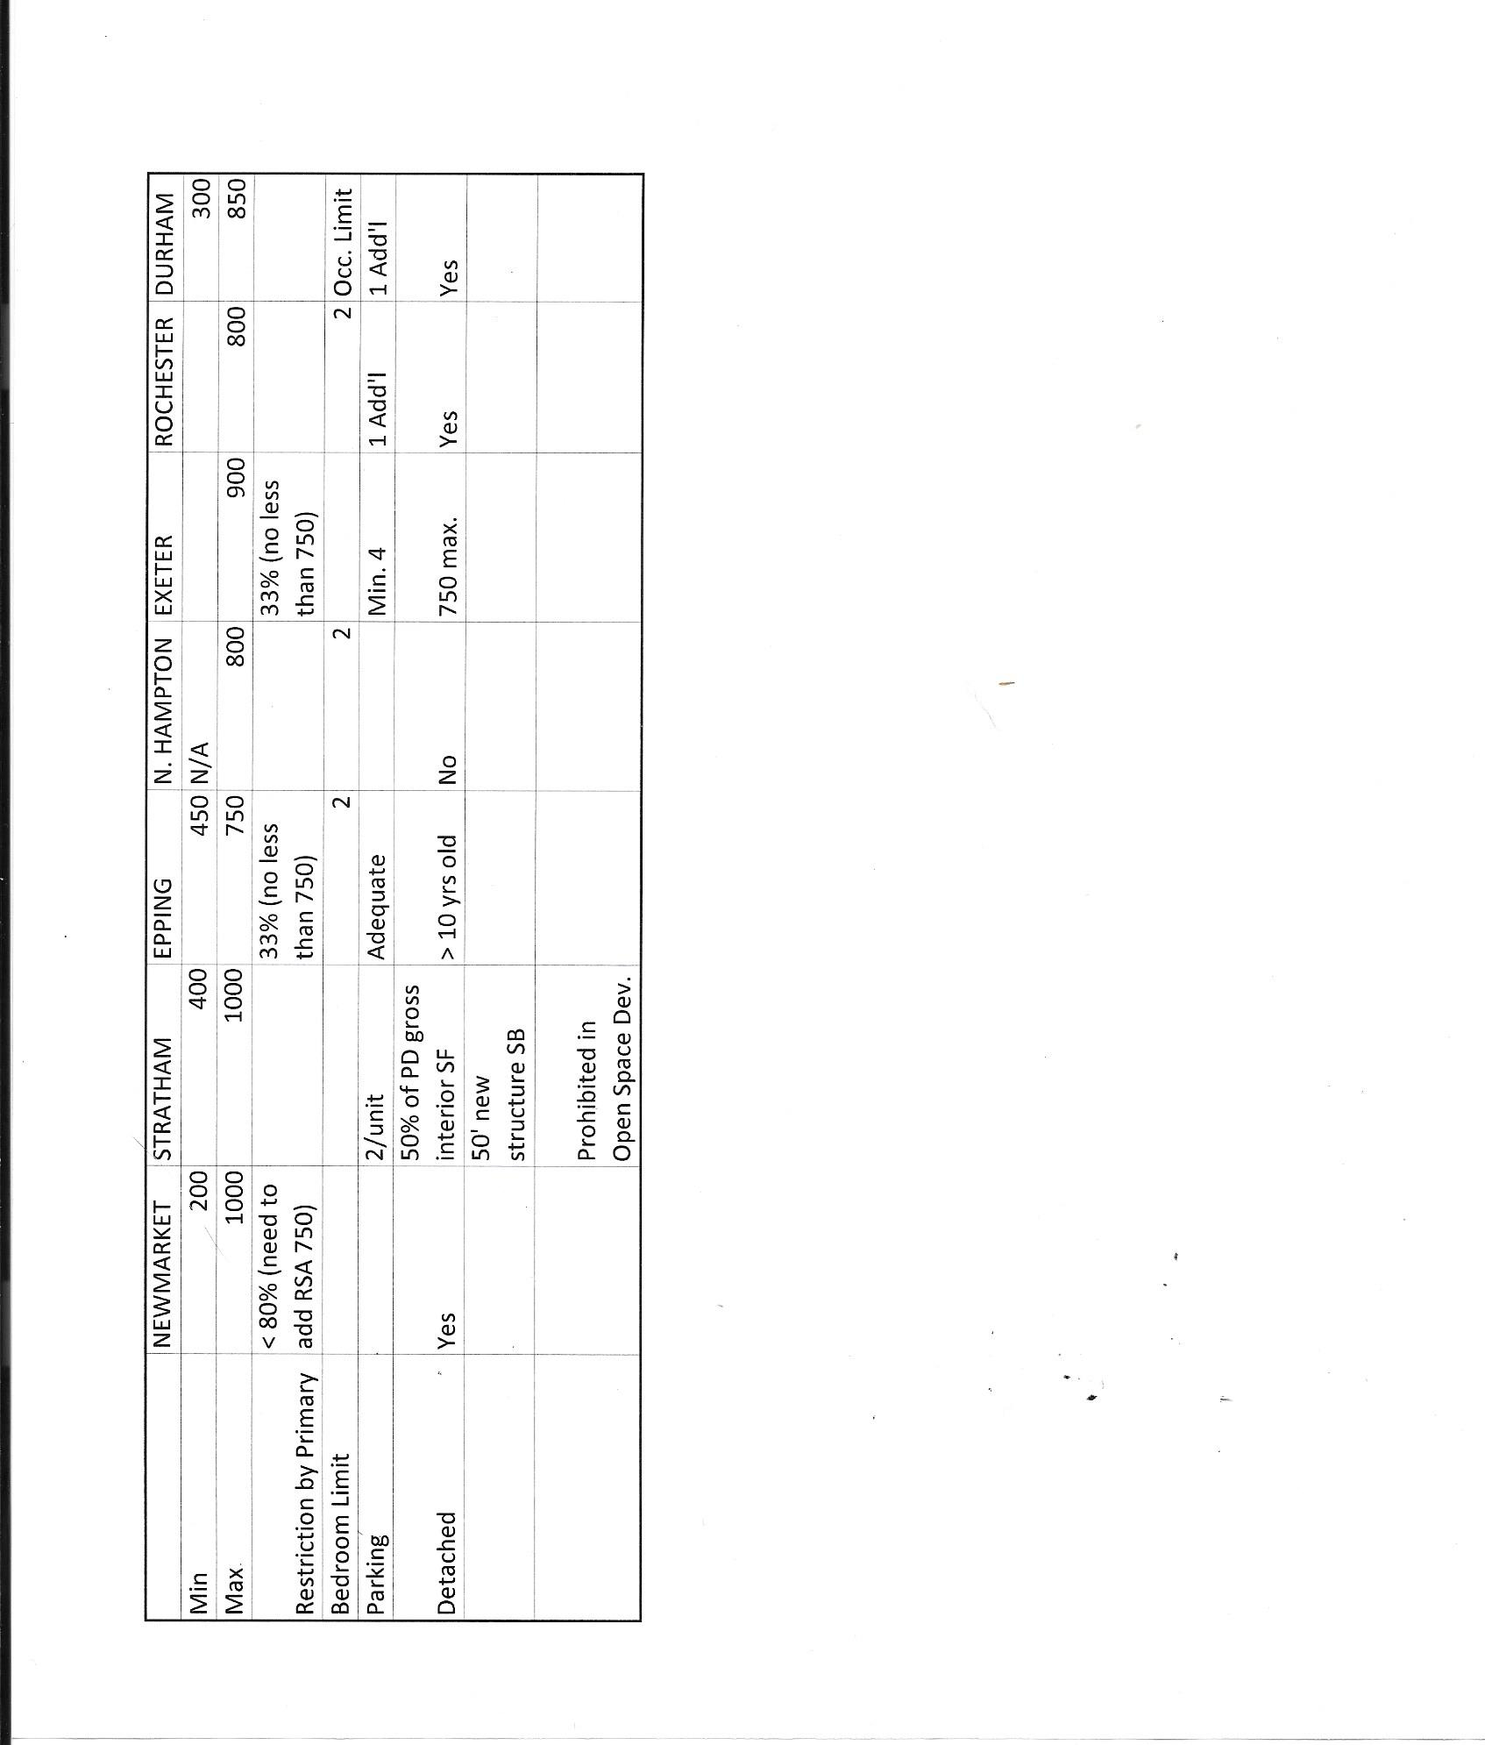
ADDENDUM #2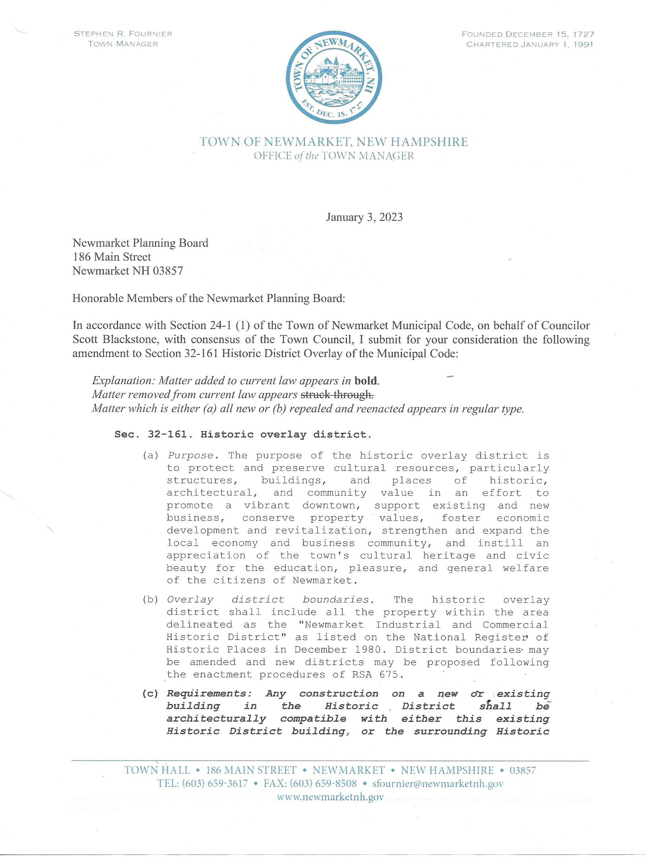
ADDENDUM #2 continued
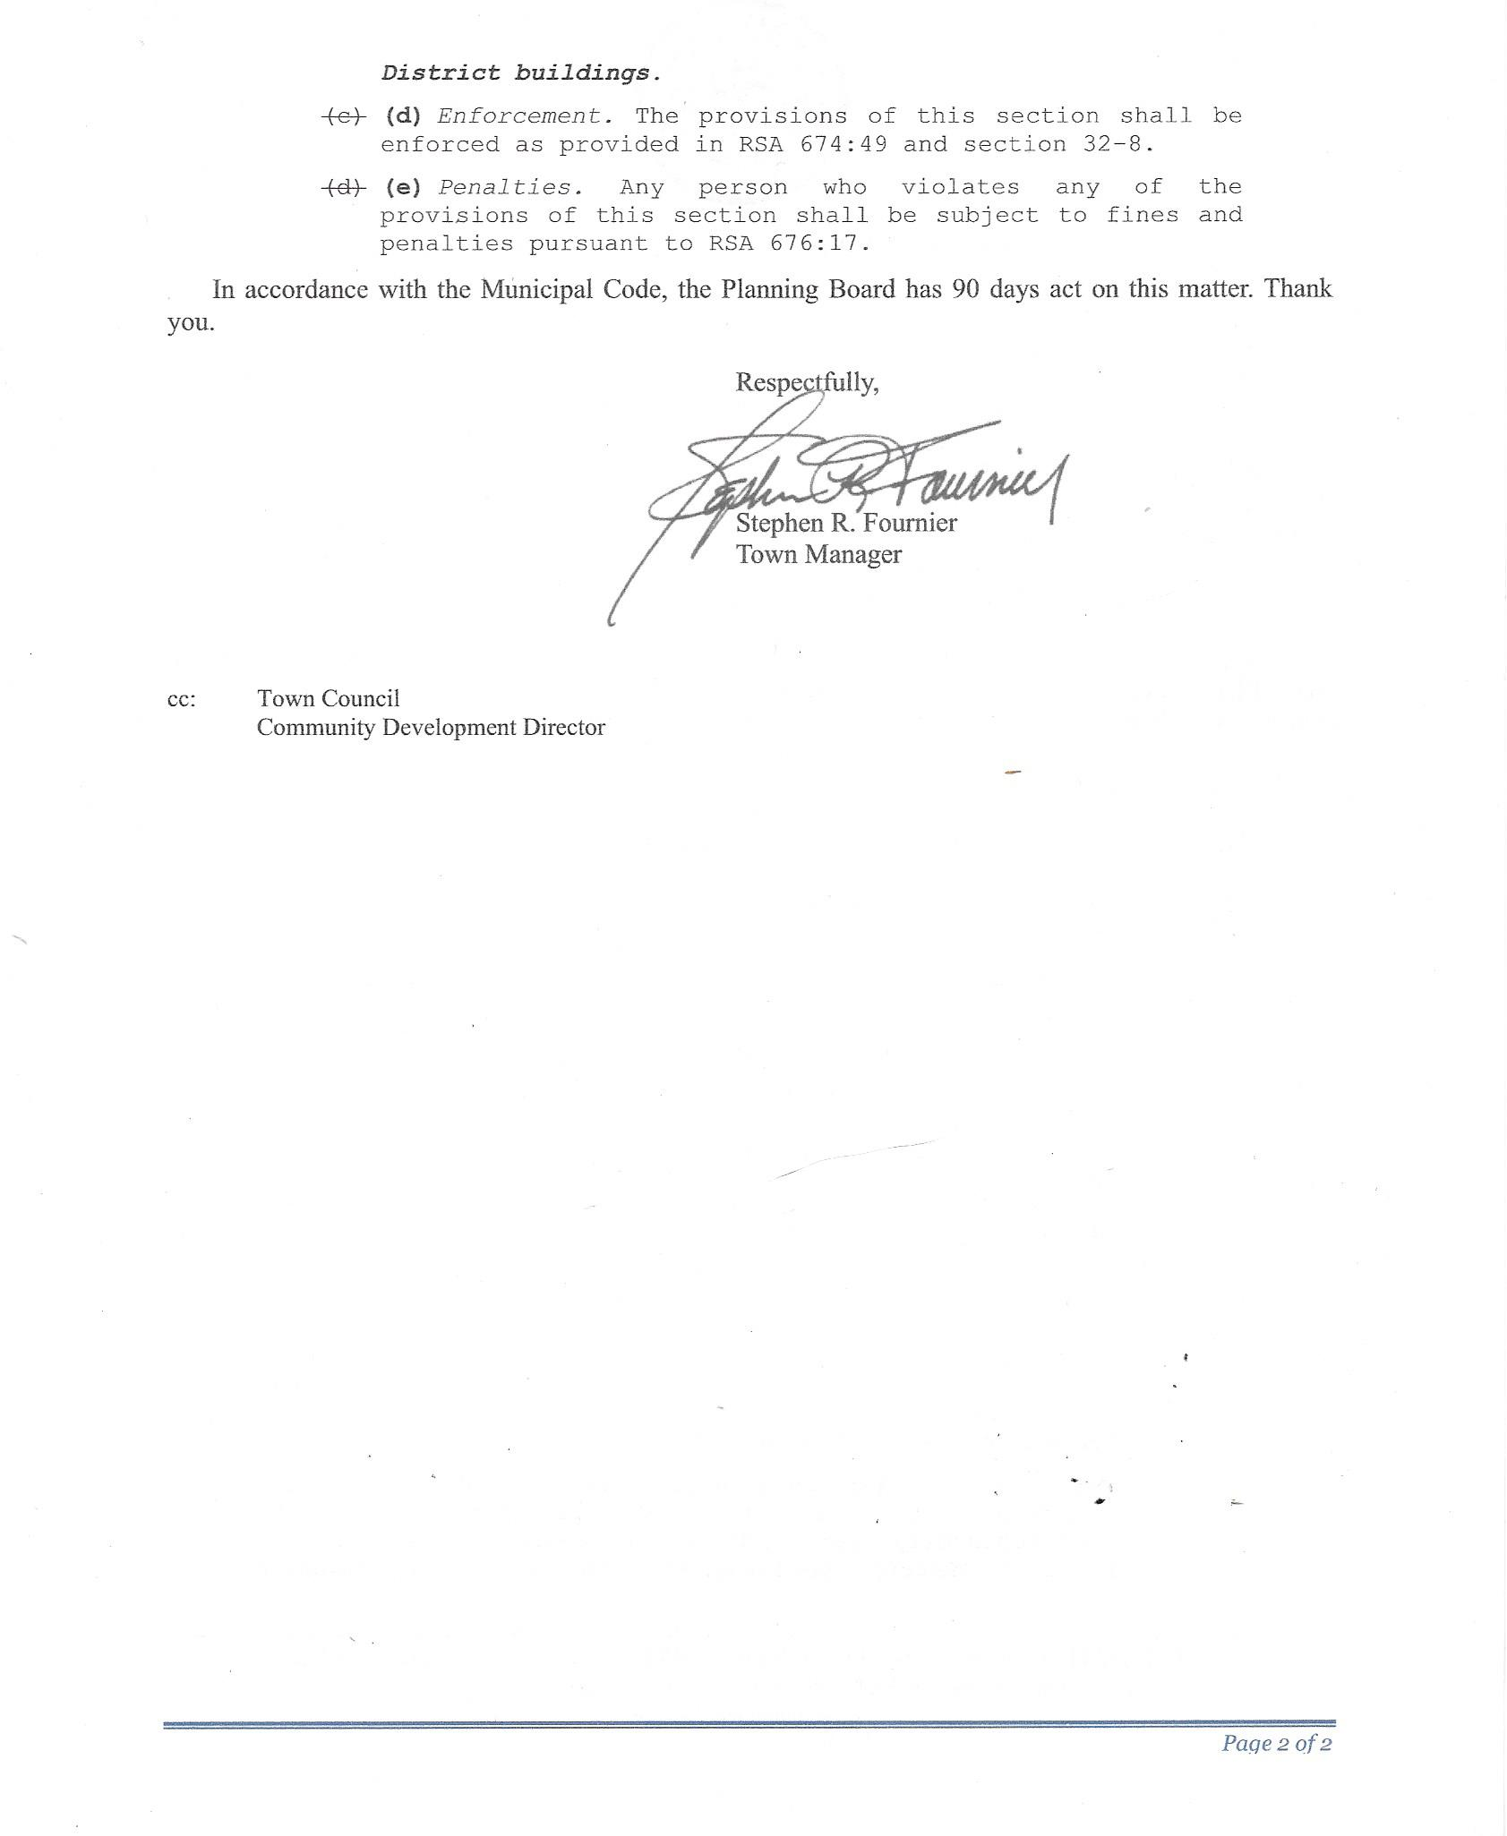
ADDENDUM #3
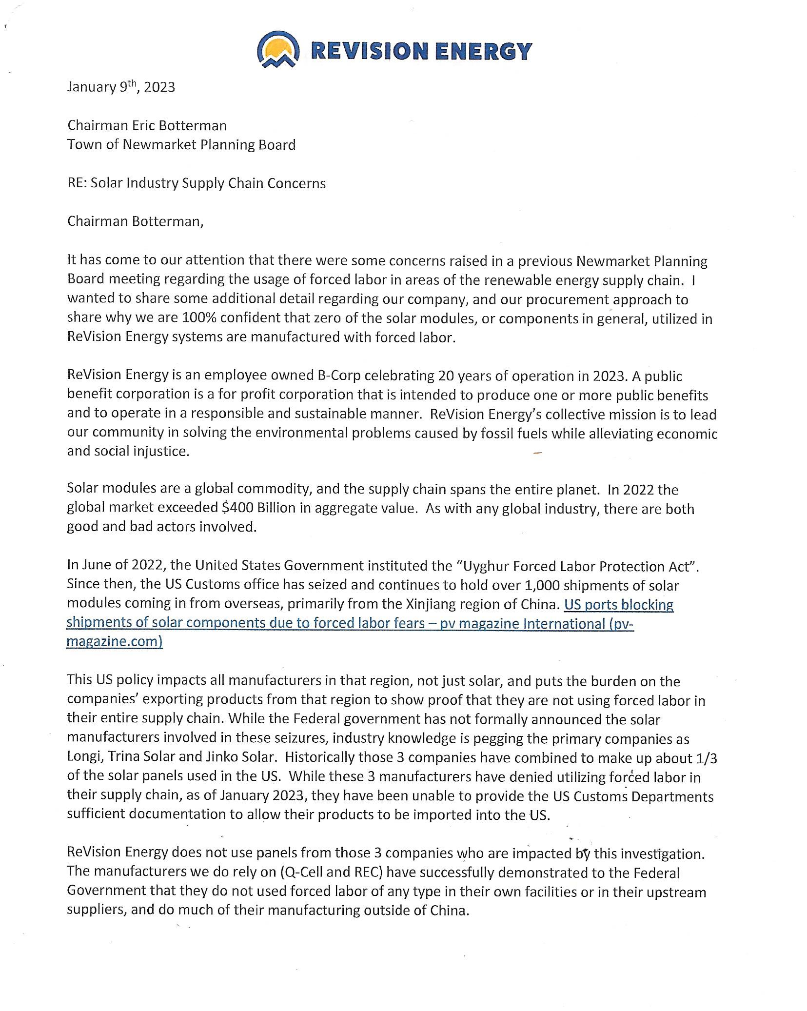
ADDENDUM #3 continued
ADDENDUM #4
