What you can do
What you can do

- Remove the bag from your lawnmower or use a mulching lawnmower. Leave the clippings to add organic matter and recycle nutrients, and avoid having to dispose of the grass clippings.

- Drop off your yard waste and lawn clippings at the Transfer Station on Ash Swamp Road for composting, free of charge. Call 659-3093 for more information.

- It needs to be bagged in yard bags or in cardboard boxes. Brush greater than 5 inches in diameter, logs and stumps will not be accepted.

- Start backyard composting (away from surface waters). See: https://www.des.nh.gov/organization/divisions/waste/swrtas/documents/compost_flier.pdf for a free “how-to” brochure.

- NEVER dispose of leaves or clippings in or near storm drains, drainage channels (where water drains rain or melting snow), wetlands or waterbodies!

- Remove the bag from your lawnmower or use a mulching lawnmower. Leave the clippings to add organic matter and recycle nutrients, and avoid having to dispose of the grass clippings.

- Put yard waste on the curb in a paper bag or reusable, clearly marked “Yard Waste” container. (if your towns offers this)

- Drop off your yard waste at the Municipal Public Works for composting. Call Phone number for more information.

- Start backyard composting (away from surface waters). See: https://www.des.nh.gov/organization/divisions/waste/swrtas/documents/compost_flier.pdf for a free “how-to” brochure.

- NEVER dispose of leaves or clippings in or near storm drains, drainage channels (where water drains rain or melting snow), wetlands or waterbodies!

More Information
Newmarket Public Works Department
4 Youngs Lane Newmarket, NH 03857
603-659-3093 Rick Malasky, Director
dirmalasky@newmarketnh.gov

NH Department of Environmental Services, 603-271-7889 or Barbara.mcmillan@des.nh.gov

What shall I do with my Yard Waste?

Rake it or leave it?

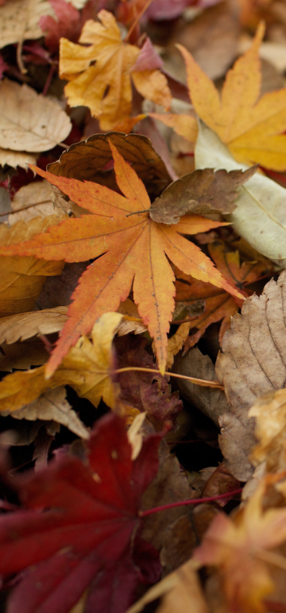 t shall

Why Does it Matter?
You Choose - your leaves and grass clippings can be a valuable resource OR a source of water pollution.

Our Community Cares
Our community cares about clean water and is doing its part to help prevent water pollution in local waterways. This outreach message helps our community meet US Environmental Protection Agency (EPA) requirements to share pollution prevention information with its residents.

As a resource . . .
GOOD

Mulched leaves or grass clippings on your lawn add valuable nutrients and organic matter.
Grass clippings provide a source of slow-release nutrients reducing the amount of lawn fertilizer needed by at least half or none. A thin layer of leaves will break down and add much needed organic matter to plant beds.

Composting leaves and grass clippings save money.
Compost is natural recycling. Compost can be used as a top dressing on your lawn or garden beds reducing or eliminating the need for fertilizer and mulch.

As a source of water pollution . . .
BAD

Decaying leaves and grass kill critters in streams, rivers, lakes, ponds, and wetlands.
Leaves and grass clippings decompose in water and wetlands by using the oxygen that other organisms such as dragonfly larvae, crabs, and fish need to live.

Yard waste on stream banks smothers natural vegetation.
Leaves or grass dumped near banks, shorelines and wetlands block sunlight and smother the natural plant life that provide food and cover to animals such as turtles, ducks, chipmunks, and deer.

Yard waste dumped near waterbodies contributes to stream algae and odors.
Seepage from yard waste piled on or near banks and shorelines will slowly make its way into the water. Algae then grow and form foul-smelling, green mats on the water surface.

Yard waste dumped in or near wetlands or surface waters is against the law!

In an effort to protect wetlands and surface waters, the NH legislature passed a law that prohibits filling streams and wetlands with waste materials, including yard waste. RSA 482-A:3

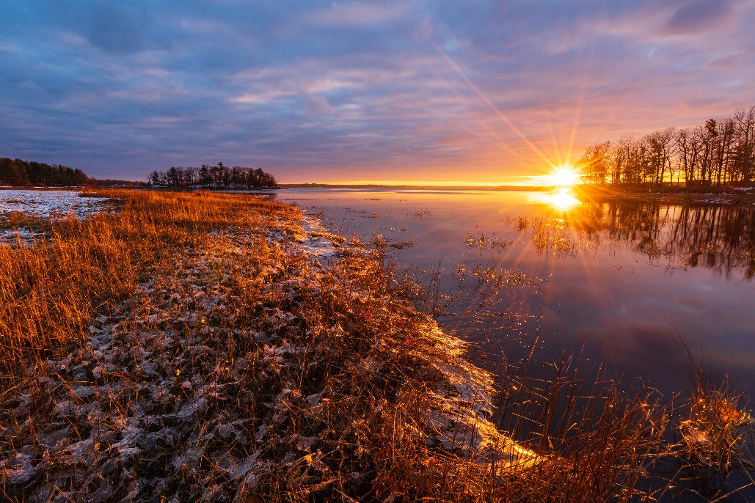
Lubberland Creek at Dawn 1
WATERBODY MAP OR PHOTO
.

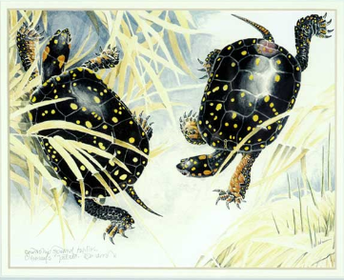
Lubberland Creek, photo by Bill Doucet

Produced by the NH Department of Environmental Services 603-271-7889 https://www.des.nh.gov/organization/divisions/water/wmb/was/index.htm
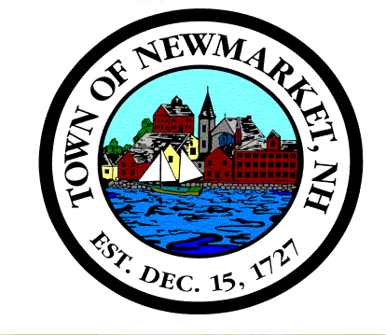
Newmarket Stormwater Management Program

