Approved Minutes
TOWN OF NEWMARKET, NH
CAPITAL IMPROVEMENT PROGRAM (CIP) COMMITTEE
September 3, 2019
5:00 PM Town Hall Auditorium
Called to Order by Russ Simon: 5:08 PM
Agenda Items:
- Introductions:
Members Present: Amy Burns (TC Rep), Joe Lamattina (Budget Committee Rep – Alternate), Christian Matthews (Budget Com Rep), Russ Simon (Member at Large) and Al Zink (School Board Rep)
Members Absent: Eric Botterman (PB Rep- Alternate), Jane Ford (PB Rep), and Jonathan Kiper (TC Rep-Alternate)
Others Present: Diane Hardy (Town Planner) and Sue Frick (Recording Secretary)

All present introduced themselves and discussed other committees they currently serve or have served on for the Town. The CIP has one position available for a ‘Member at Large’ from the community. If anyone is interested, please contact Diane Hardy.

- Election of Coordinator, Chair, and Vice Chair for the 2019-2020 CIP Committee:
Action
Motion: Russ Simon nominated Diane Hardy to serve as Coordinator.
Second: Al Zink
There were no further nominations and no discussion.
Vote: Approved Unanimously
Action
Motion: Al Zink nominated Russ Simon to serve as Chair.
Second: Christian Matthews
There were no further nominations and no discussion.
Vote: Approved Unanimously

Action
Motion: Al Zink nominated Amy Burns to serve as Vice Chair.
Second: Russ Simon
There were no further nominations and no discussion.
Vote: Approved Unanimously

- Rules of Procedure:
A copy of the Rules of Procedure, last changed and approved on September 14, 2017, was distributed to all members present by Diane Hardy. The Coordinator reviewed the Rules of Procedure with members and answered all questions. The minutes of the final two meetings for 2018 (9/25 and 9/26/ 2018) were transcribed, edited, but not approved. They will be distributed for approval at the next meeting before posting to the public. A copy of the Rules of Procedure follow the minutes of this meeting as an addendum. It was decided to keep the Rules open to change if the need arises in future meetings.
Approved Minutes
- Process and Changes from Last Year – Forms, Instruction Manual, Final Report:
Diane Hardy emailed copies of the updated forms (dates, etc.) and instructions to all of the Department Heads. The Department Heads have a deadline of September 6 to return their requests to her. She distributed copies of the FY 2019-2020 report to all members present who may have not seen the final report from last year. The final report from the CIP for 2020-2026 is due to the Town Administrator by October 1, 2019. The CIP Committee is advisory only to the Town Council, the Town Administrator, and the School Board. Russ Simon explained the step-by-step process and time frame for the benefit of all members. Diane Hardy spoke about the requirement to have a current CIP plan in place in order to be eligible for impact fees.

- Schedule:
The tentative CIP schedule for this year was emailed to the members by Diane Hardy:

Send Forms to Departments Friday 8/16/2019 Submit Forms via U Drive Friday 9/6/2019
[CIP Organizational First Meeting Tuesday 9/3/2019]
Forms and Spreadsheets to the Committee Friday 9/9 and/or 9/10/2019
-----------------------------------------------------------------------------------------------
After discussion amongst the members, the following dates were determined as tentative possibilities:

Afternoon Tour of Facilities for members Wednesday 9/11/2019
and/or Thursday 9/12/2019
Presentations to CIP Committee Wednesday 9/18/2019 (3:30-6:30 pm)
and/or Thursday 9/19/2019 (3:30 to 6:30 pm)
Deliberations and Final Recommendations Wednesday 9/25/2019 (time TBD)
and/or Thursday 9/26/2018 (time TBD)

-----------------------------------------------------------------------------------------------
Submit CIP to the Town Administrator Tuesday 10/1/2019

Diane Hardy will email everyone, arrange the tours and presentations, and confirm the schedule for the tours and meetings as soon as possible.

- Other Business
There was no other business for this meeting.

- Adjourn
Action
Motion: Al Zink moved that the meeting be adjourned.
Second: Amy Burns
Vote: Approved Unanimously

The meeting was adjourned at 5:50 pm.
Respectfully submitted,
Sue Frick, Recording Secretary
Approved Minutes
Addendum page 1
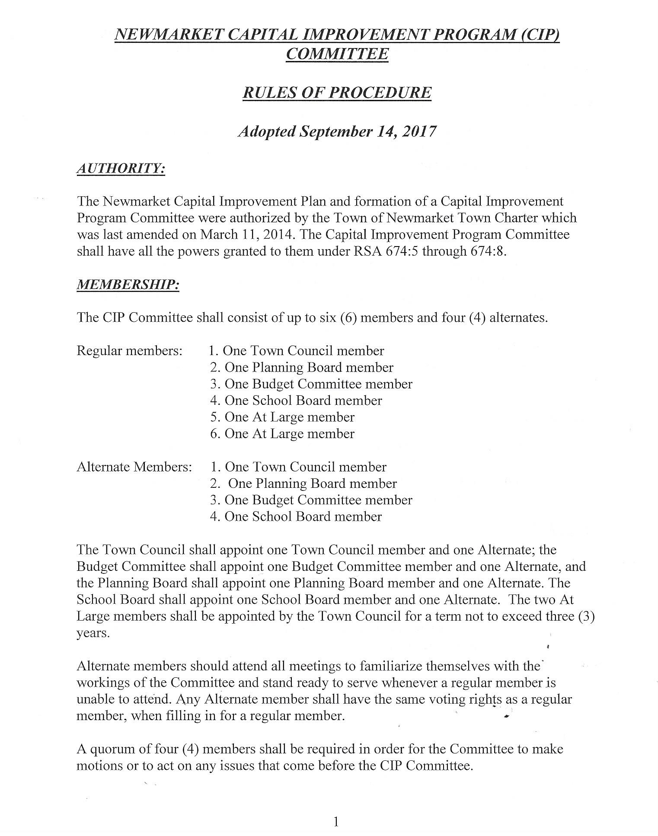

Approved Minutes
Addendum page 2
