NEWMARKET Zoning BOARD OF ADJUSTMENT
Monday, October 18, 2021
TOWN COUNCIL CHAMBERS
7:00 PM
Present: Bob Daigle (Chair), Wayne Rosa (Vice Chair), Diane Hardy (Zoning Administrator), James Drago, and Al Zink.
Absent: John Greene, Steve Minutelli, and Henry Smith (Alternate)
The Chair called the meeting to order at 7:06 PM
- Pledge of Allegiance
- Review and Approval of Minutes
a. August 23, 2021
Motion: Bob Daigle made a motion to approve the minutes of 08/23/2021.
Second: Wayne Rosa
Vote: Unanimously Approved
The Chair announced to the applicants present that they are allowed to postpone their hearing as only four members were present instead of the five required for a hearing. If they choose to go forward this evening, they would still need three of the four members for approval of their request. The parties agreed to go forward.
3. Regular Business
a. Jason & Sarah Mansfield - Public Hearing for an application for Variances from Section 32-87 Setbacks and Section 32-89 Dimensions Table of the Newmarket Zoning Ordinance requested by Jason & Sarah Mansfield, to permit the construction of a 20'x28' single car garage with a five foot rear setback from Sewall Farm's lift station parcel, where thirty feet is required, and an eighteen foot side yard variance that allows the garage to be twelve feet from the edge of the Ladyslipper Drive right-of-way on the east side of the property. The property is located at 32 Ladyslipper Drive, Tax Map R4, Lot 136, R2 Zone.
The Planner stated that all documents have been received and notifications have been made.
Jason Mansfield is present to review the history of the project, his previous presentations to the Board, approved variances of the project, and to present new materials for his request for a variance for the property at 32 Ladyslipper Drive. He provided new material which was updated on September 9, 2021 and came forward to the computer and television monitor with his thumb drive. This project is an application from last year involving some changes. Since last year, he has had the lot surveyed by a professional and found differences in the property line. He requests a variance to permit the construction of a 20'x28' single car garage with a five foot rear setback from Sewall Farm's lift station parcel, where thirty feet is required, and an eighteen foot side yard variance that allows the garage to be twelve feet from the edge of the Ladyslipper Drive right-of-way on the east side of the property.
Diane Hardy, Town Planner, informed the members that she had worked very closely with
Mr. Mansfield on the preparation of his application to make sure that the request was clear to all and followed the regulations. She attested to his accuracy of the information in this presentation and the application.
The Chair opened the meeting to public for comments at 7:19 PM. Hearing no comments, he closed public comments at 7:20 PM.
Mr. Mansfield had Rick Malasky out for a consultation walk. Mr. Malasky was not concerned with the current placement of the fire hydrant as long as it is six (6) ft. from the edge of the proposed driveway like several other properties along Ladyslipper Drive. He was also not concerned with having two driveways on the property.
Motion: James Drago made a motion to approve the application for Variances from Section 32-87 Setbacks and Section 32-89 Dimensions Table of the Newmarket Zoning Ordinance requested by Jason & Sarah Mansfield, to permit the construction of a 20'x28' single car garage with a five foot rear setback from Sewall Farm's lift station parcel, where thirty feet is required, and an eighteen foot side yard variance that allows the garage to be twelve feet from the edge of the Ladyslipper Drive right-of-way on the east side of the property. The property is located at 32 Ladyslipper Drive, Tax Map R4, Lot 136, R2 Zone. Please refer to the minutes of the ZBA meeting of October 19, 2020 when the first application was approved with a condition which has been met.
Second: Al Zink
Vote: Unanimously Approved
b. Robert & Natalie Hassold There will be a public hearing on an application for a Variance from Section 32-155 (C)(4) Wetland Protection Overlay District, requested by Robert & Natalie Hassold, to permit the expansion of an existing deck 10’x16’deck with a 10’X12 addition. The proposed deck expansion will infringe upon a 25 foot wide “no cut, no disturbance’ wetlands buffer adjacent to poorly drained “hydric” soils along the easterly side of the property. The encroachment is an area of approximately 25 square feet. The property is located at 6 Honeycomb Way Lot, Tax Map R3, Lot 23-19, M4 Zone. The full application is available to view under the October 18, 2021 Zoning Board agenda on the website.
The applicants, Robert and Natalie Hassold, are present this evening. Mr. Hassold presented his request for a variance. He explained a notice of denial was made on August 19, 2021 by Peter Rowell, Interim Building Inspector, denying a building permit to expand their existing deck which would infringe upon a 25 foot wide “no cut, no disturbance” wetlands buffer adjacent to poorly drained ‘hydric’ soils along the easterly side of the property. Mr. Hassold read the five criteria from his application into the record this evening. His narrative explaining how the criteria has been met is provided on Addendum page 1 and page 2 at the end of these minutes.
He noted that one direct abutter, David and Linda Older of 8 Honeycomb Way, has submitted a letter in support of the application.
The Chair opened the meeting to public for comments at 7:39 PM.
Mr. Stanley Chamallas, 25 Honeycomb Way, rose to speak in favor of the variance application. He indicated that, in his opinion, the disturbance to the wetlands for the posts to hold the deck addition would be minimal. The Chairman informed the Board that there were also other abutter letter sent in with the application from Joyce Gilbert at 4 Honeycomb and Dave and Linda Older at 8 Honeycomb who also did not object to the granting of the variance. Hearing no other comments, the Chair closed the public comments at 7:40 PM.
Members had a brief discussion and there were no more questions.
Motion: Al Zink made a motion to approve the application for a Variance from Section 32-155 (C)(4) Wetland Protection Overlay District, requested by Robert & Natalie Hassold, to permit the expansion of an existing deck 10’x16’deck with a 10’x 12’ addition. The proposed deck expansion will infringe upon a 25 foot wide “no cut, no disturbance’ wetlands buffer adjacent to poorly drained “hydric” soils along the easterly side of the property. The encroachment is an area of approximately 25 square feet. The property is located at 6 Honeycomb Way Lot, Tax Map R3, Lot 23-19, M4 Zone.
Second: James Drago
Vote: Unanimously Approved
- New/Old Business
None.
5. Adjourn
Motion: James Drago made a motion to adjourn.
Second: Bob Daigle
Vote: All in favor
The meeting was adjourned at 7:43 PM
Respectfully submitted,
Sue Frick, Recording Secretary.

Addendum Page 1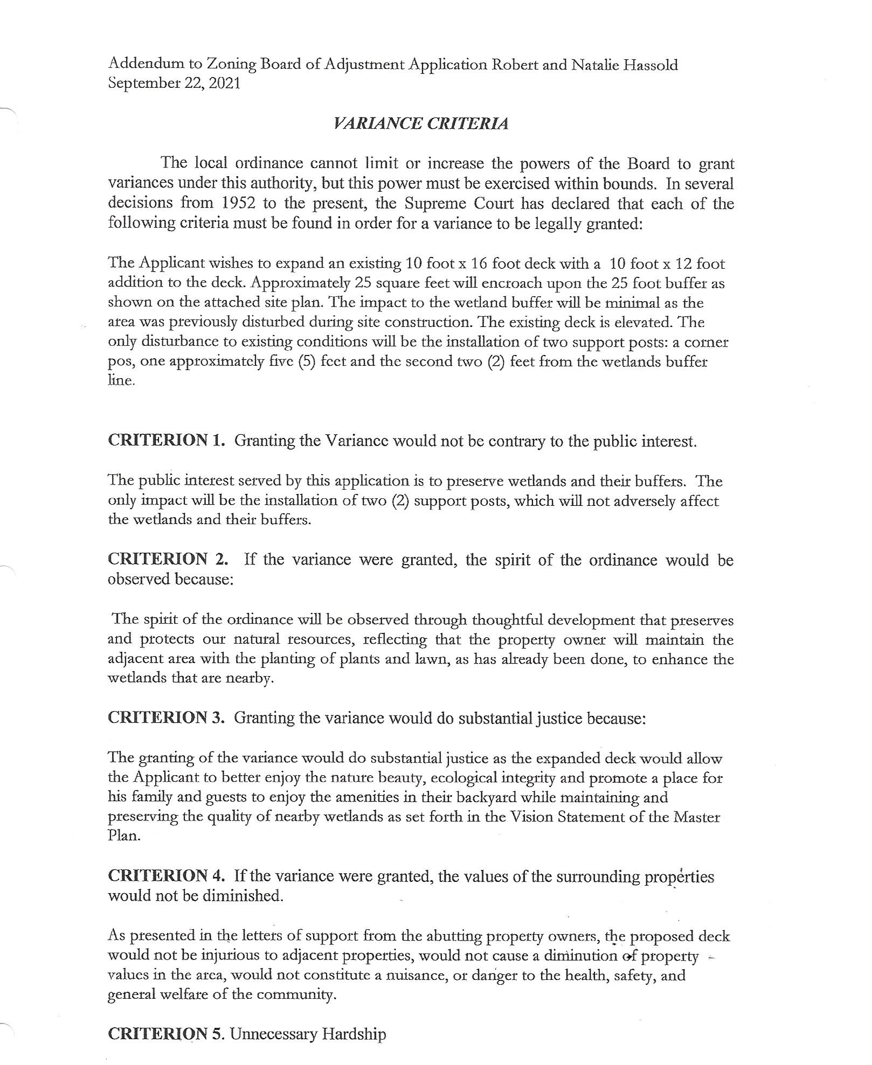
Addendum Page 2

