PLANNING BOARD
June 13, 2023 at 7:00 PM
APPROVED MEETING MINUTES
Members Present:, Scott Blackstone (Town Council Ex officio), Jane Ford,
Jeff Goldknopf, Bart McDonough (Director of Planning & Community Development), Patrick Reynolds, and Michal Zahorik (Alternate)
Members Absent: Eric Botterman (Chair), Timothy Rossignol, and Val Shelton (Vice-Chair)
Patrick Reynolds agreed to serve as Chair pro tem this evening without objection.
He opened the meeting at 7:00 PM. [time on DCAT 3:10]
The Chair appointed Michal Zahorik (Alternate) as a voting member tonight.
The voting members this evening will be Scott Blackstone, Jane Ford, Jeff Goldknopf, Patrick Reynolds, and Michal Zahorik.
1. Pledge of Allegiance
2. Public Comments
The Chair opened public comment at 7:01 PM. No one was present to speak during public comments. The Chair closed public comments at 7:01 PM.
3. Review & Approval of Minutes [time on DCAT 4:02]
a. May 9, 2023
Action
Motion: Jane Ford moved the approval of the draft minutes of May 9, 2023
as written.
Second: Jeff Goldknopf
Discussion: none
Vote: Approved 4-0-1 (Michal Zahorik abstained)
4. Regular Business
Read by the Chair: [time on 5:02-1:22:26]
a. Notice is hereby given that the Planning Board shall hold a discussion on proposed language to amend §32-161 Downtown Overlay District and §3.21 Architectural/aesthetic review of the Municipal Town Code of Newmarket, New Hampshire, that seeks to add architectural design requirements within the Downtown Overlay District, or take any other action relative thereto.
Bart began the discussion by reviewing all the changes and edits he has made in the document since the last meeting. Jane asked for clarification of the district under discussion and Bart gave the members a description by using the map provided as Addendum page 1. The current Downtown Commercial Overlay District is noted in blue and the areas the Planning Board may wish to include in the Downtown Commercial Overlay District is noted in green. The members had a discussion about other building/homes which are historical, but are not included in the district right now.
Bart read the new sections one by one in the Draft. (Addendum pages 2-5).
The members had a very good discussion about the proposed changes and thoroughly discussed edits. The members all agreed that the Sinclair Gas Station located at 44 Main Street be excluded from the District. They would like to propose that the District include both the green and blue properties as indicated on the chart (Addendum page 1), but exclude the Sinclair Gas Station. Bart will make all changes/edits from the discussion at the meeting for a 3rd Draft in July and, hopefully, the language changes will be ready for a Public Hearing in August. If the members do not feel comfortable with the public response, the Public Hearing will be continued. The members also discussed how to notify all the properties ahead of time so that we might have robust public comment regarding these changes – Bart may notice abutters twice. The Planning Board will continue this discussion/editing at the July 11, 2023 meeting.
**************************************************************************************************
Read by the Chair: [time on DCAT 1:22:52]
b. Discussion relative to forming a consultant selection committee for proposed zoning amendments along North Main Street and a discussion on forming a Master Plan Subcommittee.
Bart reported that there is a Request for Proposal (RFP) out right now to hire a consultant to help with the zoning amendments along North Main Street. The next step is to name a Selection Committee. Bart would like two members from the PB to serve along with members from the staff. Jane would like to serve. Bart pointed out that there is still time to form the Selection Committee and the Master Plan Subcommittee. It was agreed that the PB wait until the next meeting to finalize these committees.
**************************************************************************************************
5. New/Old Business [time on DCAT 1:25:11]
Chairman’s Report: None this evening.
Committee Reports:
Conservation Commission - Jeff reported on the meeting of June 8. A great presentation on the invasive Japanese Knotweed was given by Doug Cygan,
Invasive Species Coordinator, NH Dept. of Agriculture Markets and Food Plant Industry Division. It was a very informative talk and he recommends that everyone look at the beginning of the ConCom meeting on DCAT. Drew Kiefaber came to present the final SELT Management Plan for the Piscassic Greenway and Jeff recommends that everyone look at that presentation as well. The Conservation Commission may be proposing a change in the percentage distribution of the Land Use Change Tax (LUCT). They would like to recommend that the ConCom receive 100% instead of 50%. A recommendation letter was sent to the Town Council to change a portion of Old Lee Road from a Class VI Road to a Class A Trail.
Capital Improvement Program (CIP)Committee – Jane was unable to attend due to an emergency, so Bart reported on the recent meeting. The Town Manager met with the CIP and the members had a very good conversation/exchange. The discussion about the CIP report becoming a “planning document following the Master Plan” and NOT a budgeting document (as it has been for years). The CIP would like to invite the PB Chair to the next meeting.
Energy and Environment Advisory Committee - Patrick reported that the Energy Aggregation Plan Community Power Coalition is moving forward. They have submitted paperwork to the Public Utilities Commission and they hope the Town of Newmarket will go online in the 2nd quarter of 2024.
Town Council - Scott reported on the sewer leak under the Lamprey River. Divers were used to verify the small leak. An estimate for the bypass might cost about $200,000 not the $1,000,000 originally thought. He also spoke about a software company called Civic Ready for receiving notifications of all kinds from the Town. The TC is asking everyone to sign up for Civic Ready. A link is in the Friday Town Newsletter. The Town is still going through the facilities assessment. Besides the walking bridge over the dam which requires repair, the Town Hall and the Police Station will require significant work. The TC would like everyone to take the government survey on the home page of the Town website. The water and sewer rate has been set. Scott spoke about the requirement in purchasing hybrid police cruisers through the State. There is frequently a very long delay in taking possession. He also discussed the change in procurement policies in Town…if the vehicle is in the budget…the Town Manager may place the order himself without seeking approval from the Town Council.
Lamprey River Advisory Committee - Patrick mentioned that LRAC used to test the water right up near the dam, but they have moved their testing site down toward Moonlight Brook which is showing signs of pollution entering the river.
Planner’s Report:
Bart reported that in May the Planning Department applied to a Coastal Resilience Grant from NHDES. This money will be used to focus on the Riverfront portion of the Master Plan. Val, Bart, and Mike Hoffman have been attending the Housing Academy as part of the InvestNH Housing Opportunity Planning (HOP). They are learning strategies on how to listen, focus, facilitate and shepherd conversations about housing and how to build concensus.
Jeff wanted to bring back the discussion about the requirement in the regulations that all site plans must be recorded at the Registry of Deeds. Since the Registry of Deeds will no longer perform this service, what do we do? Bart mentioned that he can bring some (troublesome) regulations to each meeting as they may require a “little housekeeping” and the PB can edit a few at a time.
6. Adjourn [time on DCAT 1:52:37]
Action
Motion: Jane Ford moved to adjourn the meeting at 8:50 PM.
Second: Jeff Goldknopf
Discussion: none
Vote: Approved Unanimously
Respectfully submitted,
Sue Frick
Recording Secretary
DCAT:
https://videoplayer.telvue.com/player/XSekkdEeRsk0JHQVHAvKJVka7_5VjxKP/videos
Addendum page 1
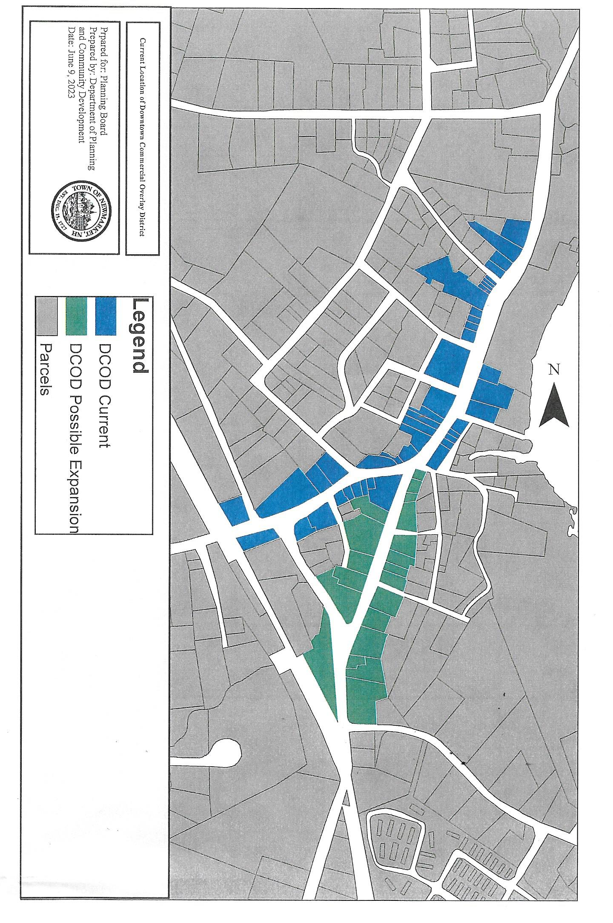

Addendum page 2
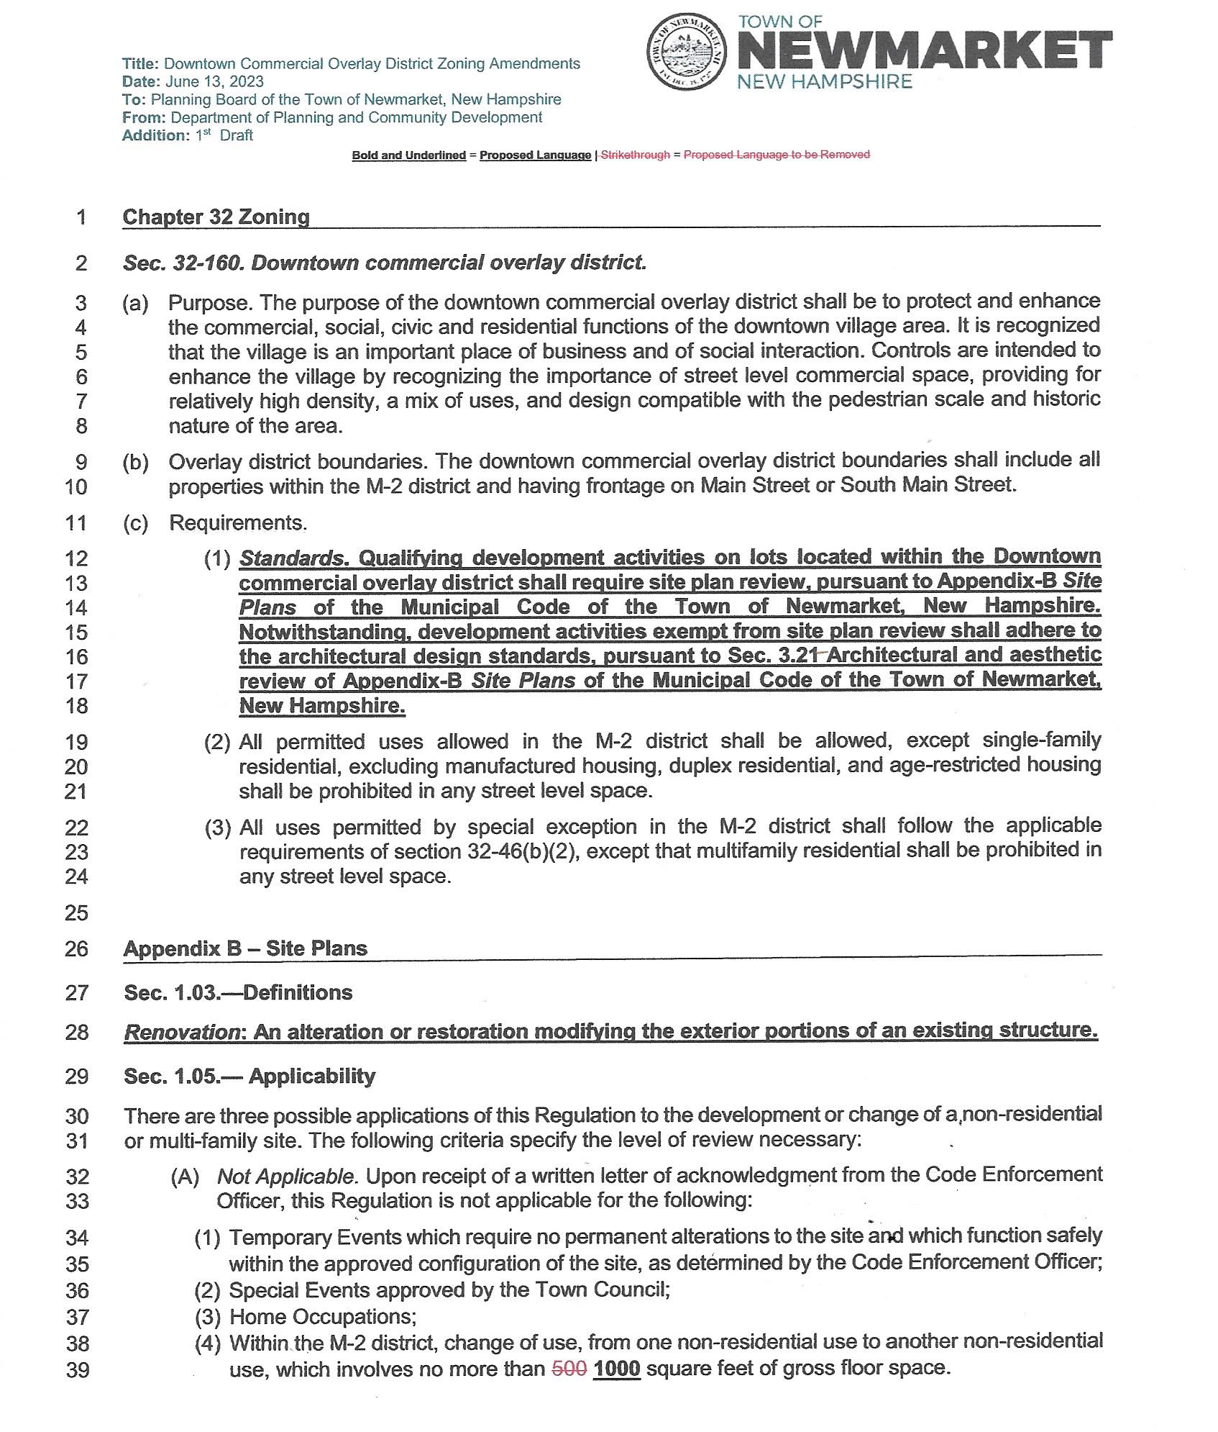
Addendum page 3
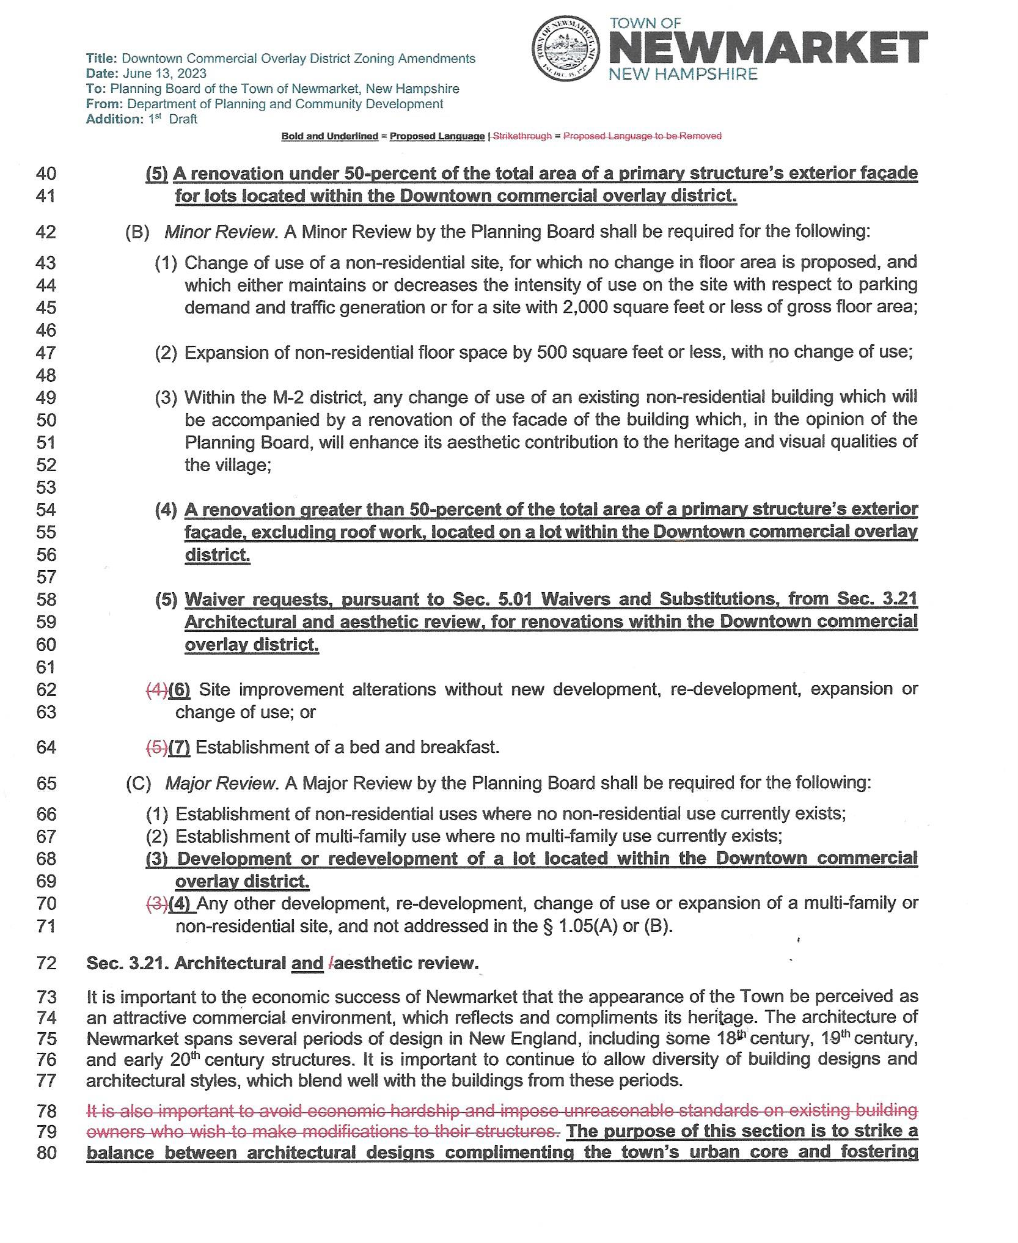
Addendum page 4
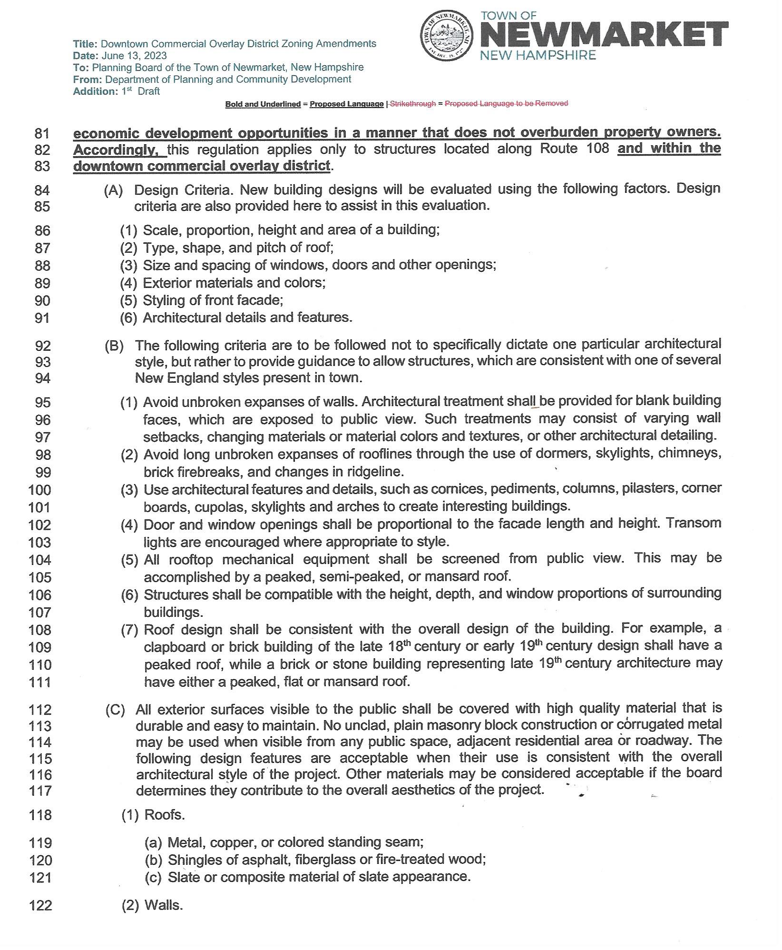
Addendum page 5
