PLANNING BOARD
May 9, 2023 at 7:00 PM
APPROVED MEETING MINUTES

Members Present: Eric Botterman (Chair), Val Shelton (Vice-Chair), Scott Blackstone (Town Council Ex officio), Jane Ford, Jeff Goldknopf, Bart McDonough (Director of Planning & Community Development), Patrick Reynolds, and Timothy Rossignol.
Member Absent: Michal Zahorik (alternate)
Chair Eric Botterman opened the meeting at 7:03 PM. [time on DCAT 5:35]
The voting members this evening will be Eric Botterman, Valerie Shelton, Scott Blackstone, Jane Ford. Jeff Goldknopf, Patrick Reynolds, and Timothy Rossignol.
1. Pledge of Allegiance
2. Public Comments
The Chair opened public comment at 7:04 PM. No one from the audience wished to speak during public comments. The Chair closed comments at 7:04 PM.
3. Acceptance of Minutes [time on DCAT 6:23]
a. March 21, 2023
Action
Motion: Valerie Shelton moved the approval of the draft minutes of March 21,
2023 as written.
Second: Tim Rossignol
Discussion: none
Vote: Approved Unanimously 7-0-0
b. April 11, 2023
Action
Motion: Jeff Goldknopf moved the approval of the draft minutes of April 11, 2023
as written.
Second: Patrick Reynolds
Discussion: none
Vote: Approved 5-0-2 (Jane Ford and Eric Botterman abstained)
4. Regular Business
Read by Chair: [time on DCAT 7:36]
a. Pursuant to RSA 675:7 and §32-238(n) Review and change of method of assessment of the Municipal Code of the Town of Newmarket, New Hampshire, notice is hereby given that the Planning Board shall hold a public hearing on proposed changes to the adopted impact fee assessment methodologies. The proposed changes seek to remove water and sewer from the impact fee schedule and to update the unit price fee while maintaining references for water and sewer usages, or take any other action relative thereto.
The Chair opened Public Comments at 7:06 PM.
Hearing none, the Chair closed Public Comments at 7:06 PM.
The Chair welcomed comments and discussion from the members. Bart was asked to review the changes. He stated that nothing in the ordinance is changing…only the methodologies are changing. The PB has previously reviewed all documents for these changes. Once approved by the members, a Public Hearing will be noticed.
Action
Motion: Valerie Shelton moved that the Planning Board approve the change in the impact fee assessment methodologies in the Municipal Code of the Town of Newmarket to remove the water and sewer from the impact fee schedule and to update the unit price fee while maintaining references for water and sewer usages.
Second: Jane Ford
Discussion: none
Vote: Approved Unanimously 7-0-0
**************************************************************************************************
Read by Chair: [time on DCAT 10:54 -1:39:06]
b. Notice is hereby given that the Planning Board shall set a hold a discussion on proposed language to amend §32-161 Historic overlay district and §3.21 Architectural/aesthetic review of the Municipal Town Code of Newmarket, New Hampshire, that seeks to add architectural design requirements within the historic overlay district, or take any other action relative thereto.
The Chair asked Bart to update the members on revisions he has made based on the lengthy discussion at the last meeting of Draft #1. At that meeting the members were discussing a way to implement thresholds. Once Bart consulted with legal counsel after the last meeting, he was informed that the Town has no authority to legislate thresholds. He thought of ways to achieve something close to thresholds by creating two new definitions. Bart will be referencing Draft #2 dated May 9, 2023 which is attached to the minutes as Addendum pages 1-5.
Reference page 2 of the addendum:
Sec. 1.03 Definitions
Redevelopment: Any construction, demolition, alteration, or improvement that disturbs more than 20,000 square feet of area or adds more than or, exceeds 5,000 square feet of additional impervious area on an existing developed parcel. This definition of the redevelopment only pertains to the stormwater management and sediment requirements of Section 3.07
Reconstruction: An alteration, restoration or expansion that modifies or adds on to the exterior portions of an existing structure.
Redevelopment, Historic overlay district: the demolition of existing structures and replacement with new development within the Historical overlay district.
Bart also added #5 to enable a non-applicability case. Reference addendum page 2, Sec. 1.05 Applicability:
(5) Reconstruction to an existing structure within the Historic overlay district that is not listed on the December 1980 National Register of Historic Places, or the reconstruction to those structures that are listed on the December 1980 National Register of Historic Places but were altered to such an extent whereby the historic characteristics, as identified on the December 1980 National Register of Historic Places, have been eliminated.
Bart also added #6 and #7 under Minor Review by the Planning Board in Sec. 1.05 Applicability. Reference page 3 of the Addendum.
(6) The reconstruction of a structure located within the Historical overlay district that is listed on the December 1980 National Register of Historic Places and does not qualify under §1.05(5) hereinabove.
(7) The redevelopment of a lot or structure located within the Historical overlay district.
Bart also discussed the changes to Sec. 3.21 Architectural and aesthetic review. He replaced paragraph two with new language. Reference page 3 of the Addendum.
It is also important to avoid economic hardship and impose unreasonable standards on existing building owners who wish to make modifications to their structures. The purpose of this section is to strike a balance between architectural designs that complement the town’s historical heritage and the economic viability of redevelopment. Accordingly, this regulation applies only to structures located along Route 108 and the historical overlay district.
The Historical Overlay District (HOD) includes 152 properties and these properties are mostly not in the downtown. The Town also has a Downtown Rt. 108 Historic District which includes all of Rt. 108 through Town to the line and is largely included in the HOD. Val asked the question: what are we trying to achieve with these changes? If the community is concerned, why has no one come to speak to the Board. Scott explained his understanding of the concerns expressed to the Town Council members.
Bart said that he looks at these changes as a stop-gap measure until the Town undergoes the planned comprehensive review of the gateway which will extend all the way along Rt. 108. This process will include a serious discussion about design and the desired character of the Town. He plans to have an architect present to help with the conversation. Bart has spoken with some developers and the major concerns were overly burdensome restrictions and costs and that when the PB members change, subjectivity could change, and there could be uncertainty about the ordinance. The members discussed other communities in the seacoast that have a separate set of restrictions and a separate review process for their HODs. Many members are concerned that no members of the public have come to share their concerns or ideas. It was agreed that if changes are to be proposed to the HOD, then all 152 properties should be noticed in order to afford them the opportunity to have input in this process (see Addendum page 6 for the map prepared in 1980) .
Val would like to know if the members want these changes to apply to the 1) Historic Overlay District or 2) the Downtown Rt. 108 Overlay District. The Chair took a straw vote and the results were (2) for the HOD, (4) for the Downtown Rt. 108, and (1) for either. Bart would like the PB to define what they want included in the Downtown Rt. 108 Overlay District. The members suggested that the district should run from the railroad tracks north to the Lamprey River Bridge.
Bart will be modifying the proposal based on the extensive conversations of the Board this evening for further discussion at the next meeting. He recapped his goals before the next meeting: 1) move all language changes to the Downtown Rt. 108 Overlay District, 2) any type of development there would go the PB for review, and 3) the proposed delineation of the Downtown Rt. 108 Overlay District. Thank you Bart!
*************************************************************************************
#5 Committee Assignments for 2023-2024 [time on DCAT 1:39:07]
The following committee assignments were made without objection for 2023-2024:
Jeff Goldknopf – Conservation Commission
Patrick Reynolds – Energy and Environment Advisory Committee
Jane Ford – Capital Improvement Program Committee (CIP)
Thank you for continuing to serve for another year!
#6 Committee Reports [time on DCAT 1:41:28]
Town Council: Scott Blackstone reported on that the TC now has a full membership, so committee appointments will be happening shortly. The two new members are Sonke Dornblut and Justin Glazebrook. The Town has completed a facilities study focusing mainly on the Town Hall and the Fire Station. Arbor Park (across from the Post Office) is being redeveloped. They have budgeted ~ $90,000 for new landscaping and a Wentworth Cheswell sculpture in the form of a bench with Mr. Cheswell sitting/reading on the bench. After the TC approved the new 15 minute parking spots on Central Street, it was discovered that they had already been approved in 2006, but no signage was posted.
Energy and Environment Advisory Committee: Patrick Reynolds reported that, although he did not attend the last meeting, he believes that their work is complete on the Community Power Initiative. They have held all of their hearings and it is ready to go forward to the Town Council. The energy section recommendations for the Master Plan are complete as well and will be coming to the Planning Board shortly.
Conservation Commission: Jeff Goldknopf reported that the ConCom had a very interesting speaker at the April 13th meeting. Cody Crytzer, a graduate student at UNH, gave a very informative presentation of his M.S. thesis to the ConCom. His research objectives were to 1) understand barriers and opportunities of access to nature and its benefits for underserved communities, 2) share information about barriers and opportunities with local, regional, and state organizations in this sector, and 3) contribute to strategies to ensure equity is at the forefront of all environmental protection, justice efforts, and future policy considerations. Jeff wanted to recommend that members check out the DCAT recording at: Newmarket NH Video on Demand (telvue.com) .
Planner’s Report: Bart reported that the RFP for the rezoning project for the gateway has gone out and bids are expected in June for the work to begin in July. A steering committee will be set up for this project soon. The RFP for the Master Plan Update has also gone out and, hopefully, the update will begin toward the end of July. Val asked about the Economic Development Committee and if the Town Manager had mentioned that to him. Bart will check on that for the members. Bart, Val, and Mike Hoffman attended a Housing Opportunity Housing Academy. As part of the grant application, this was one of several meetings meant to help them become better facilitators during community engagement to achieve a successful outcome. NH Finance provides so much helpful information on housing. St. Anslem College has just published a ‘Zoning Atlas’. NH Zoning Atlas (anselm.edu) . The Town is applying for Coastal Resilience Grant to fund a draft Master Plan Chapter for the riverfront area. This would help the Town create a vision and set goals. They will go with Strafford Regional Planning Commission and Plan NH and a charrette will be planned if we get the funding by the end of June. Bart reported that he was asked to go to Concord to testify about what Newmarket has done with the recent ADU changes and where we see challenges in the Town regarding planning. Bart, Ellen Snyder, and Tom Jones have completed the draft initiative called “Pathways for People and Nature”. The three goals are 1) To protect our drinking water supplies, restore and maintain the natural shoreline along the Lamprey and Piscassic Rivers, and protect freshwater wetlands and salt marsh that provide many benefits to our community. 2) To protect critical natural habitats and places to maintain connectivity across the landscape for animals on land and in the water, and 3) To create trail connectivity across town and between our neighboring communities to ensure safe recreating and commuting for pedestrians and cyclists. Once the Conservation Commission discussed the draft at their next meeting, Bart will send a copy to the PB members. The Durham Planning Board has invited Bart and Ellen Snyder to speak to at the May 24th meeting to discuss: 1) Current planning issues in Newmarket, 2) Potential for connectivity of trails between Durham and Newmarket, 3) Possible zoning changes on Route 108 in Newmarket, and 4) Opportunity to ask any planning-related questions to the Newmarket Town Planner. Val asked if there were any updates on some of the projects approved by the Board. Bart mentioned the Mill Town project off of Tanner Circle is proceeding, but other projects are having funding difficulties.
#7 Adjourn [time on DCAT 2:10:37]
Motion: Jane Ford moved to adjourn the meeting at 9:06 PM.
Second: Tim Rossignol
Discussion: none
Vote: Approved Unanimously 7-0-0
Respectfully submitted,
Sue Frick
Recording Secretary
DCAT:
https://videoplayer.telvue.com/player/XSekkdEeRsk0JHQVHAvKJVka7_5VjxKP/videos
Addendum page 1
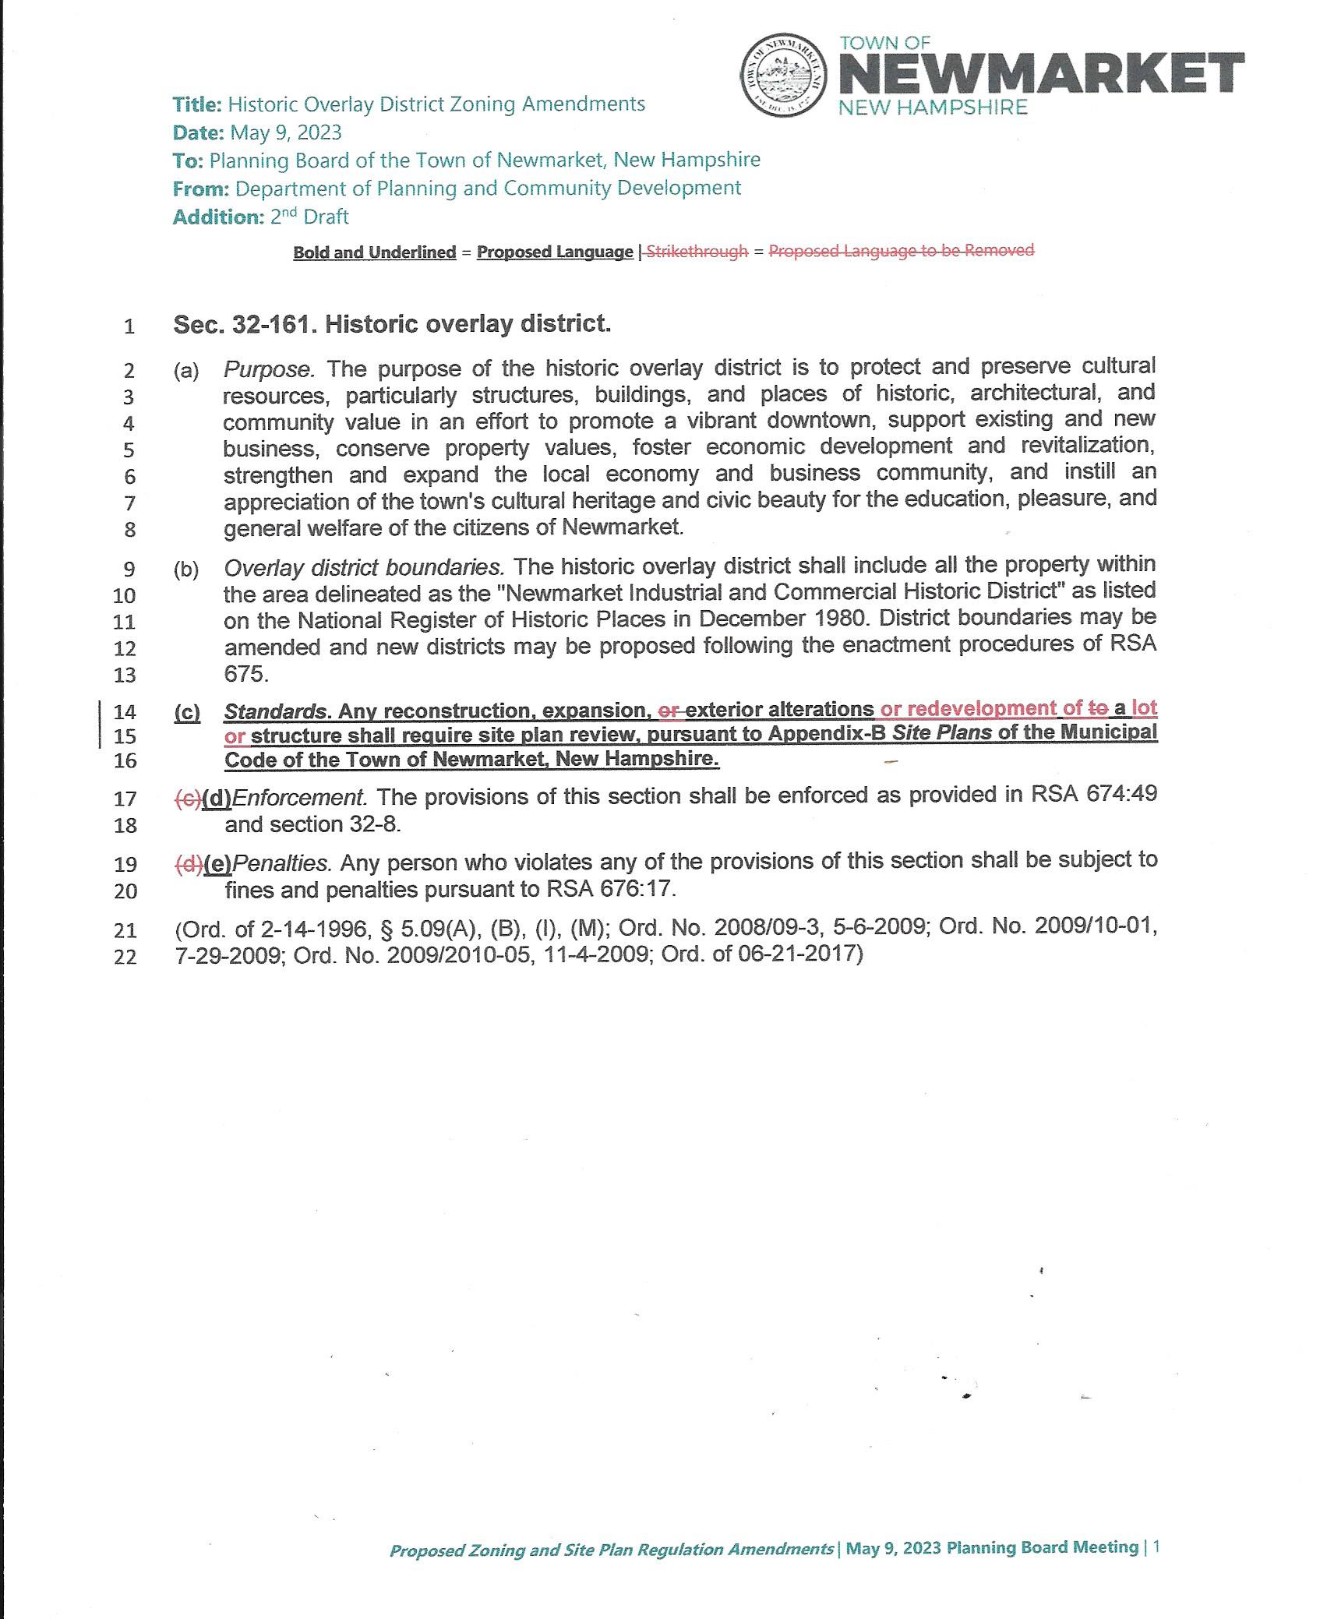
Addendum page 2
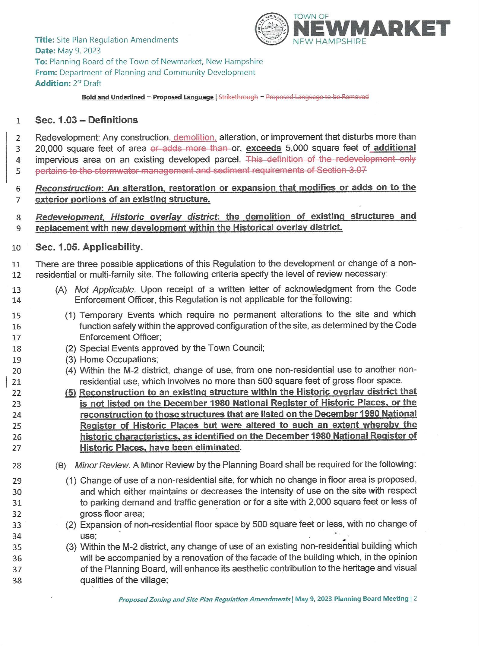
Addendum page 3
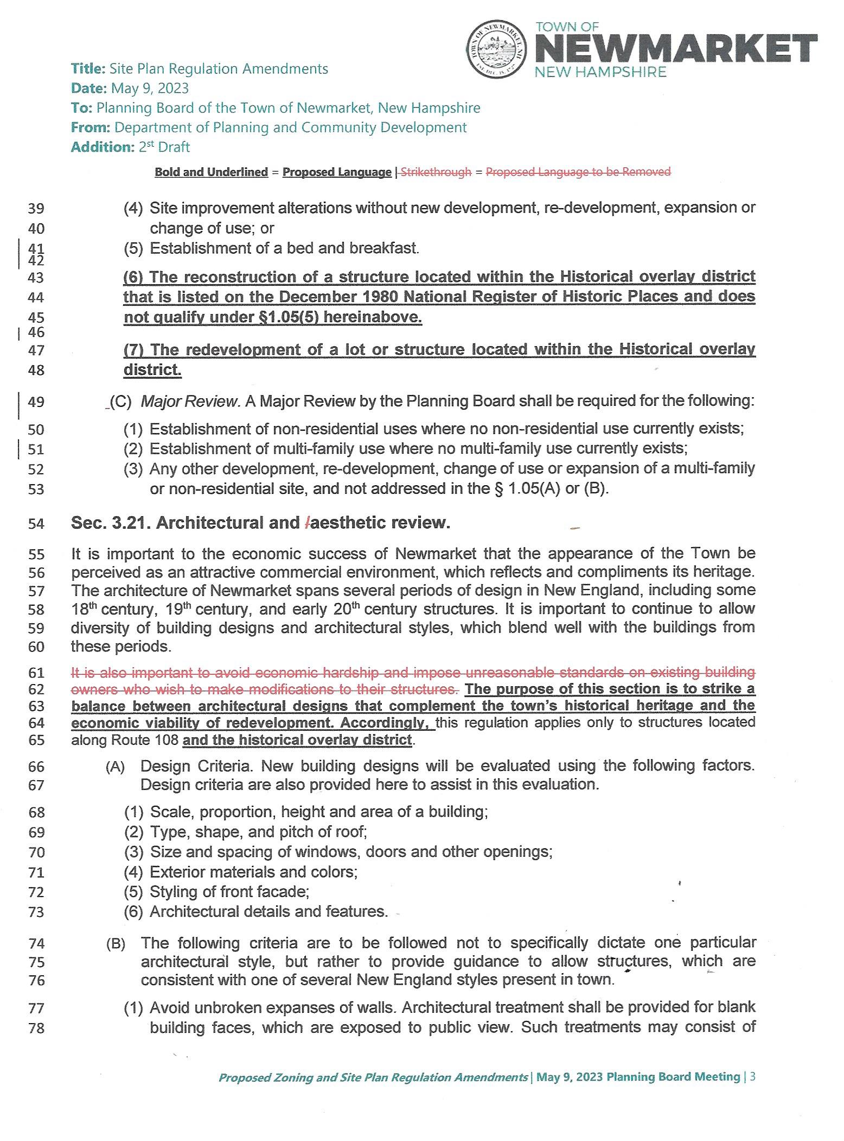
Addendum page 4
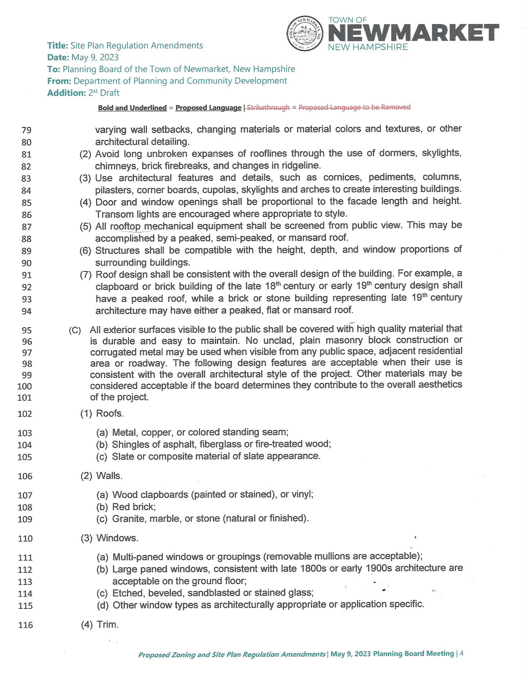
Addendum page 5
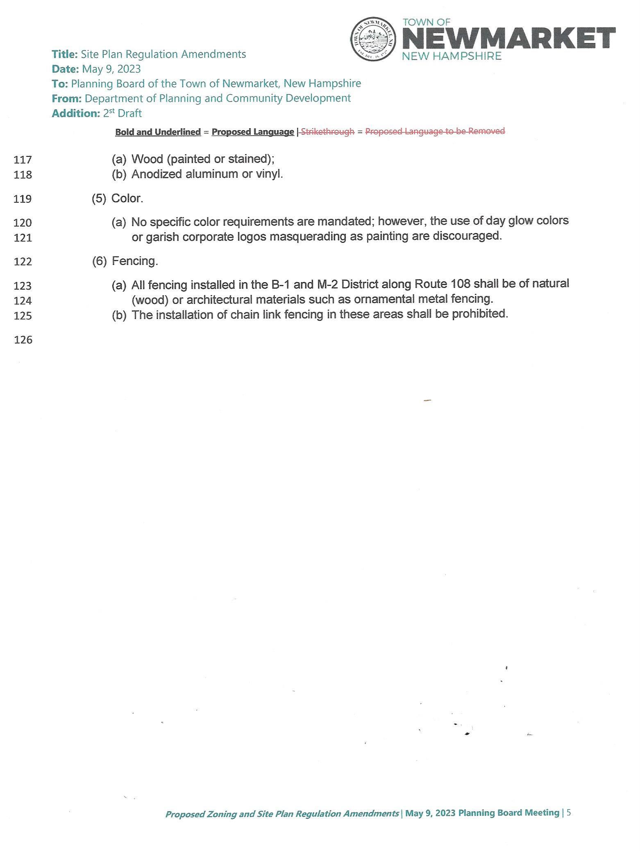
Addendum page 6
